第二章作业
运行截图：
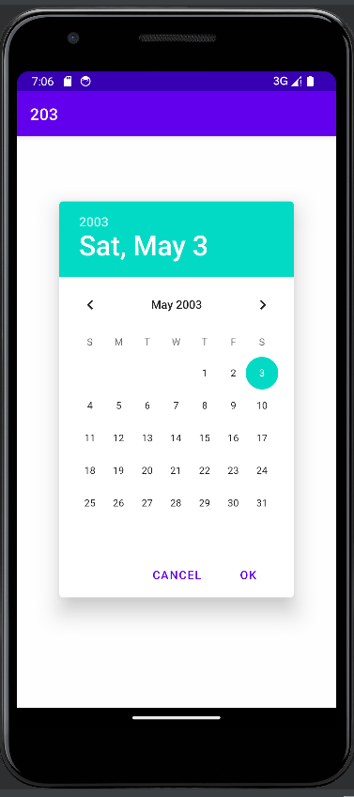
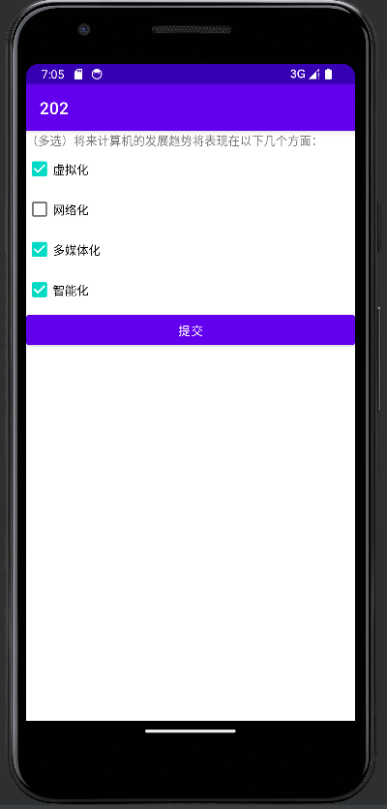

代码如下：
import androidx.appcompat.app.AppCompatActivity;
import android.content.Intent;
import android.os.Bundle;
import android.view.View;
import android.widget.Button;
public class MainActivity extends AppCompatActivity {
@Override
protected void onCreate(Bundle savedInstanceState) {
super.onCreate(savedInstanceState);
setContentView(R.layout.activity_main);
Button bt1=findViewById(R.id.button1);
bt1.setOnClickListener(
new View.OnClickListener() {
@Override
public void onClick(View view) {
Intent intent = new Intent(MainActivity.this,MainActivity2.class);
startActivity(intent);
}
}
);
Button bt2=findViewById(R.id.button2);
bt2.setOnClickListener(
new View.OnClickListener() {
@Override
public void onClick(View view) {
Intent intent = new Intent(MainActivity.this,MainActivity3.class);
startActivity(intent);
}
}
);
}
}
Button btn1=findViewById(R.id.button0);
btn1.setOnClickListener(view -> {
StringBuilder sb1=new StringBuilder();
if( ((CheckBox)(findViewById(R.id.checkBox1))).isChecked()) {
sb1.append(((CheckBox)(findViewById(R.id.checkBox1))).getText());
sb1.append(";");
}
if( ((CheckBox)(findViewById(R.id.checkBox2))).isChecked()) {
sb1.append(((CheckBox)(findViewById(R.id.checkBox2))).getText());
sb1.append(";");
}
if( ((CheckBox)(findViewById(R.id.checkBox3))).isChecked()) {
sb1.append(((CheckBox)(findViewById(R.id.checkBox3))).getText());
sb1.append(";");
}
if( ((CheckBox)(findViewById(R.id.checkBox4))).isChecked()) {
sb1.append(((CheckBox)(findViewById(R.id.checkBox4))).getText());
sb1.append(";");
}
((EditText)findViewById(R.id.s0)).setText(sb1);
});
}

