第五章作业
p150 5.1：
实现登录后显示用户名的效果。输入用户名、密码后登录，启动一个新的Activity显示用户名。
截图：
登陆界面
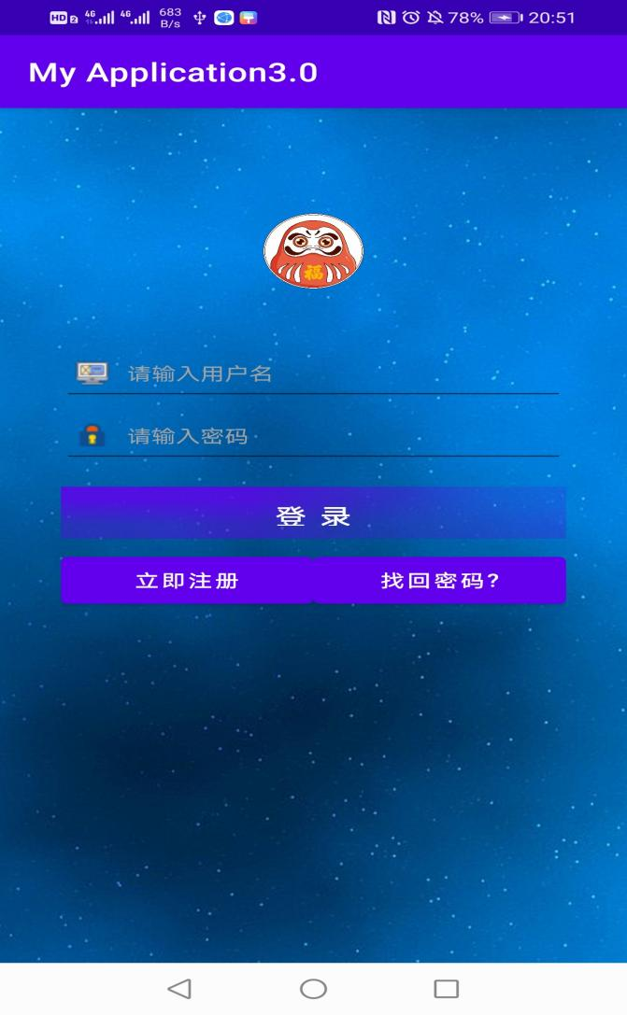
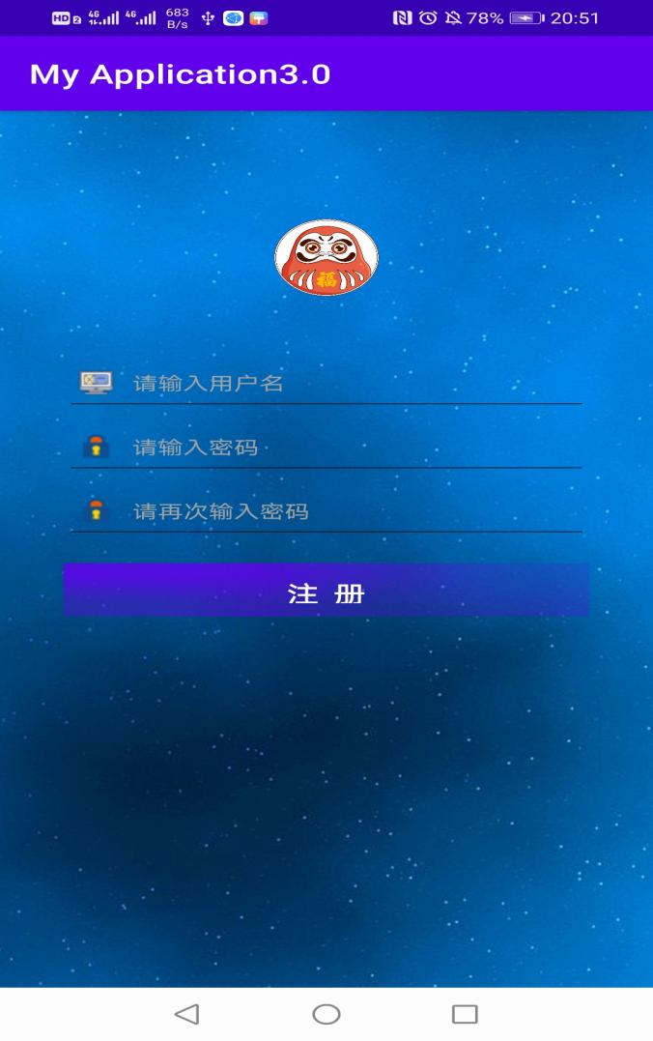
注册界面

代码部分：
由于注册界面的代码不是本次作业的要求，故不展示
登录界面后端业务逻辑代码：
public class MainActivity extends AppCompatActivity {
private EditText edtUsername;
private EditText edtPassword;
private Button btnLogin;
private Button btnCancel;

@Override
protected void onCreate(Bundle savedInstanceState) {
super.onCreate(savedInstanceState);
setContentView(R.layout.activity_main);
edtUsername=findViewById(R.id.et_user_name);
edtPassword=findViewById(R.id.et_psw);
Button bt2=findViewById(R.id.btn_login);
Button bt1=findViewById(R.id.tv_register);
bt1.setOnClickListener(new View.OnClickListener() {
@Override
public void onClick(View view) {
Intent intent =new Intent(MainActivity.this,RegisterActivity.class);
startActivity(intent);
}
});
bt2.setOnClickListener(new View.OnClickListener() {
@Override
public void onClick(View v) {
String strUsername = edtUsername.getText().toString().trim();
String strPassword = edtPassword.getText().toString().trim();
if (strUsername.equals("zzc") && strPassword.equals("admin")) {
Toast.makeText(MainActivity.this,
"恭喜,用户名和密码正确!", Toast.LENGTH_SHORT).show();
Intent intent =new Intent(MainActivity.this,MainActivity2.class);
intent.putExtra("Username",strUsername);
intent.putExtra("Password",strPassword);
startActivity(intent);

} else {
Toast.makeText(MainActivity.this,
"遗憾,用户名或密码错误!", Toast.LENGTH_SHORT).show();
}
}
});
}
}

个人主页后端业务代码：

public class MainActivity2 extends AppCompatActivity {
private TextView tvMessage;

@Override
protected void onCreate(Bundle savedInstanceState) {
super.onCreate(savedInstanceState);
setContentView(R.layout.activity_main2);
tvMessage=findViewById(R.id.et_username);
Intent intent =getIntent();
if(intent!=null){
String username = intent.getStringExtra("Username");
String password = intent.getStringExtra("Password");
String message = "登录成功!\n用户:" + username + "\n密码:" + password;
tvMessage.setText(message);
}
Button btn=findViewById(R.id.btn_quit);
btn.setOnClickListener(new View.OnClickListener() {
@Override
public void onClick(View v) {
finish();
}
});
}
}

登陆界面前端代码：
<LinearLayout
xmlns:android="http://schemas.android.com/apk/res/android"
android:layout_width="match_parent"
android:layout_height="match_parent"
android:background="@drawable/login_bg"
android:orientation="vertical">
<!--标题栏-->
<include layout="@layout/main_title_bar"></include>
<!--显示头像，记得加入id iv_head -->
<ImageView
android:id="@+id/iv_head"
android:layout_width="70dp"
android:layout_height="70dp"
android:layout_marginTop="25dp"
android:layout_gravity="center_horizontal"
android:background="@drawable/default_icon"/>
<!--输入框-->
<EditText
android:id="@+id/et_user_name"
android:layout_width="fill_parent"
android:layout_height="48dp"
android:layout_marginTop="35dp"
android:layout_marginLeft="35dp"
android:layout_marginRight="35dp"
android:layout_gravity="center_horizontal"
android:drawableLeft="@drawable/user_name_icon"
android:drawablePadding="10dp"
android:paddingLeft="8dp"
android:gravity="center_vertical"
android:hint="请输入用户名"
android:singleLine="true"
android:textColor="#000000"
android:textColorHint="#a3a3a3"
android:textSize="14sp"/>
<!--输入框-->
<EditText
android:id="@+id/et_psw"
android:layout_width="fill_parent"
android:layout_height="48dp"
android:layout_gravity="center_horizontal"
android:layout_marginLeft="35dp"
android:layout_marginRight="35dp"
android:drawableLeft="@drawable/psw_icon"
android:drawablePadding="10dp"
android:paddingLeft="8dp"
android:gravity="center_vertical"
android:hint="请输入密码"
android:inputType="textPassword"
android:singleLine="true"
android:textColor="#000000"
android:textColorHint="#a3a3a3"
android:textSize="14sp"/>
<!--按钮-->
<Button
android:id="@+id/btn_login"
android:layout_width="fill_parent"
android:layout_height="40dp"
android:layout_marginTop="15dp"
android:layout_marginLeft="35dp"
android:layout_marginRight="35dp"
android:layout_gravity="center_horizontal"
android:background="@drawable/register_selector"
android:text="登 录"
android:textColor="@android:color/white"
android:textSize="18sp"/>
<!--显示tv register , find_psw -->
<LinearLayout
android:layout_width="fill_parent"
android:layout_height="fill_parent"
android:layout_marginTop="8dp"
android:layout_marginLeft="35dp"
android:layout_marginRight="35dp"
android:gravity="center_horizontal"
android:orientation="horizontal">
<Button
android:id="@+id/tv_register"
android:layout_width="0dp"
android:layout_height="wrap_content"
android:layout_weight="1"
android:gravity="center_horizontal"
android:padding="8dp"
android:text="立即注册"
android:textColor="@android:color/white"
android:textSize="14sp" />
<!--layout_weight="1" layout_width="0dp"实现均分效果-->
<Button
android:id="@+id/tv_find_psw"
android:layout_width="0dp"
android:layout_height="wrap_content"
android:layout_weight="1"
android:gravity="center_horizontal"
android:padding="8dp"
android:text="找回密码?"
android:textColor="@android:color/white"
android:textSize="14sp" />
</LinearLayout>
</LinearLayout>

