计算机2101肖皓哲2106410118
P22 1．下载最新版本的Android Studio，安装后如果需要更新Gradle，则将其更新到最新版本。
P22 2．创建一个任意类型的手机App工程，分别使用虚拟设备和物理设备运行。
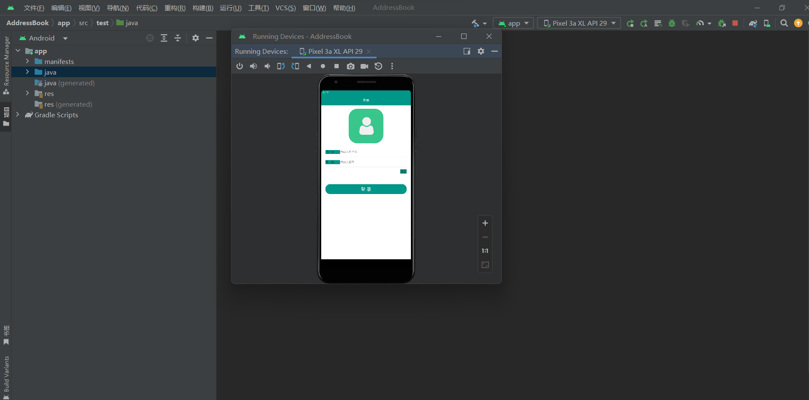

P73 2.2 实现多选题的界面效果。
代码：
<?xml version="1.0" encoding="utf-8"?>
<androidx.constraintlayout.widget.ConstraintLayout xmlns:android="http://schemas.android.com/apk/res/android"
xmlns:app="http://schemas.android.com/apk/res-auto"
xmlns:tools="http://schemas.android.com/tools"
android:layout_width="match_parent"
android:layout_height="match_parent"
tools:context=".MainActivity">
<CheckBox
android:id="@+id/checkBox5"
android:layout_width="352dp"
android:layout_height="78dp"
android:rotationX="-1"
android:textSize="30dp"
android:text="钓鱼"
app:layout_constraintBottom_toBottomOf="parent"
app:layout_constraintEnd_toEndOf="parent"
app:layout_constraintHorizontal_bias="0.493"
app:layout_constraintStart_toStartOf="parent"
app:layout_constraintTop_toTopOf="parent"
app:layout_constraintVertical_bias="0.104" />
<CheckBox
android:id="@+id/checkBox4"
android:layout_width="352dp"
android:layout_height="78dp"
android:rotationX="-1"
android:text="游泳"
android:textSize="30dp"
app:layout_constraintBottom_toBottomOf="parent"
app:layout_constraintEnd_toEndOf="parent"
app:layout_constraintHorizontal_bias="0.491"
app:layout_constraintStart_toStartOf="parent"
app:layout_constraintTop_toTopOf="parent"
app:layout_constraintVertical_bias="0.269" />
<CheckBox
android:id="@+id/checkBox3"
android:layout_width="352dp"
android:layout_height="78dp"
android:rotationX="-1"
android:textSize="30dp"
android:text="喝水"
app:layout_constraintBottom_toBottomOf="parent"
app:layout_constraintEnd_toEndOf="parent"
app:layout_constraintHorizontal_bias="0.491"
app:layout_constraintStart_toStartOf="parent"
app:layout_constraintTop_toTopOf="parent"
app:layout_constraintVertical_bias="0.415" />
<CheckBox
android:id="@+id/checkBox6"
android:layout_width="352dp"
android:layout_height="78dp"
android:rotationX="-1"
android:textSize="30dp"
android:text="篮球"
app:layout_constraintBottom_toBottomOf="parent"
app:layout_constraintEnd_toEndOf="parent"
app:layout_constraintHorizontal_bias="0.491"
app:layout_constraintStart_toStartOf="parent"
app:layout_constraintTop_toTopOf="parent"
app:layout_constraintVertical_bias="0.572" />
<TextView
android:id="@+id/textView"
android:layout_width="362dp"
android:layout_height="43dp"
android:gravity="center"
android:text="你的爱好是什么?"
android:textSize="20dp"
app:layout_constraintBottom_toBottomOf="parent"
app:layout_constraintEnd_toEndOf="parent"
app:layout_constraintStart_toStartOf="parent"
app:layout_constraintTop_toTopOf="parent"
app:layout_constraintVertical_bias="0.023" />
<Button
android:id="@+id/button"
android:layout_width="164dp"
android:layout_height="66dp"
android:layout_marginTop="48dp"
android:layout_marginBottom="183dp"
android:text="确定"
app:layout_constraintBottom_toBottomOf="parent"
app:layout_constraintEnd_toEndOf="parent"
app:layout_constraintHorizontal_bias="0.497"
app:layout_constraintStart_toStartOf="parent"
app:layout_constraintTop_toBottomOf="@+id/checkBox6"
app:layout_constraintVertical_bias="0.0" />
</androidx.constraintlayout.widget.ConstraintLayout>

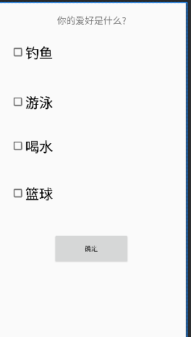

p73 2.3 实现选择出生日期的界面效果。
代码：
<?xml version="1.0" encoding="utf-8"?>
<LinearLayout xmlns:android="http://schemas.android.com/apk/res/android"
android:layout_width="match_parent"
android:layout_height="match_parent"
android:gravity="center"
android:orientation="vertical">
<TextView
android:id="@+id/textView3"
android:layout_width="425dp"
android:layout_height="41dp"
android:gravity="center"
android:text="请选择你的出生日期：" />
<DatePicker
android:id="@+id/date_picker"
android:layout_width="match_parent"
android:layout_height="wrap_content"
android:calendarViewShown="false"
android:datePickerMode="spinner"
android:startYear="2020" />
<Button
android:id="@+id/button1"
android:layout_width="wrap_content"
android:layout_height="wrap_content"
android:text="重置" />
<Button
android:id="@+id/button2"
android:layout_width="wrap_content"
android:layout_height="wrap_content"
android:text="确定" />
</LinearLayout>
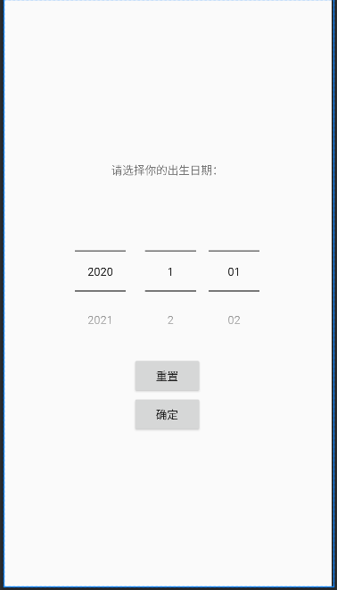

第三章
3.1 实现注册界面的布局效果，至少包括用户名、密码、忘记密码、登录等控件。
<?xml version="1.0" encoding="utf-8"?>
<!--线性布局 LinearLayout 根布局-->
<LinearLayout
xmlns:android="http://schemas.android.com/apk/res/android"
android:layout_width="match_parent"
android:layout_height="match_parent"
android:orientation="vertical"
android:fitsSystemWindows="true"
android:background="@color/colorWhite">
<!--标题栏-->
<LinearLayout
android:layout_width="match_parent"
android:layout_height="50dp"
android:gravity="center"
android:background="@color/colorPrimary">
<TextView
android:layout_width="wrap_content"
android:layout_height="wrap_content"
android:textColor="@color/colorWhite"
android:textSize="16dp"
android:text="登录"/>
</LinearLayout>
<!--表单布局-->
<LinearLayout
android:layout_width="match_parent"
android:layout_height="wrap_content"
android:paddingLeft="20dp"
android:paddingRight="20dp"
android:orientation="vertical">
<ImageView
android:layout_width="match_parent"
android:layout_height="200dp"
android:src="@drawable/ic_logo"/>
<!--账号-->
<LinearLayout
android:layout_width="match_parent"
android:layout_height="wrap_content"
android:background="@drawable/bg_border_bottom"
android:paddingTop="15dp"
android:paddingBottom="15dp"
android:orientation="horizontal">
<!--TextView 文本 html的p标签-->
<TextView
android:layout_width="70dp"
android:layout_height="wrap_content"
android:gravity="start"
android:background="@color/colorPrimary"
android:textSize="14dp"
android:text="用户名"/>

<EditText
android:id="@+id/et_account"
android:layout_width="0dp"
android:layout_height="wrap_content"
android:layout_weight="2"
android:background="@null"
android:hint="请输入用户名"
android:singleLine="true"
android:textSize="14dp" />
</LinearLayout>
<!--密码-->
<LinearLayout
android:layout_width="match_parent"
android:layout_height="wrap_content"
android:background="@drawable/bg_border_bottom"
android:paddingTop="15dp"
android:paddingBottom="15dp"
android:orientation="horizontal">
<TextView
android:layout_width="70dp"
android:layout_height="wrap_content"
android:gravity="start"
android:background="@color/colorPrimary"
android:textSize="14dp"
android:text="密 码"/>
<EditText
android:id="@+id/et_password"
android:layout_width="0dp"
android:layout_height="wrap_content"
android:layout_weight="1"
android:background="@null"
android:inputType="textPassword"
android:textSize="14dp"
android:singleLine="true"
android:hint="请输入密码"/>
</LinearLayout>
<RelativeLayout
android:layout_width="match_parent"
android:layout_height="wrap_content"
android:orientation="horizontal">

<TextView
android:id="@+id/tv_register"
android:layout_width="wrap_content"
android:layout_height="wrap_content"
android:layout_alignParentRight="true"
android:layout_marginTop="10dp"
android:background="@color/colorPrimary"
android:text="注册"
android:textSize="16dp" />
</RelativeLayout>
<!--登录按钮-->
<Button
android:id="@+id/btn_login"
android:layout_width="match_parent"
android:layout_height="wrap_content"
android:layout_gravity="center"
android:layout_marginTop="50dp"
android:background="@drawable/btn_border_fill"
android:textColor="@color/colorWhite"
android:textSize="22dp"
android:textAllCaps="false"
android:text="登 录"/>
</LinearLayout>
</LinearLayout>
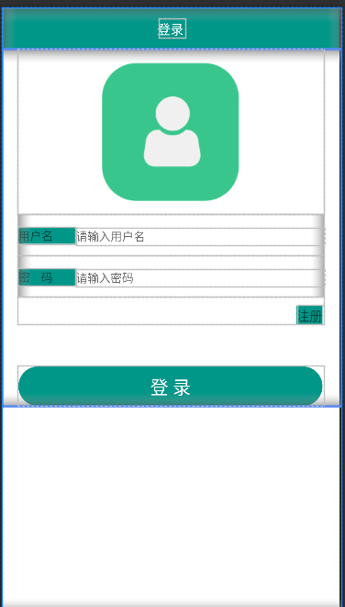

p122 4.3 实现京东首页的轮播广告效果，至少包括3个产品广告的图像。
public class MainActivity extends AppCompatActivity {
private ViewFlipper mVewFlipper;
@Override
protected void onCreate(Bundle savedInstanceState) {
super.onCreate(savedInstanceState);
setContentView(R.layout.activity_main);
View view3 = View.inflate(MainActivity.this, R.layout.view_flipper_page3, null);
ImageView imageView4 = new ImageView(this);
imageView4.setAdjustViewBounds(true);
imageView4.setImageResource(R.mipmap.img_9546);
mVewFlipper = findViewById(R.id.view_flipper);
mVewFlipper.addView(imageView4);
mVewFlipper.addView(view3,2);
mVewFlipper.startFlipping();
mVewFlipper.setOnClickListener(v -> Toast.makeText(MainActivity.this, "当前显示的子视图索引号为"+mVewFlipper.getDisplayedChild(), Toast.LENGTH_SHORT).show());
Button startBtn = findViewById(R.id.button_start); //开始按钮
startBtn.setOnClickListener(v -> mVewFlipper.startFlipping());
Button stopBtn = findViewById(R.id.button_stop); //停止按钮
stopBtn.setOnClickListener(v -> mVewFlipper.stopFlipping());
Button previousBtn = findViewById(R.id.button_previous);
previousBtn.setOnClickListener(v -> //上一页按钮mVewFlipper.showPrevious());
Button nextBtn = findViewById(R.id.button_next); //下一页按钮
nextBtn.setOnClickListener(v -> mVewFlipper.showNext());
}}
<?xml version="1.0" encoding="utf-8"?>
<GridLayout xmlns:android="http://schemas.android.com/apk/res/android"
android:layout_width="match_parent"
android:layout_height="wrap_content"
android:layout_gravity="top|fill"
android:alignmentMode="alignMargins"
android:background="#eeeeee"
android:columnCount="4"
android:rowCount="2">
<ViewFlipper
android:id="@+id/view_flipper"
android:layout_width="wrap_content"
android:layout_height="wrap_content"
android:layout_columnSpan="4"
android:flipInterval="3000"
android:inAnimation="@anim/view_flipper_right_in"
android:outAnimation="@anim/view_flipper_left_out">
<include layout="@layout/view_flipper_page1" />
<include layout="@layout/view_flipper_page2" />
</ViewFlipper>
<Button
android:id="@+id/button_start"
android:layout_width="wrap_content"
android:layout_height="wrap_content"
android:layout_columnWeight="1.0"
android:text="开始" />
<Button
android:id="@+id/button_stop"
android:layout_width="wrap_content"
android:layout_height="wrap_content"
android:layout_columnWeight="1.0"
android:text="停止" />
<Button
android:id="@+id/button_previous"
android:layout_width="wrap_content"
android:layout_height="wrap_content"
android:layout_columnWeight="1.0"
android:text="上一页" />
<Button
android:id="@+id/button_next"
android:layout_width="wrap_content"
android:layout_height="wrap_content"
android:layout_columnWeight="1.0"
android:text="下一页" />
</GridLayout>
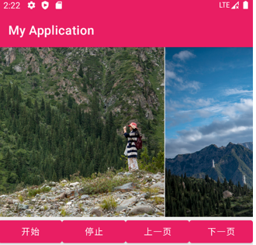

p150 5.1 实现登录后显示用户名的效果。输入用户名、密码后登录，启动一个新的Activity显示用户名。
代码：
public class MainActivity extends AppCompatActivity {
private static final int REQUEST_CODE = 101;
private EditText mResultEditText;
protected void onCreate(Bundle savedInstanceState) {
super.onCreate(savedInstanceState);
setContentView(R.layout.activity_main);
mResultEditText = findViewById(R.id.edit_text_result);
findViewById(R.id.button_send).setOnClickListener(new View.OnClickListener() {//发送数据（没有回传数据）
public void onClick(View v) {
Intent intent = new Intent(MainActivity.this, ReceiveActivity.class);
intent.putExtra("id", 10407);
intent.putExtra("msg", "MainActivity发送的信息1");
startActivity(intent);
mResultEditText.setText("");}});
findViewById(R.id.button_send_for_result).setOnClickListener(new View.OnClickListener() {
public void onClick(View view) {
Intent intent = new Intent(MainActivity.this, ReceiveActivity.class);
intent.putExtra("id", 20408);
intent.putExtra("msg", "MainActivity发送的信息2");
startActivityForResult(intent, REQUEST_CODE);
mResultEditText.setText("");}}); }
protected void onActivityResult(int requestCode, int resultCode, Intent data) {//处理回调数据
super.onActivityResult(requestCode, resultCode, data);
mResultEditText.setText("正在处理回调数据");
if (requestCode == REQUEST_CODE) { //判断请求码
if (resultCode == ReceiveActivity.RESULT_CODE) {
String result = data.getStringExtra("data");
mResultEditText.setText(result);
}else{
mResultEditText.setText("没有回传数据");}}}}
public class ReceiveActivity extends AppCompatActivity {
public static final int RESULT_CODE = 201;
private EditText mIdEditText;
private EditText mMsgEditText;
protected void onCreate(Bundle savedInstanceState) {
super.onCreate(savedInstanceState);
setContentView(R.layout.activity_receive);
Intent intent = getIntent();//获取传递数据
int id = intent.getIntExtra("id", 0);
String msg = intent.getStringExtra("msg");
mIdEditText = findViewById(R.id.edit_text_id); //显示传递数据
mIdEditText.setText(String.valueOf(id));
mMsgEditText = findViewById(R.id.edit_text_name);
mMsgEditText.setText(msg);
findViewById(R.id.button_finish).setOnClickListener(view -> {
finish();//关闭当前Activity}); findViewById(R.id.button_finish_result).setOnClickListener(view -> {
Intent intent1 = new Intent();//设置返回的数据//关闭（发送回传数据）
intent1.putExtra("data", "已经查阅信息！");
setResult(RESULT_CODE, intent1);
finish();//关闭当前Activity});}}
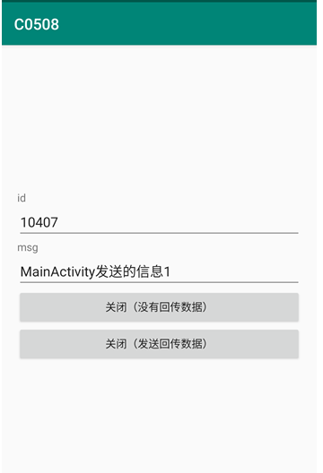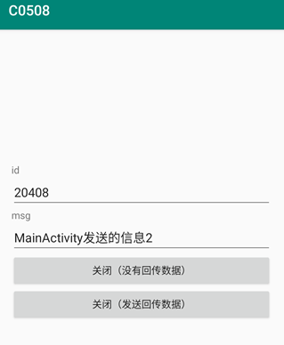

第六章：
p176 6.3 通过广播接收器实现两个App之间通过自定义广播进行数据通信。
代码：
public class MainActivity extends AppCompatActivity {
protected void onCreate(Bundle savedInstanceState) {
super.onCreate(savedInstanceState);
setContentView(R.layout.activity_main);
findViewById(R.id.button_send_broadcast).setOnClickListener(new View.OnClickListener() {//发送标准广播
public void onClick(View v) {
Intent intent=new Intent();
intent.setAction("MyBroadcastReceiver.Custom");
intent.putExtra("info","悄悄地告诉你一个秘密^6^");
intent.addFlags(Intent.FLAG_ACTIVITY_PREVIOUS_IS_TOP);
sendBroadcast(intent); }});
findViewById(R.id.button_send_ordered_broadcast).setOnClickListener(new View.OnClickListener() {//发送有序广播（连续传递）
public void onClick(View v) {
Intent intent=new Intent();
intent.setAction("OrderedBroadcast.Custom");
intent.putExtra("info","悄悄地告诉你一个秘密^6^");
intent.addFlags(Intent.FLAG_ACTIVITY_PREVIOUS_IS_TOP);
sendOrderedBroadcast(intent,null);}});
findViewById(R.id.button_send_ordered_broadcast_stop).setOnClickListener(new View.OnClickListener() {//发送有序广播（传递一次）
public void onClick(View v) {
Intent intent=new Intent();
intent.setAction("OrderedBroadcast.Custom");
intent.putExtra("stop",true);
intent.putExtra("info","悄悄地告诉你一个秘密 不要告诉别人哦^6^"); intent.addFlags(Intent.FLAG_ACTIVITY_PREVIOUS_IS_TOP);
sendOrderedBroadcast(intent,null);}});}}
public class MyBroadcastReceivers1 extends BroadcastReceiver {
private static final String TAG = "MyBroadcastReceiver";
public void onReceive(Context context, Intent intent) {
Log.d(TAG, "-----------Receivers1-----------");
Log.d(TAG, "Action: " + intent.getAction());
Log.d(TAG, "URI: " + intent.toUri(Intent.URI_INTENT_SCHEME));
Log.d(TAG, "自定义广播的info：" + intent.getStringExtra("info"));}}
public class MyBroadcastReceivers2 extends BroadcastReceiver {
private static final String TAG = "MyBroadcastReceiver";
public void onReceive(Context context, Intent intent) {
Log.d(TAG, "-----------Receivers2-----------");
Log.d(TAG, "Action: " + intent.getAction());
Log.d(TAG, "URI: " + intent.toUri(Intent.URI_INTENT_SCHEME));
Log.d(TAG, "自定义广播的info：" +intent.getStringExtra("info"));
if(intent.getBooleanExtra("stop",false)){
abortBroadcast();}}}
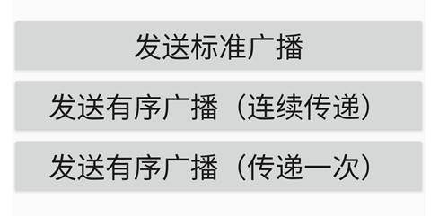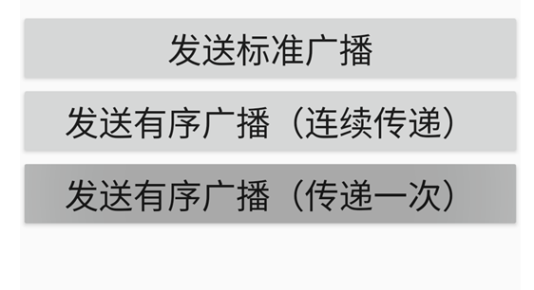

第七章：
p213 7.2 使用SQLite实现记录登录时间的功能，并且能够查询登录的历史记录。
代码：
public class SQLiteDBHelper extends SQLiteOpenHelper {
static final String CREATE_SQL[] = {// 创建数据库
"CREATE TABLE news (" +
"_id INTEGER NOT NULL PRIMARY KEY AUTOINCREMENT," +"title varchar," +"content varchar," +"keyword varchar," +"category varchar," +"author INTEGER," +"publish_time varchar" +")",
"CREATE TABLE user (" +"_id INTEGER NOT NULL PRIMARY KEY AUTOINCREMENT," +"name varchar," +"password varchar," +"email varchar," +"phone varchar," +"address varcher" +")",
"INSERT INTO userVALUES(1,'admin',123,'admin@163.com',123,'沈阳')",
"INSERT INTO user VALUES (2,'zhangsan',123,'zhangsan@163.com',123,'北京')",
"INSERT INTO user VALUES (3,'lisi',123,'lisi@163.com',123,'上海')",
"INSERT INTO user VALUES (4,'wangwu',123,'wangwu@163.com',123,'深圳')"};
public SQLiteDBHelper(@Nullable Context context, @Nullable String name, int version) {// 调用父类的构造方法(便于之后进行初始化赋值)
super(context, name, null, version); }
public void onCreate(SQLiteDatabase db) {
Log.i("sqlite_____", "create Database");// 创建数据库
for (int i = 0; i < CREATE_SQL.length; i++) {// 执行 SQL 语句
db.execSQL(CREATE_SQL[i]); }
Log.i("sqlite_____", "Finished Database");// 完成数据库的创建}
public class SQLiteListActivity extends AppCompatActivity {
ListView listView01;
SQLiteDBHelper dbHelper;
protected void onCreate(Bundle savedInstanceState) {
super.onCreate(savedInstanceState);
setContentView(R.layout.activity_sqlite_list);
Toast.makeText(this,"登录成功！",Toast.LENGTH_LONG).show();
listView01 = findViewById(R.id.listView01);
dbHelper = new SQLiteDBHelper(this,"sqlite.db",1);
SQLiteDatabase db = dbHelper.getReadableDatabase();
Cursor cursor = db.query("user",new String[]{"_id","name"},null,null,null,null,null,null);
SimpleCursorAdapteradapter=newSimpleCursorAdapter(this,android.R.layout.simple_list_item_1,cursor,new String[]{"_id","name"},new int[]{android.R.id.text1,android.R.id.text1},0);
listView01.setAdapter(adapter);}
protected void onDestroy() {
super.onDestroy();
dbHelper.close();}}
public class SQLiteLoginActivity extends AppCompatActivity {
SQLiteDBHelper dbHelper;
EditText etUsername;
EditText etPassword;
protected void onCreate(Bundle savedInstanceState) {
super.onCreate(savedInstanceState);
setContentView(R.layout.activity_sqlite_login);
dbHelper = new SQLiteDBHelper(this,"sqlite.db",1);
etUsername = findViewById(R.id.etUsername);
etPassword = findViewById(R.id.etPassword);}
public void onClick(View view) {
String username = etUsername.getText().toString();
String password = etPassword.getText().toString();
SQLiteDatabase db = dbHelper.getReadableDatabase();
Cursor cursor = db.query("user",new String[]{"name","password"}, "name=?",new String[]{username},null,null,null,"0,1");
if(cursor.moveToNext()) {@SuppressLint("Range") String dbPassword = cursor.getString(cursor.getColumnIndex("password"));
cursor.close();
if(password.equals(dbPassword)) {
Intent intent = new Intent(this, SQLiteListActivity.class);
startActivity(intent); // 启动
return;}}
cursor.close();// 跳转失败也要进行关闭
Toast.makeText(this,"输入信息有误！",Toast.LENGTH_LONG).show();}
public void onDestroy() {
super.onDestroy();
dbHelper.close();}}
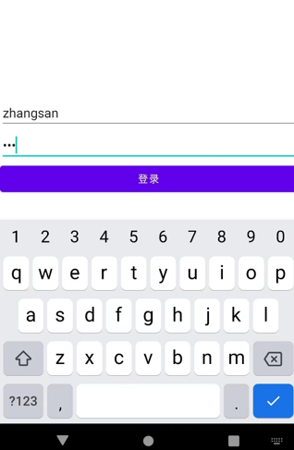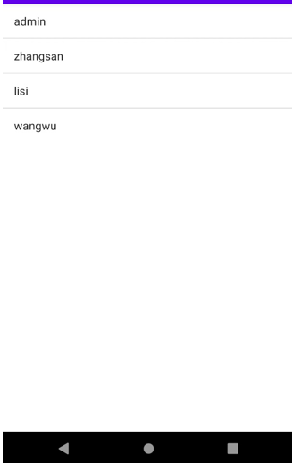

p271 8.1 使用Camera2实现定时拍照的功能。
代码：
public void onClick(View view) {
takePhoto();
}
@SuppressLint("MissingPermission") // 打开摄像头
private void openCamera(int width, int height) {
Log.d(TAG, "openCamera()");
if (!Permissions.hasPermissionsGranted(mContext, PERMISSIONS)) {Permissions.requestPermissions(mContext, PERMISSIONS);
return;}
try {// 2500毫秒内请求获取1个许可，否则抛出异常。
if (!mSemaphore.tryAcquire(2500, TimeUnit.MILLISECONDS)) {
throw new RuntimeException("打开摄像头超时");}
mCameraManager = (CameraManager) getSystemService(Context.CAMERA_SERVICE);
CameraCharacteristics characteristics = // 获取摄像头支持的属性特征
mCameraManager.getCameraCharacteristics(mCameraId);
StreamConfigurationMap map = characteristics.get(CameraCharacteristics.SCALER_STREAM_CONFIGURATION_MAP); // 获取摄像头捕捉的最大尺寸读取图片
Size largest = Collections.max(Arrays.asList(map.getOutputSizes(ImageFormat.JPEG)), new Util.CompareSizesByArea());
mImageReader = ImageReader.newInstance(largest.getWidth(), largest.getHeight(), ImageFormat.JPEG, 2); // 选择最佳预览尺寸
mPreviewSize = Util.chooseOptimalSize(mContext, map.getOutputSizes(SurfaceTexture.class), width, height, MAX_PREVIEW_WIDTH, MAX_PREVIEW_HEIGHT, largest);
mPreviewView.setAspectRatio(mPreviewSize.getHeight(), mPreviewSize.getWidth());// 设置预览尺寸
mCameraManager.openCamera(mCameraId, //打开摄像头mCameraDeviceStateCallback, mBackgroundHandler);
} catch (CameraAccessException e) {
e.printStackTrace();
} catch (InterruptedException e) {
throw new RuntimeException("打开摄像头被中断", e);}}
private void startPreview() { // 创建摄像头预览会话
Log.d(TAG, "startPreview()");
if (null == mCameraDevice || !mPreviewView.isAvailable() || null == mPreviewSize) { return; }
try {
closePreview();// 创建摄像头预览会话
SurfaceTexture texture = mPreviewView.getSurfaceTexture();
texture.setDefaultBufferSize(mPreviewSize.getWidth(), mPreviewSize.getHeight());// 设置预览输出的Surface
Surface surface = new Surface(texture);
mCaptureRequestBuilder = mCameraDevice.createCaptureRequest(CameraDevice.TEMPLATE_PREVIEW);
mCaptureRequestBuilder.addTarget(surface); mCameraDevice.createCaptureSession(Arrays.asList(surface, mImageReader.getSurface()), new CameraCaptureSession.StateCallback() { public void onConfigured(CameraCaptureSession cameraCaptureSession) {
mCaptureSession = cameraCaptureSession;
updatePreview();}
public void onConfigureFailed(CameraCaptureSession cameraCaptureSession) {
Toast.makeText(mContext, "摄像头配置失败", Toast.LENGTH_LONG).show();}}, mBackgroundHandler);
} catch (CameraAccessException e) {
e.printStackTrace();}}
private void takePhoto() { // 拍照
Log.d(TAG, "takePhoto()");
if (null == mCameraDevice || !mPreviewView.isAvailable() || null == mPreviewSize) {
return;}
try {
closePreview();
mCaptureRequestBuilder = mCameraDevice.createCaptureRequest(CameraDevice.TEMPLATE_STILL_CAPTURE); // 设置预览的缓冲区大小
SurfaceTexture texture = mPreviewView.getSurfaceTexture();
texture.setDefaultBufferSize(mPreviewSize.getWidth(), mPreviewSize.getHeight());// 设置预览的Surface
List<Surface> surfaces = new ArrayList<>();
Surface previewSurface = new Surface(texture);
surfaces.add(previewSurface);
mCaptureRequestBuilder.addTarget(previewSurface);
Surface imageReaderSurface = mImageReader.getSurface();
surfaces.add(imageReaderSurface);
mCaptureRequestBuilder.addTarget(imageReaderSurface);
mCameraDevice.createCaptureSession(surfaces, new CameraCaptureSession.StateCallback() {
public void onConfigured(@NonNull CameraCaptureSession cameraCaptureSession) {
Log.d(TAG, "CameraCaptureSession.onConfigured()");
mCaptureSession = cameraCaptureSession; mImageReader.setOnImageAvailableListener(mOnImageAvailableListener, mBackgroundHandler);
mCaptureRequest = mCaptureRequestBuilder.build();
try {// 拍摄照片
mCaptureSession.capture(mCaptureRequest, null, null);
} catch (CameraAccessException e) {
e.printStackTrace();}}
public void onConfigureFailed(CameraCaptureSession cameraCaptureSession) {
Toast.makeText(mContext, "摄像头配置失败", Toast.LENGTH_LONG).show();}}, mBackgroundHandler);
} catch (CameraAccessException e) {
e.printStackTrace();}}
public static void requestPermissions(final Context context, String[] permissions) {
if (shouldShowRequestPermissionRationale(context, permissions)) {
String msg = "";
for (int i = 0; i < permissions.length; i++) {
if (i == 0) {
msg = permissions[i];
} else {
msg = msg + "\n" + permissions[i];}}
