

Student enrollment support system for FPT University

**Student enrollment support system for FPT University**

Prepared by: Hoàng Huy Thắắng – HE141054

Prepared by: Hoàng Huy Thắắng – HE141054

Prepared by: Hoàng Huy Thắắng – HE141054

**Prepare by: Bùi Quang Dương – HE15006**

**Class: SE1603-KS**

Prepared by: Hoàng Huy Thắắng – HE14105

– Hanoi, Feburary 2023 –

**Table of Contents**

1 Overall Description 3

1.1 Introduction 3

1.2 Feature Descriptions 4

1.2.1 Screen Functions 4

1.2.2 Non-Screen Functions 4

1.2.3 Common Requirements 4

1.3 Screen Description 4

1.3.1 Screen Flow 4

1.3.2 Screen Details 4

1.3.3 User Authorization 5

2 System Features 6

2.1 <<Feature Name 1>> 6

1.1 Login 6

1.2 <Use case ID> - <Use case name> 8

1.3 <Name of Function Group> 8

# 1 Identified the problems and writing the problems in software requirement

## Identify Functional requirements

1.1.1: Function Table

|  |  |
| --- | --- |
| **Primary Actor** | **Use cases** |
| User  (Student) | * Log in to the system to access their profile. * View Application Status * Submit Application: The student can submit their admission application online and attach any required documents. * Request Information: The student can request more information about the admission process or the program they are interested in * Update Contact Information: The student can update their contact information, such as their email address or phone number. * Schedule an Interview: The student can schedule an interview with the admissions staff if one is required. * View Acceptance Letter: The student can view their acceptance letter once it has been issued. * Accept/Decline Offer: The student can accept or decline the offer of admission. * Submit Acceptance Deposit: The student can submit their acceptance deposit to secure their spot in the program. * View Financial Aid Status: The student can view the status of their financial aid application and see if any further action is required. * Request Financial Aid: The student can request financial aid by completing an application and providing the required documents. * View Course Schedule: The student can view their course schedule for the upcoming semester. * Register for Courses: The student can register for courses online and select their preferred sections. * Drop/Withdraw from Courses: The student can drop or withdraw from courses if they need to change their schedule. * View Grades: The student can view their grades for each course they have taken. * Request Transcript: The student can request an official transcript to be sent to another institution or for personal use. |
| User  (Teacher) | * View student profiles * Update student information * Record student attendance * Add grades for student assignments and exams * View class schedules * Create and manage class schedules * View student academic progress reports * Communication with students and parents * Manage student conduct records * Manage student enrolment and admission process * Send notifications and announcements to students * Create and manage student groups and clubs |
| Admission staff | * View incoming student applications * Review student profiles and supporting documents * Assign student applications to reviewers for further evaluation * Manage student application status and updates * Enter and maintain student information in the database * Communicate with students via email or phone * Generate admission reports and analytics * Collaborate with other departments to review student applications * Update admission policies and procedures * Manage student scholarships and financial aid information * Prepare and send admission offers to selected students * Respond to student inquiries regarding the admission process. |

## Use Case Diagram

1.2.1 Student Use Case Diagram

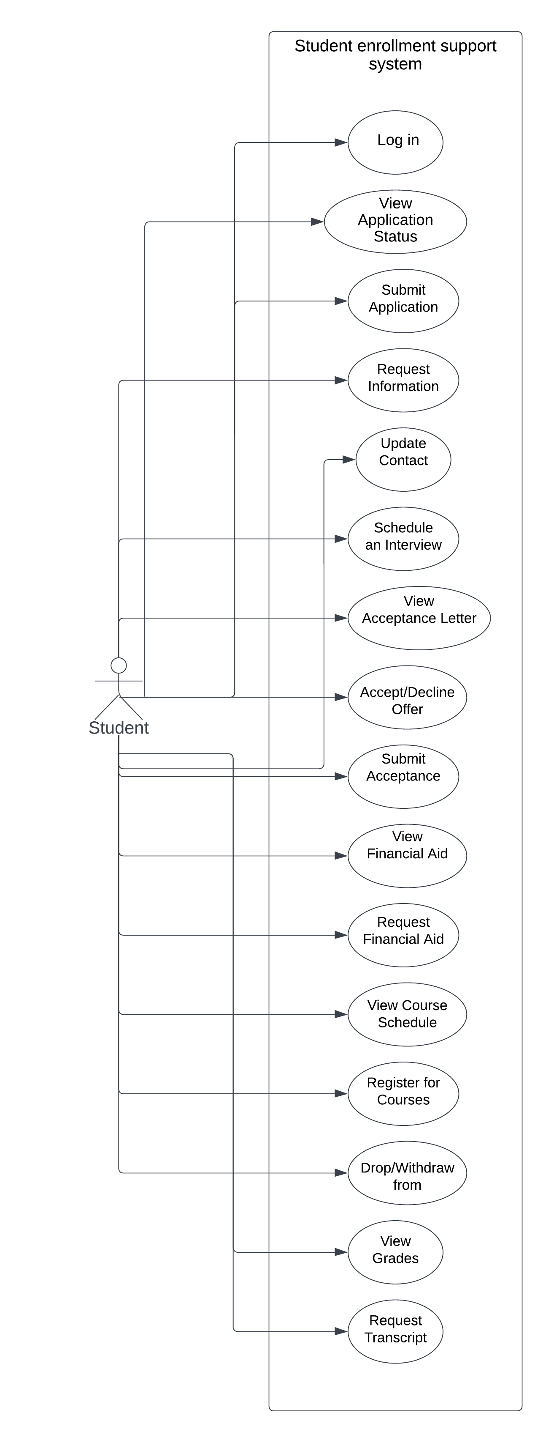

**Figuage 1.2.1: Student Use Case Diagram**

1.2.2 Teacher Use Case Diagram

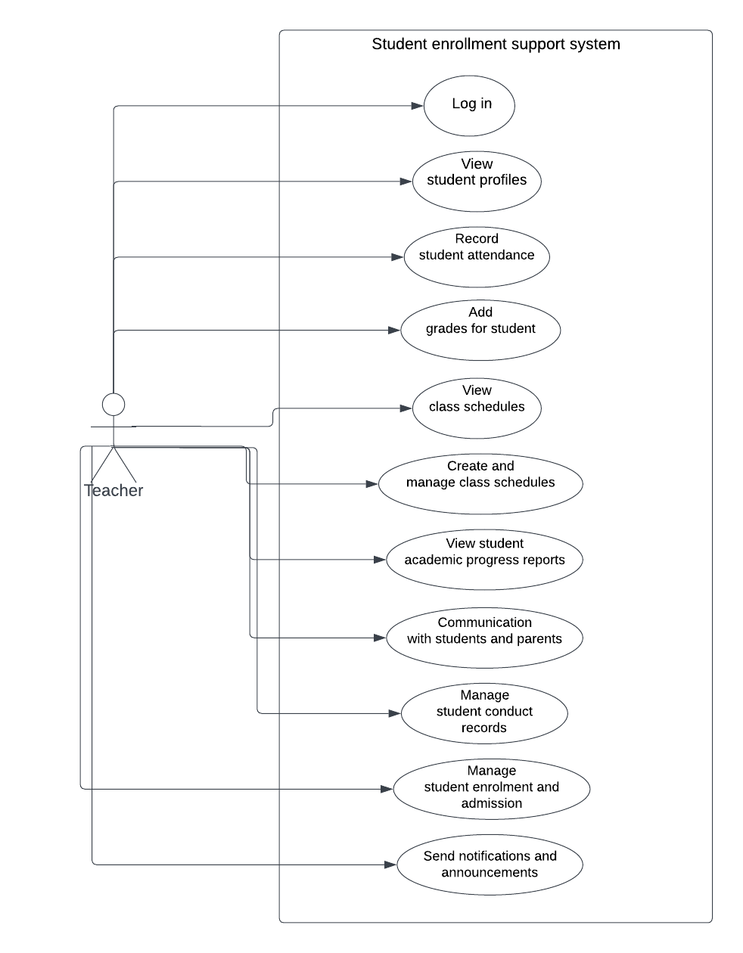

**Figuage 1.2.2: Teacher Use Case Diagram**

1.2.3 Admission Staff Use Case Diagram

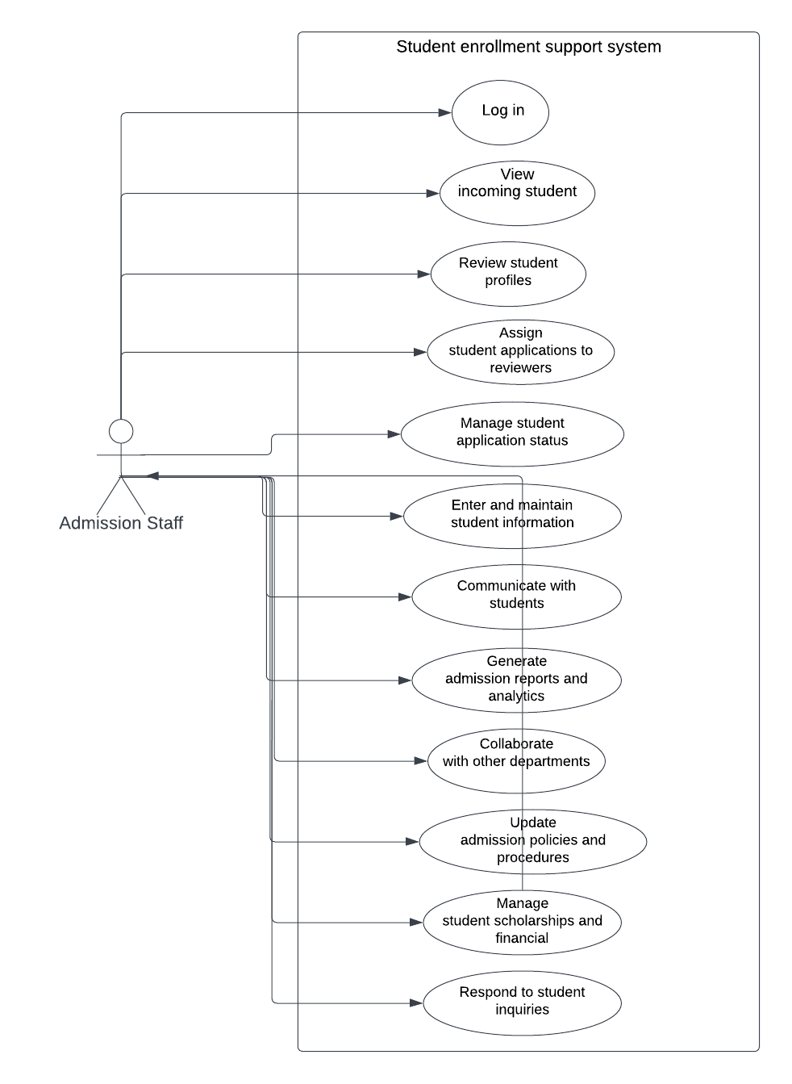

**Figuage 1.2.3: Admission Staff Use Case Diagram**

## Feature Tree

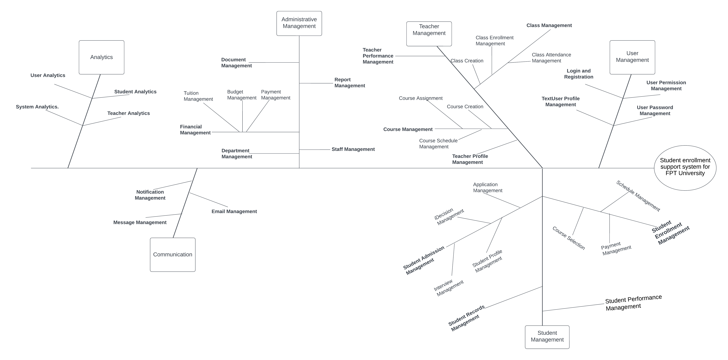

**Figuage 1.2.3: Feature Tree For Student Enrolment Support System For FPT University**

## Screen Flow

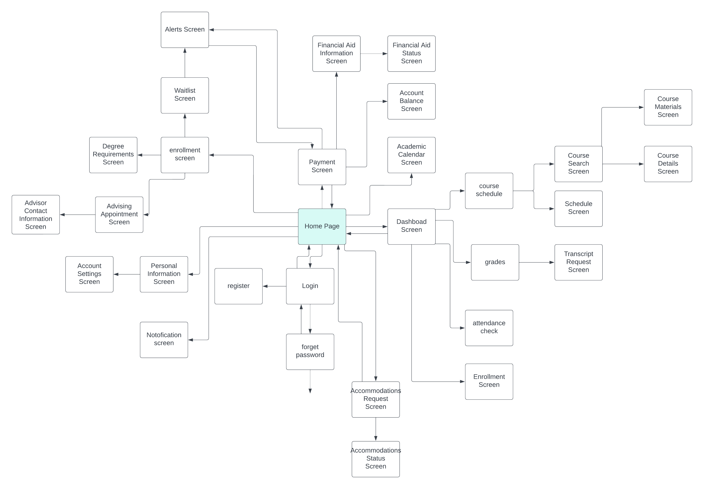

**Figuage 1.4.1: Screen Flow For Student Enrolment Support System For FPT University**

## 1.5 Non-functional requirements

Non-functional requirements for a Student Enrollment Support System include:

* Reliability: The system should be reliable and available to students at all times, with minimal downtime or system failures.
* Security: The system should be secure, with appropriate measures to protect sensitive student data from unauthorized access or breaches.
* Performance: The system should perform efficiently and quickly, with minimal delays or waiting times for students accessing the system.
* Scalability: The system should be able to handle a large volume of users and transactions, particularly during peak enrollment periods.Usability: The system should be easy to use and navigate for students, with a user-friendly interface and intuitive features.
* Accessibility: The system should be accessible to students with disabilities or different needs, with appropriate accommodations and accessibility features.
* Compatibility: The system should be compatible with various devices and platforms, such as desktops, laptops, and mobile devices.
* Maintainability: The system should be maintainable, with regular updates and maintenance to ensure its ongoing functionality.
* Compliance: The system should comply with relevant regulations and standards, such as FERPA, ADA, and data privacy laws.
* Interoperability: The system should be able to integrate with other campus systems and technologies, such as the learning management system or student information system.

# 2 Software Architecture Design

## 2.1 Context Diagram

2.2 Database Table Diagram

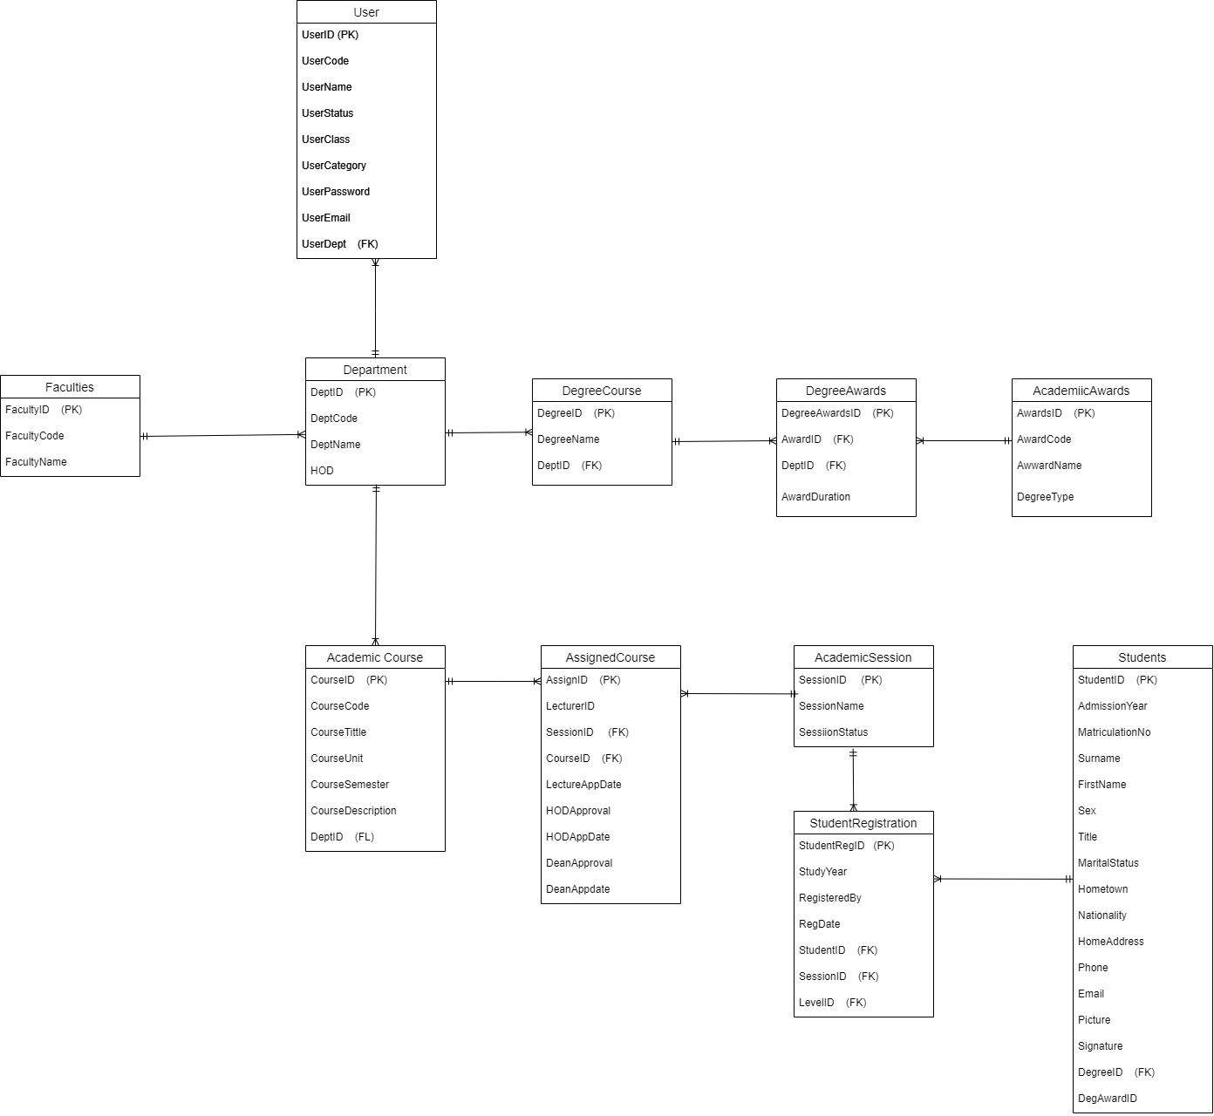

**Figuage 2.2.1:** Database Table Diagram **For Student Enrolment Support System For FPT University**

The database models representing some of the entities are:

Table 1: User Table

|  |  |  |  |  |
| --- | --- | --- | --- | --- |
| # | Field Name | Data Type | Constraints | Character Length |
| 1 | UserID | NUMBER | NOT NULL | 9 |
| 2 | UserCode | VARCHAR | NOT NULL | 10 |
| 3 | UserName | VARCHAR | NOT NULL | 50 |
| 4 | UserCategory | VARCHAR | NOT NULL | 25 |
| 5 | PassWord | VARCHAR | NOT NULL | 10 |
| 6 | UserDept | NUMBER | NOT NULL | 9 |
| 7 | Email | VARCHART | NULL | 100 |
| 8 | UserClass | VARCHAR | NOT NULL | 20 |
| 9 | UserStatus | VACHAR | NOT NULL | 15 |

### 1.1 Login

#### 1.1.1 Screen Design

|  |  |  |  |  |  |  |  |
| --- | --- | --- | --- | --- | --- | --- | --- |
| **Login** |  |  |  |  |  |  |  |
|  |  |  |  |  |  |  |  |
|  |  | User name |  |  |  |  |  |
|  |  |  |  |  |  |  |  |
|  |  | Password |  |  |  |  |  |
|  |  | Login | | |  |  |  |
|  |  |  |  |  |
|  |  |  |  |  |
|  |  |  |  |  |  |  |  |
|  |  |  |  |  |  |  |  |

**Figure 3-1**: Screen Design of Login

**Table 1-1: Screen Definition**

|  |  |  |  |  |  |
| --- | --- | --- | --- | --- | --- |
| # | Field Name | Type | Mandatory | Max Length | Description |
| 1 | User Name | Text | Yes | 20 |  |
| 2 | Password | Text | Yes | 20 | Display "*" instead of clear character |
| 3 | Login | Button |  |  | Go to home page |
| 4 | Close | Button |  |  |  |
|  |  |  |  |  |  |
|  |  |  |  |  |  |

#### 1.1.2 Use case Specification

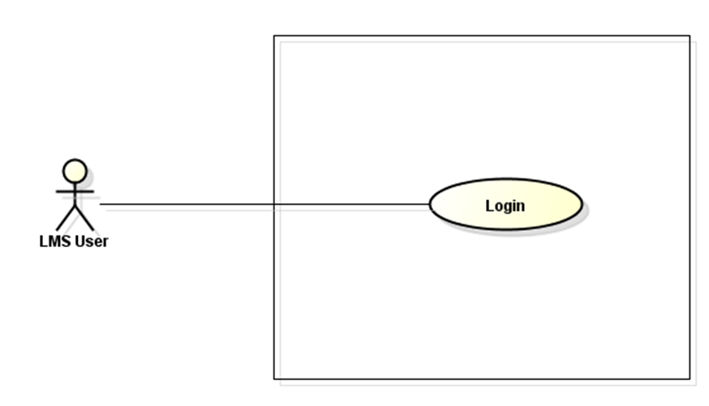

LMS

**Figure 3-2:** Login Use-Case Diagram

|  |  |  |  |  |  |  |
| --- | --- | --- | --- | --- | --- | --- |
| **Use Case ID** | | **UC01** | **Use Case Name** | | **Login** | |
| **Author** | | **HungNV** | **Version** | **1.0** | **Date** | **11/05/2013** |
| **Actor** | | LMS User | | | | |
| **Description** | | The function allows a user to be able to login in the software when he/she have registered an account and his/her account is still active. | | | | |
| **Precondition** | | PRE-01:  PRE-02: | | | | |
| **Trigger** | | TRG-01: | | | | |
| **Post-Condition** | | POS-01: | | | | |
| **Main flows** | | | | | | |
| ***Step*** | ***Actor*** | ***Action*** | | | | |
| *1* | User | Type URL into location field of internet browser and then press enter | | | | |
| *2* | LMS | Display Login screen with the following fields:  - User Name  - Password  - Login and Close button | | | | |
| *3* | User | Enter user name & password into User Name & Password fields on the Login screen, then click on Login button. | | | | |
| *4* | LMS | Validate the entered user name & password and then display Home screen | | | | |
|  |  |  | | | | |

**Alternative flows**

|  |  |  |
| --- | --- | --- |
| **AT1** | At step 2 in the main flows**,** if there is an internal error in the system, | |
| **Sub step** | **Actor** | **Action** |
| 2.1 | LMS | Display "Error" page with message "Internal System Error, please contact with administrator" |
|  |  |  |
|  |  |  |

|  |  |  |
| --- | --- | --- |
| **AT2** | At step 4 in the main flows**,** if LMS failed to validate user name & password | |
| **Sub step** | **Actor** | **Action** |
| 4.1 | LMS | Display "Login" page with message "Your user name or password is not correct." |
|  |  |  |

***Business Rules***

|  |  |
| --- | --- |
| ***#*** | ***Rule Description*** |
| *BR01* |  |
| *BR02* |  |

### 1.2 <Use case ID> - <Use case name>

#### 1.2.1 Screen Design

*[Mock-up and screen description which should include field name, type, field length…*

*Mock-up và mô tả mock-up]*

#### 1.2.2 Use case Specification

*[Specify use case diagram, use case specification details, business rules...]*

### 1.3 <Name of Function Group>

#### 1.3.1 Use Case diagram

*[Include use case diagram and use case description]*

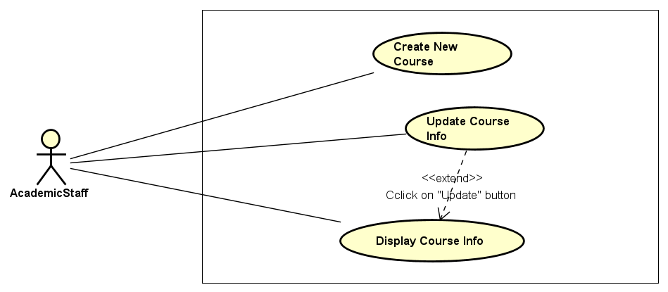

|  |  |  |
| --- | --- | --- |
| Use Case ID | User case Name | Description |
| UC-0201 | Create New Course | Allow an authorized user to create a new course in the system |
| UC-0202 | Update Course Info | Allow the user to update the course information |
|  |  |  |

#### 1.3.2 <Use case ID> - <Use case name>

##### 1.3.2.1 Screen Design

*[Mock-up and screen description which should include field name, type, field length…*

*Mock-up và mô tả mock-up]*

##### 1.3.2.2 Use case Specification

*[Specify use case specification details, business rules... – No use case diagram]*

#### 1.3.3 <Use case ID> - <Use case name>

##### 1.3.3.1 Screen Design

*[Mock-up and screen description which should include field name, type, field length…*

*Mock-up và mô tả mock-up]*

##### 1.3.3.2 Use case Specification

*[Specify use case specification details, business rules... – No use case diagram]*