

**CSE6224 Software Requirements Engineer**

**System Documentation**

**for**

**Campus Accessibility Navigation System with Facilities and Event Integration**

**Kano Model**

**TT3L**

**GROUP 1**

**Prepared by:**

|  |  |  |
| --- | --- | --- |
| **NAME** | **STUDENT ID** | **EMAIL** |
| MUHAMMAD NAQIB BIN ZULL AZRI | 1211112306 | 1211112306@student.mmu.edu.my |
| MUHAMMAD HARITH AIMAN BIN MUHD ZULKAPLI | 1211112350 | 1211112350@student.mmu.edu.my |
| DHARVIN DARAN A/L ELANGOO | 1231303548 | 1231303548@student.mmu.edu.my |
| GOH YENG XUN | 1231303430 | 1231303430@student.mmu.edu.my |

# Kano Model

This Kano Model was created from the feedback we gathered during our elicitation process. It helps us understand what users truly care about by grouping the features into things they expect, things that make their experience better, and things that pleasantly surprise for the User.

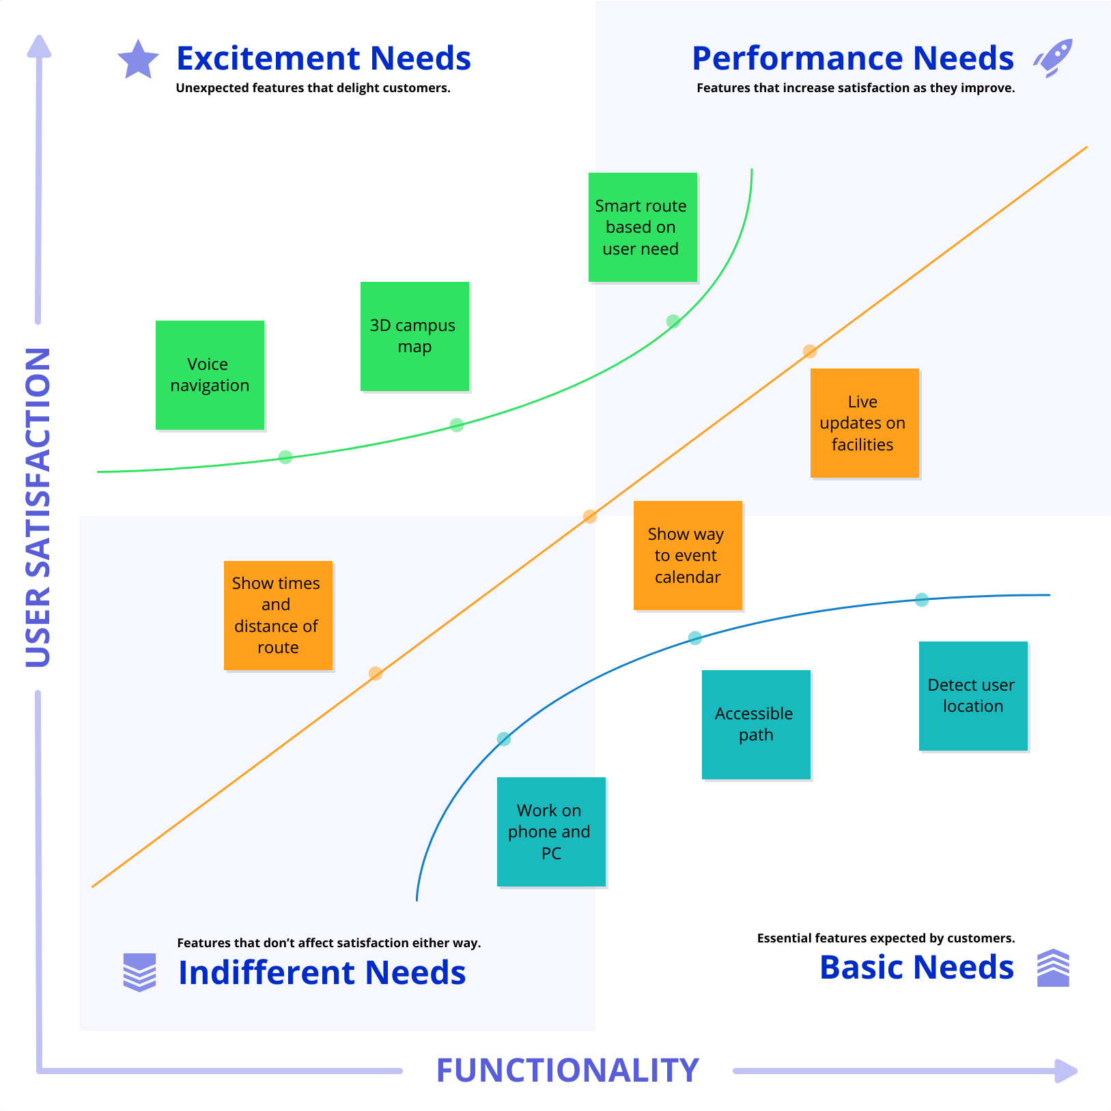

#### Figure 1.0 Kano Model