Submitted by: Yuriy Rusanov – 340915149, Elad Orpaz - XXXXXXXXX

Deep Learning
Exercise 2

We have used the train/test sets from the provided links.
- The training set contains 2200 pairs.
- The test set contains 1000 pairs.
We have also used 80/20 train/validation split.

We have implemented Siamese Network architecture exactly as it was described in the paper with slight modifications to our dataset (input not grayscale and contains 3 dims for RGB).
The Architecture:
- CNN Branch:
  - Block 1:
    - Convolutional layer 10x10 with 64 filters
    - ReLU
    - Max Pooling 2x2
  - Block 2:
    - Convolutional layer 7x7 with 128 filters
    - ReLU
    - Max Pooling 2x2
  - Block 3:
    - Convolutional layer 4x4 with 128 filters
    - ReLU
    - Max Pooling 2x2
  - Block 4:
    - Convolutional layer 4x4 with 256 filters
    - ReLU
    - Flattenning
  - Fully Connected Layer with flattened input and EMBEDDING_DIM configurable parameter as output
- Fully Connected Final Layer
  - Fully Connected Layer with EMBEDDING_DIM input and output of size 1
  - Sigmoid
Weight Initialization:
We used the same weights initialization as it was described in paper:
" Weight initialization. We initialized all network weights in the convolutional layers from a normal distribution with zero-mean and a standard deviation of ${10}^{-2}$. Biases were also initialized from a normal distribution, but with mean 0.5 and standard deviation ${10}^{-2}$. In the fully-connected layers, the biases were initialized in the same way as the convolutional layers, but the weights were drawn from a much wider normal distribution with zero-mean and standard deviation $2 × {10}^{-1}$."

Total Trainable Parameters: 605,185,585

Loss Function and Optimizer:
Initially we used the same training process as described in the paper to establish the baseline:
- Loss Function: BCE with L2 regularization (using weight decay in our case)
- Optimizer: SGD with Momentum=0.5, decaying the learning rate constantly by 1% per epoch

Training Process:
We trained the model for 10 epochs with learning rate = 0.00001, EMBEDDING_DIM = 4096 (as paper) and batch size of 64.

Initial Results:
Loss |  |  | Accuracy
Training | Validation | Test | Training | Validation | Test | Training Time
0.2648 | 0.8802 | 0.9227 | 0.9237 | 0.5909 | 0.567 | 153.44 sec

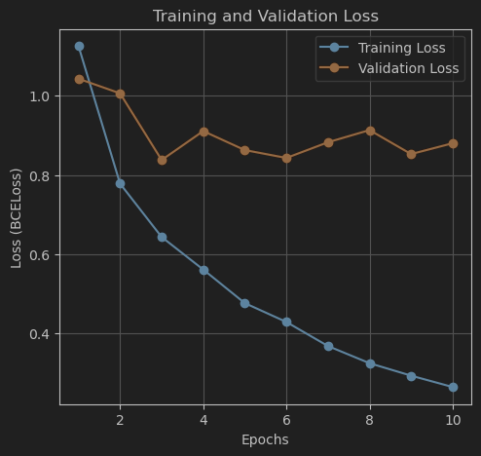
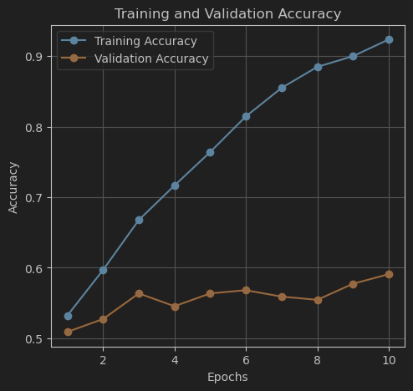
As we can see the model overfitted to training dataset and we needed to allow better generalization.
After we established the baseline, we started experiments.

Experiments:
Loss |  |  | Accuracy
Training | Validation | Test | Training | Validation | Test | Training Time
0.0665 | 0.9667 | 1.1359 | 1 | 0.5909 | 0.561 | 243.94 sec
- The first thing we tried to change is the SGD optimizer, while it was popular in the time the paper was published, currently, Adam is considered the most reliable and requires less tuning optimizer. We have used smaller learning rate = 0.00001

We can see that test set had better results now, but the model overfitted hardly

- We have decided to reduce the paper's original EMBEDDING_DIM from 4096 to 1024
Loss |  |  | Accuracy
Training | Validation | Test | Training | Validation | Test | Training Time
0.1711 | 0.8647 | 0.8428 | 0.9881 | 0.5818 | 0.6 | 133.94 sec

Now test set had much better results
- Normalize the input images with standard norm and std of ImageNet dataset and save the best model based on validation accuracy
Loss |  |  | Accuracy
Training | Validation | Test | Training | Validation | Test | Training Time
0.9983 | 1.5662 | 0.1138 | 0.9983 | 0.5932 | 0.58 | 153.84 sec

- In this experiment, we tried a completely different approach. To match the paper in terms of input, we have decided to resize the images to original 105x105 as in paper, transform the images to grayscale and normalize using 0.5 mean and std
Loss |  |  | Accuracy
Training | Validation | Test | Training | Validation | Test | Training Time
0.3577 | 0.6475 | 0.6159 | 0.921 | 0.6477 | 0.658 | 49.81 sec
The results were very promising, it took much less time to train and performed much better, so we decided to refine this approach.
- We have decided to change weights initialization in model
  - Bias was initialized constantly
    - Convolutional layers: 0
    - Fully Connected layers: 0.5
  - Weights
    - Convolutional layers: kaiming normal distribution
    - Fully Connected layers: mean: 0, std: 0.01
Loss |  |  | Accuracy
Training | Validation | Test | Training | Validation | Test | Training Time
0.5773 | 0.6143 | 0.598 | 0.7233 | 0.6591 | 0.701 | 50.52 sec

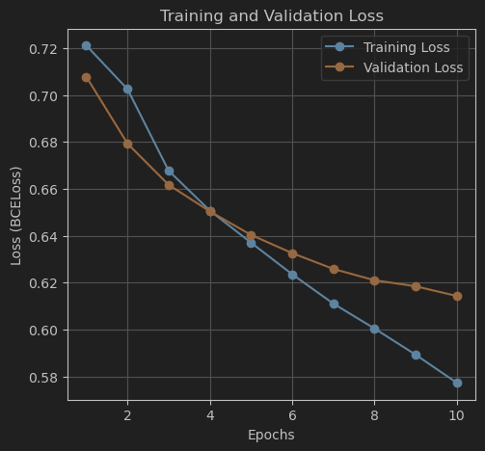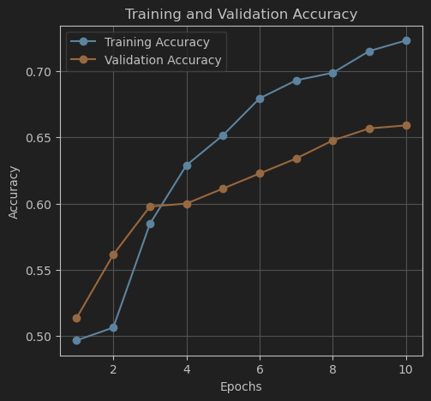
The results were beyond any expectations, and since we can see that the model did not overfit, we hypothesized that increasing learning rate or number of epochs could help. Unfortunately, from our further experiments we did not achieve better results on test set.
- Additional (one of many) experiment with increasing learning rate to 0.0001
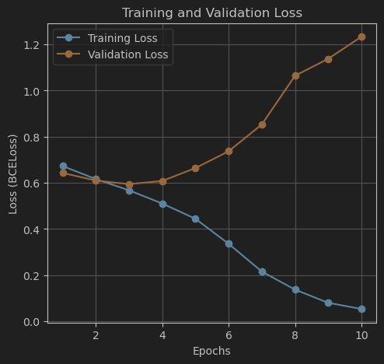
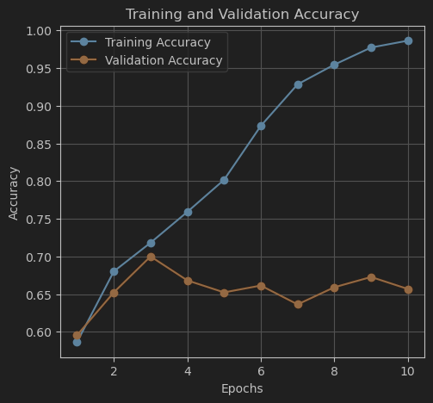
We can see the model overfits and we take the best with best validation accuracy, but it still does not outperform the previous model.

