Submitted by: Yuriy Rusanov – 340915149, Elad Orpaz - 206216517

Deep Learning
Exercise 2

Dataset Analysis:
Train/Test Split: We adhered to the specific train/test pair lists provided:
- pairsTrain.txt: Contains 2200 pairs of images used for training the similarity function. 1100 matching pairs (same person) and 1100 non-matching pairs (different people).
- pairsTest.txt: Contains 1000 pairs of images used for evaluating the one-shot performance. [Optional but good: This typically includes 500 matching pairs and 500 non-matching pairs].
Validation Set: A validation set was created by splitting the original 2200 training pairs. We used an 80/20 stratified split, resulting in:
- Training Pairs: 1760 (80% of 2200)
- Validation Pairs: 440 (20% of 2200) The validation set was used for hyperparameter tuning and monitoring model generalization during training (e.g., selecting the best epoch).

Siamese Network Architecture:
Our implementation utilizes a Siamese network structure with two identical, weight-sharing CNN branches. We began by implementing the architecture described in the Koch et al. paper to establish a performance baseline.
The Architecture:
- CNN Branch (Identical for both inputs, weights shared):
  - Block 1:
    - Conv2D: 64 filters, kernel size 10x10, stride 1.
    - ReLU activation.
    - MaxPool2D: kernel size 2x2, stride 2.
  - Block 2:
    - Conv2D: 128 filters, kernel size 7x7, stride 1.
    - ReLU activation.
    - MaxPool2D: kernel size 2x2, stride 2.
  - Block 3:
    - Conv2D: 128 filters, kernel size 4x4, stride 1.
    - ReLU activation.
    - MaxPool2D: kernel size 2x2, stride 2.
  - Block 4:
    - Conv2D: 256 filters, kernel size 4x4, stride 1.
    - ReLU activation.
  - Flatten: Reshape the output feature map into a flat vector.
  - Fully Connected Layer 1 (Embedding Layer): Linear layer mapping flattened features to an embedding vector of size EMBEDDING_DIM.
- Distance Calculation: The absolute difference (L1 distance) was computed elementwise between the embedding vectors (h1​, h2​) from the two branches: ∣h1​−h2​∣.
- Final Classification Layer:
  - Fully Connected Layer 2: Linear layer mapping the L1 distance vector to a single logit.
  - Sigmoid Activation: Applied to the output logit to produce a similarity score between 0 and 1 (representing the probability that the two input images are of the same person).
Total Trainable Parameters of Initial Model: 605,185,585

Baseline Configuration Details:
Input:
LFW-a images with 250x250 resolution. EMBEDDING_DIM = 4096.
Weight Initialization (Paper’s Method):
- Convolutional Layers:
  - Weights initialized using $N(μ=0,σ={10}^{-2})$
  - Biases initialized using $N(μ=0.5,σ={10}^{-2})$
- Fully-Connected Layers:
  - Weights initialized using $N(μ=0,σ={2*10}^{-1})$
  - Biases initialized using $N(μ=0.5,σ={10}^{-2})$
Loss Function:
Binary Cross-Entropy (BCE) with L2 regularization (weight decay).
Optimizer:
SGD with momentum = 0.5.
Learning Rate Schedule:
Initial Learning Rate ${10}^{-4}$, decayed by 1% per epoch.
Training:
- Epochs: 10
- Batch Size: 64
Reasoning for Architectural Choices:
We replicated the paper's setup as closely as possible to create a valid starting point, with the noted exception of using RGB input initially as the LFW dataset images are color.

Baseline Model Performance:
Training the baseline model with the configuration described above yielded the following results:
Loss |  |  | Accuracy
Training | Validation | Test | Training | Validation | Test | Training Time
0.3858 | 0.789 | 0.7946 | 0.8443 | 0.6068 | 0.583 | 99.76 seconds
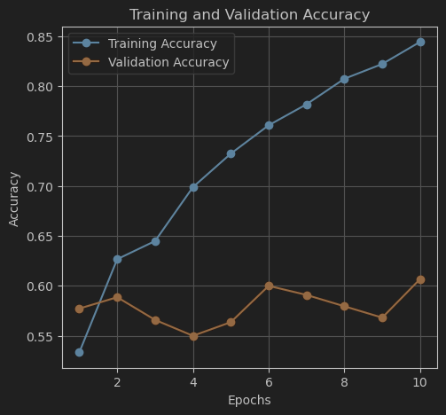
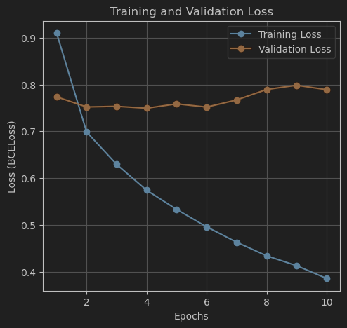

Observation: The baseline model achieved high accuracy on the training set but performed poorly on the validation and test sets (accuracy below 60%). The significant gap between training and validation/test performance clearly indicates overfitting. This motivated our subsequent experiments aimed at improving generalization.

Incremental Experiments and Refinements:
We conducted a series of experiments, modifying one aspect of the model or training process at a time, using the validation and test sets performance to guide our decisions.
- Optimizer Change: SGD to Adam
- Rationale: While SGD was popular at the time the paper was published, currently Adam is a widely used optimizer known for adaptive learning rates and often faster convergence compared to SGD.
- Configuration: Replaced SGD with Adam optimizer, reduced Learning Rate to ${10}^{-5}$. All other baseline parameters remained (RGB input, Embed Dim 4096, paper's weight initialization).
- Results:
Loss |  |  | Accuracy
Training | Validation | Test | Training | Validation | Test | Training Time
0.1185 | 0.7743 | 0.8488 | 0.9977 | 0.6409 | 0.607 | 668.85 seconds

Observation: Although the learning rate was reduced, Adam led to even faster and more severe overfitting (perfect training accuracy, validation/test accuracy slightly worse than baseline). Training time also increased, possibly due to Adam's overhead.

- Reducing Embedding Dimension
- Rationale: High dimensionality (4096) in the embedding layer contributes significantly to model complexity and parameter count, potentially causing overfitting. Reducing it might improve generalization.
- Configuration: Changed EMBEDDING_DIM from 4096 to 1024. Used Adam optimizer (Learning Rate ${10}^{-5}$), kept RGB input and paper's weight initialization.
- Results:
Loss |  |  | Accuracy
Training | Validation | Test | Training | Validation | Test | Training Time
0.3801 | 0.6898 | 0.7226 | 0.8841 | 0.6432 | 0.578 | 84.08 seconds

Observation: Reducing the embedding dimension significantly decreased training time but reduced test accuracy compared to the previous Adam experiments. Although overfitting was still prominent, we have decided to return to EMBEDDING_DIM 4096, since it yielded better results.
- Input Resize and Normalization
- Rationale: Normalizing input data is standard practice. We tried to resize the input data according to paper 105x105 image and normalize grayscale images using 0.5 mean and 0.5 standard deviation.
- Configuration: Resized images to 105x105 and applied 0.5 normalization to grayscale inputs. Used Adam, EMBEDDING_DIM=4096, paper's weight initialization.
- Results:
Loss |  |  | Accuracy
Training | Validation | Test | Training | Validation | Test | Training Time
0.3117 | 0.6271 | 0.6615 | 0.9494 | 0.6818 | 0.629 | 39.37

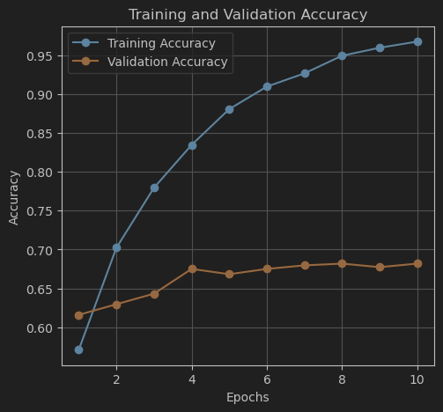
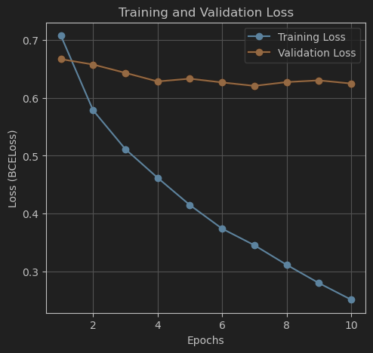
Observation: This was a significant improvement. Training time dropped drastically (due to smaller, single-channel input). Both validation and test accuracy improved notably. This became our new baseline approach.

- Weight Initialization Change
- Rationale: While the paper's initialization worked, modern techniques like Kaiming initialization are often preferred for ReLU-based networks. We experimented with a different initialization strategy.
- Configuration: Kept grayscale input, Adam, EMBEDDING_DIM=1024. Changed weight/bias initialization:
  - Convolutional: Weights - Kaiming Normal, Biases - Constant 0.
  - Fully Connected: Weights - $N(μ=0, σ=0.01)$, Biases - Constant 0.5.
Explanation: We chose Kaiming Normal as it is specifically designed for ReLU activations, helping maintain gradient flow. For the FC layers, initializing weights with smaller std. aims to promote stable learning in initial epochs. The constant biases are for the same purpose.
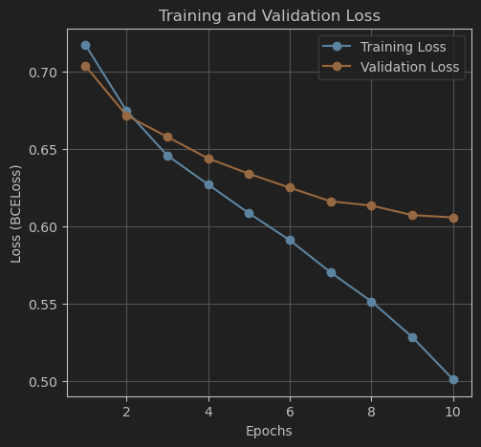
- Results:
Loss |  |  | Accuracy
Training | Validation | Test | Training | Validation | Test | Training Time
0.5911 | 0.625 | 0.6128 | 0.717 | 0.6773 | 0.677 | 39.61 seconds
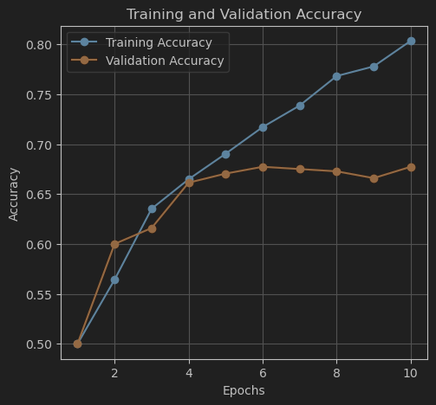

Observation: This experiment yielded the best results so far, achieving ~68% test accuracy. Notably, the training accuracy (72%) is much closer to the validation (68%) and test accuracy, indicating significantly reduced overfitting compared to all previous trials.

- Decrease EMBEDDING_DIM
- Rationale: To potentially improve generalization and reduce model complexity further, we reduced the EMBEDDING_DIM from 4096 to 2048, keeping the other best-performing parameters.
- Configuration: Used the setup from Experiment 5 but decreased EMBEDDING_DIM from 4096 to 2048.
Loss |  |  | Accuracy
Training | Validation | Test | Training | Validation | Test | Training Time
0.5456 | 0.6035 | 0.5949 | 0.7574 | 0.6818 | 0.7010 | 39.14 seconds
- Results:

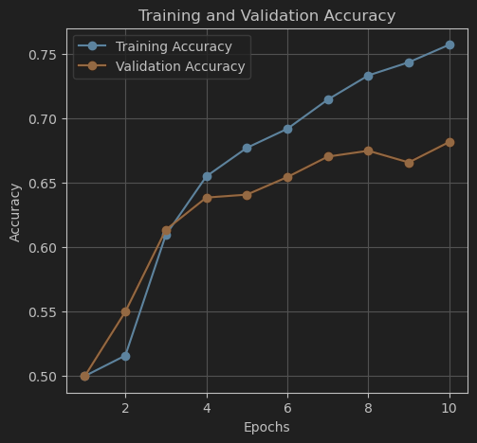
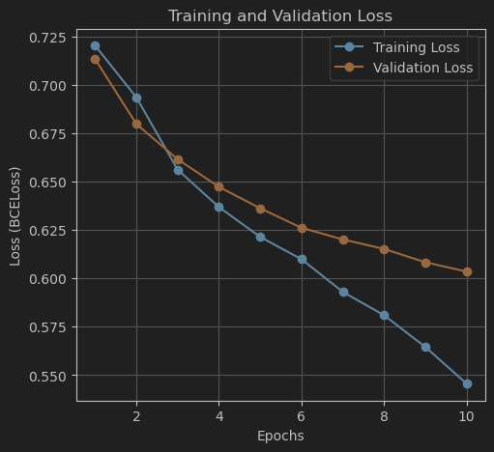

- Observation: This achieved the highest test accuracy (70.10%) and slightly improved validation accuracy (68.18%). Although the training/test accuracy gap increased slightly compared to the previous step, the superior test performance made this the final, best configuration.
This configuration represents our final, optimized model. The trainable parameter count for this model is approximately 20,073,281 (105x105 inputs, 2048 embedding dim).

Analysis of Classification Examples:
To better understand the model's performance and limitations, we analyzed specific examples from the test set, displaying one representative case for the most and least certain predictions within each category.
- Most Certain TP (Highest Score): he model correctly identified this pair as the same person with high confidence, even if the pictures weren't exactly identical.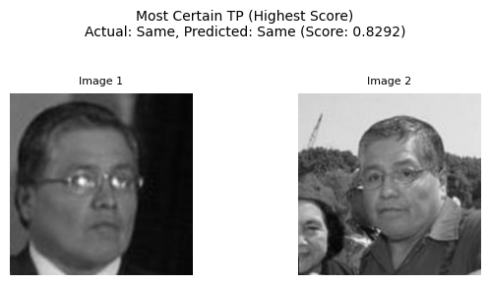
- Least Certain TP (Score ~ 0.5): Different looking glasses made this challenging, but the model correctly predicted it with low certainty, likely relying on other consistent features (headphones).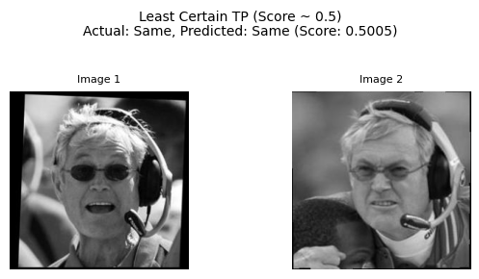

- Most Certain TN (Lowest Score): This pair shows clearly different individuals, which the model correctly identified as 'Different' with high confidence.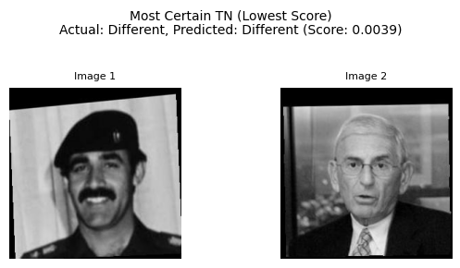
- Least Certain TN (Score ~ 0.5): These different individuals share some visual similarities. The model correctly predicted 'Different' but with reduced certainty.
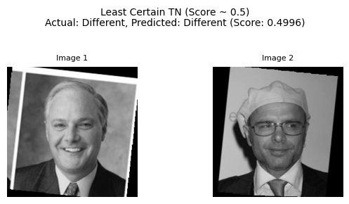

- Most Certain FP (Highest Score - Predicted Same, Actual Different): Although these different individuals have clear visual distinctions, the model incorrectly predicted 'Same' with high confidence, likely focusing strongly on misleading similarities.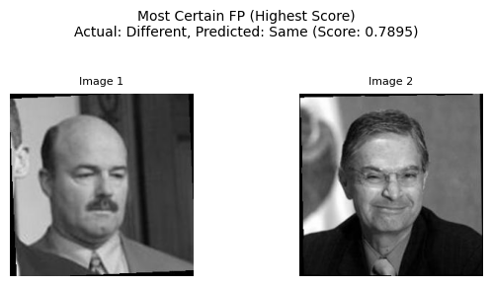

- Least Certain FP (Score ~ 0.5 - Predicted Same, Actual Different): Shared similarities between these different individuals likely confused the model, leading to an incorrect 'Same' prediction made with low certainty.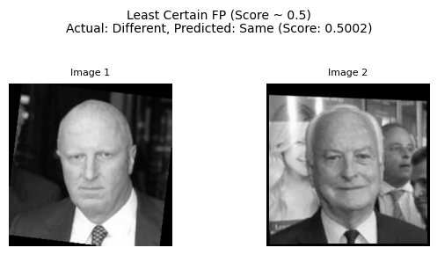

- Most Certain FN (Lowest Score - Predicted Different, Actual Same): Major visual changes (e.g., hat, hair, expression) between images of the same person caused the model to confidently, but incorrectly, predict 'Different'.
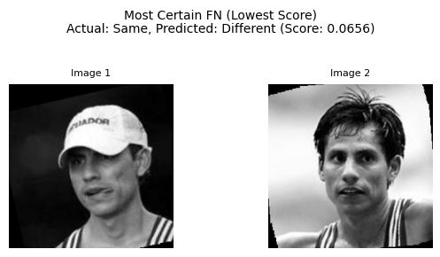
- Least Certain FN (Score ~ 0.5 - Predicted Different, Actual Same): Appearance variations (e.g., hair color, expression) for the same person created uncertainty, resulting in an incorrect 'Different' prediction with a score just below the threshold.