Submitted by: Yuriy Rusanov – 340915149, Elad Orpaz - 206216517

Deep Learning
Exercise 3

- Data Preparation and Preprocessing:
1.1 Data Loading
- Lyrics Data: The lyrics were provided in a .csv file, containing columns for artist, song title, and the lyrics themselves. Training data consisted of 600 songs, and the test set contained 5 songs.
- MIDI Data: MIDI files corresponding to the songs were provided in a .zip archive. The pretty_midi library was utilized for parsing and analyzing these files.
1.2. Lyrics Preprocessing and Tokenization
- Lowercase Conversion: All text was converted to lowercase to ensure consistency.
- Line Splitting: Lyrics, often formatted with '&' as a line delimiter in the raw data, were split into individual lines.
- Tokenization: Each line was tokenized into words using a regular expression (r"\b\w+(?:'\w+)*\b") designed to capture whole words, including those with apostrophes (e.g., "don't"). Empty lines after tokenization were skipped.
The result was a list of lists, where each inner list represents a line of tokenized words. The training set yielded 23659 tokenized lines and test set 189 lines.
1.3. Vocabulary Building
A vocabulary was constructed from the tokenized training lyrics:
- Word Counts: A frequency count of all words in the training set was performed.
- Special Tokens: Four special tokens were added to the vocabulary:
  - <PAD>: For padding sequences.
  - <NEXT LINE>: To signify the end of a lyrical line.
  - <START>: To mark the beginning of a song's lyrics.
  - <END>: To mark the end of a song's lyrics.
- Vocabulary Creation: All unique words were added to the vocabulary, and each word was mapped to a unique integer index. The resulting vocabulary size was 7384.
1.4. Word Embeddings (Word2Vec)
To represent words as dense vectors, a Word2Vec model was trained on the tokenized training lyrics:
- Model: A Skip-gram Word2Vec model was trained using the gensim library.
- Parameters:
  - vector_size: 300 (embedding dimension)
  - window: 5 (context window size)
  - epochs: 20
- Embedding Matrix: An embedding matrix of shape (vocab_size, embedding_dim) was created. For words present in the Word2Vec model's vocabulary, their respective vectors were used. The special tokens (<NEXT LINE>, <START>, <END>) were initialized with random vectors drawn from a uniform distribution U(-0.25, 0.25). The <PAD> token's vector remained zeros. This matrix was used to initialize the embedding layer in our neural network models.

2. Approach 1: Simple Model - Global Melody Features
The first approach involved a model that considers global features of the melody, providing a general musical context for lyrics generation.
2.1. Dataset for Simple Model
- For this model, a fixed set of global features was extracted from each MIDI file:
  - Tempo: Mean tempo of the song (derived from tempo changes).
  - Average Pitch: Mean pitch of all notes in the song.
  - Pitch Standard Deviation: Standard deviation of pitches.
  - Pitch Range: Difference between maximum and minimum pitch.
  - Average Duration: Mean duration of notes.
  - Average Velocity: Mean velocity (loudness) of notes.
  - Note Density: Total number of notes divided by the song's total duration.
- Sequence Preparation: For each song, lyrics were tokenized, and special tokens (<START>, <NEXT LINE>, <END>) were added. <START> was prepended, <NEXT LINE> was appended after each actual line, and the final <NEXT LINE> was replaced by <END>.
- Input-Target Pairs: The entire song's token sequence was used to create input-target pairs. For each token word_i in the sequence, the input was word_i and the target was word_{i+1}.
- The full dataset was split into training (80%) and validation (20%) sets. DataLoaders were created with a batch size of 64, and the training DataLoader shuffled the data.
  - Train dataset size: 143243 samples.
  - Validation dataset size: 35811 samples.
2.2. Simple Model Architecture
The model is an LSTM-based network:
- Inputs: Current word_input (index) and global melody_features (vector).
- Embedding Layer: nn.Embedding(vocab_size, embedding_dim) initialized with the pretrained Word2Vec embedding matrix. It converts the word_input index into a dense vector.
- Melody Projection: nn.Linear(melody_dim, embedding_dim) projects the 7-dimensional melody feature vector to the same dimension as the word embeddings (300). This allows for easy concatenation.
- Concatenation: The word embedding and the projected melody embedding are concatenated along their feature dimension, resulting in a vector of size embedding_dim * 2. This combined vector is unsqueezed to add a sequence length dimension of 1, making it suitable for LSTM input (batch, 1, embedding_dim * 2).
- LSTM Layer: nn.LSTM(input_size=embedding_dim * 2, hidden_size=512, num_layers=4, batch_first=True, dropout=0.3). This layer processes the sequence of (word + melody) features.
- Dropout Layer: nn.Dropout(0.3) applied to the LSTM output for regularization.
- Fully Connected (FC) Layer: nn.Linear(hidden_dim, vocab_size) maps the LSTM's hidden state output to a score distribution over the entire vocabulary, predicting the next word.
- Outputs: Raw logits for the next word and the updated LSTM hidden state.
2.3. Simple Model Training
- Loss Function: nn.CrossEntropyLoss, suitable for multi-class classification (predicting the next word).
- Optimizer: optim.Adam with a learning rate of 1×10−4.
- Learning Rate Scheduler: optim.lr_scheduler.ReduceLROnPlateau was used to reduce the learning rate by a factor of 0.5 if the validation loss did not improve for 2 consecutive epochs.
- Epochs: The model was trained for 50 epochs.
- Gradient Clipping: Gradients were clipped to a maximum norm of 5.0 (torch.nn.utils.clip_grad_norm_) to prevent exploding gradients.
- Best Model Saving: The state of the model with the lowest validation loss was saved during training.

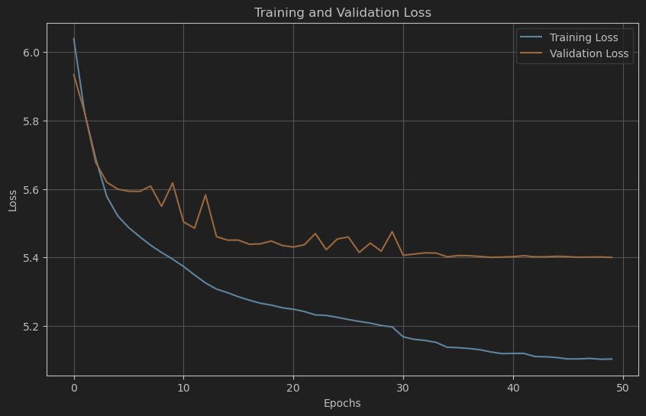
Best model training loss: 5.1033, validation loss: 5.4003
We can see that at the specific point model stops learning, as validation loss stops decreasing. In our setup we load the best model based on validation loss.
2.4 Simple Model Test Results
Starting Words: Three different starting words were used for each test melody:
- <START> - context not provided, the model should rely only on melody features at the beginning.
- Love – general positive context provided.
- Hate – general negative context provided.
Generation Loop:
- The model takes the current word and the (constant) melody features to predict the next word's probability distribution.
- Sampling: The next word is chosen by sampling from this distribution using torch.multinomial. A temperature parameter (set to 0.9 for testing) was used to scale the logits before applying the softmax and sampling. Higher temperatures lead to more randomness, while lower temperatures make the model more deterministic.
- The chosen word becomes the input for the next step.
- The process continues until an <END> token is generated, or a max_length (set to 750 words) is reached.
Formatting: The generated sequence of tokens (words) was formatted:
- <START> and <END> tokens were removed.
- <NEXT LINE> tokens were converted to newline characters (\n). Consecutive newlines were collapsed.
- The final output is a string of generated lyrics.

3. Approach 2: Advanced Model - Time-Aware Melody Features
The second approach aimed to integrate melody information more dynamically by considering musical features that are temporally aligned with the words being generated.
  - Dataset for Advanced Model
- This model uses melody features extracted for specific time windows corresponding to words or sequences of words.
  - Line Duration Allocation (allocate_line_durations): The total duration of a MIDI file was distributed among its lyric lines based on the number of characters in each line. This provided an estimated duration for each line.
  - Word Timing Estimation (estimate_word_durations): Within each line, the estimated line duration was further distributed among its words based on the number of letters in each word, plus a small overhead per word. This yielded estimated start and end times for each word relative to the song's beginning.
  - Feature Extraction (extract_time_based_features): For each word's estimated time window (start_time, end_time), extended by a context of +/- 5 seconds, the following features were extracted from the MIDI data:
    - pitch_mean: Mean pitch of notes within the window.
    - pitch_std: Standard deviation of pitches within the window.
    - velocity_mean: Mean velocity of notes within the window.
    - duration_mean: Mean duration of notes within the window.
    - note_density: Number of notes within the window. If no notes were found in a window, these features were set to 0.
  - Feature Normalization: The extracted features were normalized (e.g., pitch mean / 127.0, pitch std / 12.0, velocity mean / 127.0). The final feature vector for each word timing was 5-dimensional
- Context Size: A context_size of 16 words was used.
- Sequence Preparation:
  - Lyrics were tokenized similarly to the simple model.
  - Each song's lyrics sequence was prepended with context_size <START> tokens. Corresponding dummy musical features (all zeros) were used for these <START> tokens.
  - Time-based musical features were extracted for each actual word in the song as described above. <NEXT LINE> tokens reused the features of the preceding word. The final <NEXT LINE> became <END>.
- Input-Target Pairs: A sliding window of context_size was moved across the full token sequence. For each window:
  - context_words: A sequence of context_size word indices.
  - context_features: A sequence of context_size corresponding 5-dimensional musical feature vectors.
  - target_word: The word index immediately following the context window.
  - target_features: The 5-dimensional musical feature vector corresponding to the timing of the target_word.
The dataset was split into training (80%) and validation (20%). DataLoaders used a batch size of 64.
  - Advanced Model Architecture
This model uses an LSTM with attention and incorporates time-specific musical features for both context and target words.
- Inputs: context_words (indices), context_features (vectors for context), target_features (vector for the timing of the word to be predicted).
- Embedding Layer: nn.Embedding(vocab_size, embedding_dim) initialized with pretrained Word2Vec embeddings.
- Feature Encoder: A nn.Sequential module processes musical features. It consists of two linear layers with ReLU activations and Dropout, mapping the 5-dimensional feature vector to hidden_dim // 2. This encoder is used for both context features and target features.
- Context Processing:
  - Word embeddings for context_words are obtained.
  - Musical features for context_features are encoded using the feature encoder.
  - The word embeddings and encoded music features are concatenated for each item in the context sequence. The combined dimension is embedding_dim + (hidden_dim // 2).
  - LSTM Layer: nn.LSTM(input_size=embedding_dim + (hidden_dim // 2), hidden_size=512, num_layers=4, batch_first=True, dropout=0.3) processes this combined sequence.
  - Attention Layer: nn.MultiheadAttention(embed_dim=hidden_dim, num_heads=4, batch_first=True) is applied to the LSTM output sequence (query, key, and value are all the LSTM output). This allows the model to weigh the importance of different context words.
- Combining Information:
  - The final hidden state of the LSTM (h_n[-1]).
  - The attention output corresponding to the last element of the context sequence (attn_output[:, -1, :]).
  - These two are concatenated.
- Target Feature Integration: The target_features (musical features for the timing of the word to be predicted) are encoded using the same feature encoder.
- Final Representation: The (LSTM hidden + attention output) representation is concatenated with the encoded target_features. The total dimension of this combined vector is hidden_dim + hidden_dim + (hidden_dim // 2).
- Output FC Layers: A nn.Sequential module with a linear layer, ReLU, Dropout, and a final linear layer maps this comprehensive representation to scores over the vocab_size.
- Output: Raw logits for the next word.
  - Advanced Model Training
- Loss Function: nn.CrossEntropyLoss.
- Optimizer: optim.Adam with a learning rate of 1×10−4.
- Learning Rate Scheduler: optim.lr_scheduler.ReduceLROnPlateau (patience=2, factor=0.5).
- Epochs: The model was trained for 20 epochs.
- Gradient Clipping: Max norm of 5.0.
- Best Model Saving: Based on validation loss.
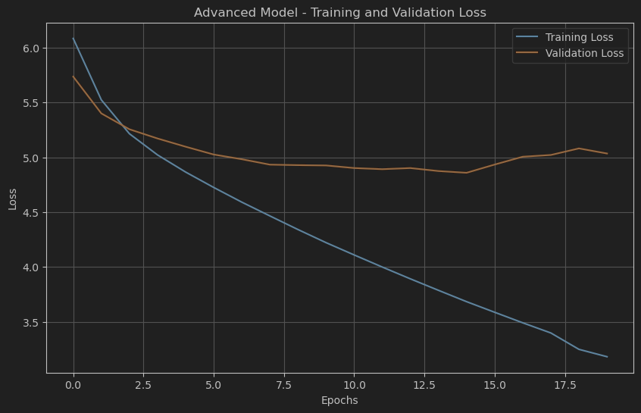
Best model traninig loss: 3.6836, validation loss: 4.8750.
Now we can see that validation loss was much lower than simple model’s. The model captured the semantic’s nuances much better.

  - Simple Model Test Results
Context Preparation: The input start_words were padded with <START> tokens to match the model's context_size.
Timing Estimation for Generation:
- The total duration of the MIDI and the max_length of lyrics to generate were used to estimate an average word_duration.
- An initial current_time cursor was set.
- For the initial context words, musical features were extracted based on their estimated timings.
Generation Loop:
  - For the next word to be predicted, its timing (start and end) was estimated by advancing current_time by word_duration (with some added randomness: random.uniform(-2, 2) seconds to the duration).
  - Musical features for this target timing were extracted.
  - The model predicted the next word based on the current word context, context musical features, and target timing musical features.
  - Sampling with temperature (0.9 for testing) was used.
  - The chosen word was added to the output, and the context (words and their features) was updated by sliding the window. current_time was advanced.
  - This continued until <END> or max_length (750 words).
Formatting: Similar to the simple model, lyrics were formatted to handle special tokens and newlines.

