**Detyra 1.**

**Kodi:**

int num = 20;

bool even = num % 2 == 0 ? true : false;

Console.WriteLine("{0} is even ? {1}", num, even);

**Rezultati:**

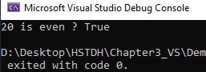

**Detyra 2.**

**Kodi:**

int num = Convert.ToInt32(Console.ReadLine());

bool perpjestueshem = num % 35 == 0 ? true : false;

Console.WriteLine("{0} eshte i perpjestushem me 5 dhe 7? {1}", num, perpjestueshem);

**Rezultati:**

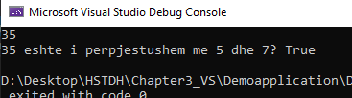

**Detyra 3.**

**Kodi:**

int num = Convert.ToInt32(Console.ReadLine());

bool isSeven = (num / 100) % 10 == 7 ? true : false;

Console.WriteLine("digit i trete i {0} eshte 7? {1}", num, isSeven);

Rezultati:

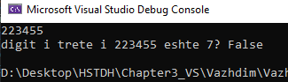

**Detyra 4.**

**Kodi:**

**Rezultati:**

**Detyra 5.**

**Kodi:**

int a = Convert.ToInt32(Console.ReadLine());

int b = Convert.ToInt32(Console.ReadLine());

int h = Convert.ToInt32(Console.ReadLine());

int S = (a + b) * h / 2;

Console.WriteLine("a={0}, b={1}, h={2}, S={3}", a, b, h, S);

**Rezultati;**

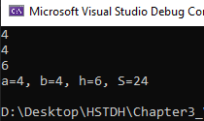

**Detyra6.**

**Kodi:**

Console.WriteLine("Enter a: ");

int a = Convert.ToInt32(Console.ReadLine());

Console.WriteLine("Enter b: ");

int b = Convert.ToInt32(Console.ReadLine());

int shuma = a * b;

int p = (a + b) * 2;

Console.WriteLine("Syprina={0} Perimetri={1}", shuma, p);

Rezultati:

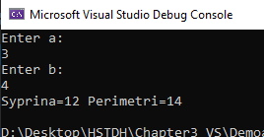

**Detyra 7;**

**Kodi:**

Console.WriteLine("Pesha ne Toke: ");

int P = Convert.ToInt32(Console.ReadLine());

int neHane = P * 17 / 100;

Console.WriteLine("Pesha juaj ne Toke eshte {0}, ndersa ne hane eshte {1}", P, neHane);

**Rezultati:**

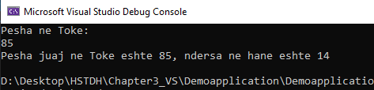

**Detyra 8.**

**Kodi:**

Console.WriteLine("Enter x: ");

int x = Convert.ToInt32(Console.ReadLine());

Console.WriteLine("Enter y: ");

int y = Convert.ToInt32(Console.ReadLine());

bool isInside = (x * x + y * y <= 5) ? true : false;

Console.WriteLine("The point O ({0}, {1}) is inside K ((0,0),5)?: {2}", x, y, isInside);

**Rezultati:**

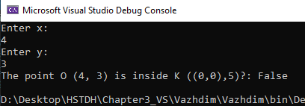

**Detyra 9.**

**Kodi:**

Console.WriteLine("Enter x: ");

int x = Convert.ToInt32(Console.ReadLine());

Console.WriteLine("Enter y: ");

int y = Convert.ToInt32(Console.ReadLine());

bool Circle = (x * x + y * y <= 5) ? true : false;

bool Rectangle = (x < -1 && x > 5 && y < 1 && y > 5) ? true : false;

Console.WriteLine("The point O({0},{1}) is inside K((0,0),5)?: {2}", x, y, Circle); Console.WriteLine("The point O({0},{1}) is outside the rectangle ((-1,1), (5, 5))?: {2}", x, y, Rectangle);

**Rezultati:**

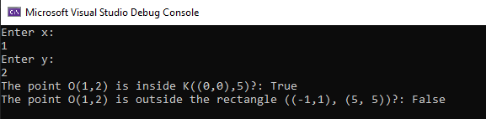

**Detyra 10.**

**Kodi:**

Console.Write("Enter number: ");

int number = Convert.ToInt32(Console.ReadLine());

int a = number / 1000;

int b = (number / 100) % 10;

int c = (number / 10) % 10;

int d = number % 10;

Console.WriteLine("1.Sum of digits = {0}", a + b + c + d);

Console.WriteLine("2.Digits backwards = {3}{2}{1}{0}", a, b, c, d);

Console.WriteLine("3.Last digit on first place = {3}{0}{1}{2}", a, b, c, d);

Console.WriteLine("4.Replace third and second digit = {0}{2}{1}{3}", a, b, c, d);

**Rezultati:**

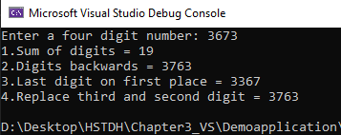

**Detyra 11.**

**Kodi:**

nt n = 35;

int p = 6;

int i = 1;

int mask = i << p;

Console.WriteLine((n & mask) != 0 ? "Third bit is 1" : "Third bit is 0");

**Rezultati:**

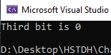

**Detyra 12.**

**Kodi:**

int v = 350;

int p = 350;

int mask = 1 << p;

bool isOne = (v & mask) != 0 ? true : false;

Console.WriteLine("The bit at position {0} of number {1} is 1? {2}", p, v, isOne);

**Rezultati:**



**Detyra 13.**

**Kodi:**

int n = 58;

int v = 0;

int p = 3;

n = (v == 0) ? n = n & (~(1 << p)) : n = n | (1 << p);

Console.WriteLine(n);

**Rezultati:**

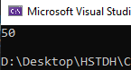

**Detyra 14.**

**Kodi:**

Console.WriteLine("Add a number");

int num = Convert.ToInt32(Console.ReadLine());

bool isPrime = true;

if (num > 2)

for (int i = 2; i <= Math.Ceiling(Math.Sqrt(num)); ++i)

{

if (num % i == 0) isPrime = false;

}

Console.WriteLine("{0} is prime?: {1}", num, isPrime);

**Rezultati:**

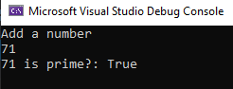

**Detyra 15.**