**Console Input and Output**

Detyra 1

Kodi:

Console.WriteLine("Enter a number");

int a = Int32.Parse(Console.ReadLine());

Console.WriteLine("Enter second number");

int b = Int32.Parse(Console.ReadLine());

Console.WriteLine("Enter third number");

int c = Int32.Parse(Console.ReadLine());

int sum = a + b + c;

Console.WriteLine("The sum is:{0}", sum);

Rezultati:

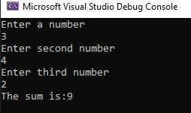

Detyra e 2

Console.WriteLine("Add a number ");

int r = Int32.Parse(Console.ReadLine());

Console.WriteLine("P is {0} and S= {1}", 2 * Math.PI * r, Math.PI * r * r);

Rezultati:

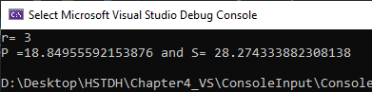

Detyra 3.

Kodi:

Console.Write("Emri: ");

string emri = Console.ReadLine();

Console.Write("Mbiemri: ");

string mbiembri = Console.ReadLine();

Console.Write("Kompania: ");

string komp = Console.ReadLine();

Console.Write("Numri: ");

int num = Convert.ToInt32(Console.ReadLine());

Console.Write("Addresa: ");

string addresa = Console.ReadLine();

Console.WriteLine(); Console.WriteLine();

Console.WriteLine("Emri i menaxherit eshte: {0}", emri);

Console.WriteLine("Mbiemri i menaxherit eshte {0}", mbiembri);

Console.WriteLine("Emri i kompanis eshte {0}", komp);

Console.WriteLine("Numri i telefonit eshte {0}", num);

Console.WriteLine("Addresa e kompanise eshte {0}", addresa);

Rezultati:

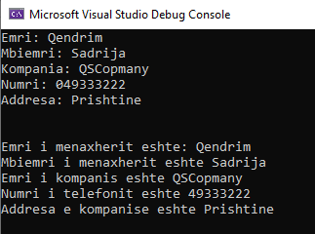

Detyra 4.

Kodi:

Rezultati:

Detyra 5.

Kodi:

Console.Write("Enter first number: ");

int a = Int32.Parse(Console.ReadLine());

Console.Write("Enter second number: ");

int b = Int32.Parse(Console.ReadLine());

int counter = 0;

for (int i = a; i <= b; i++)

{

if (i % 5 == 0) counter++;

}

Console.WriteLine("{0} numbers found.", counter);

Rezultati:

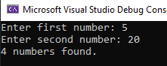

DETYRA 6

Kodi:

Console.WriteLine("Enter first number: ");

int num1 = Int32.Parse(Console.ReadLine());

Console.WriteLine("Enter second number: ");

int num2 = Int32.Parse(Console.ReadLine());

Console.WriteLine("{0} >= {1}", Math.Max(num1, num2), Math.Min(num1, num2));

Rezultati:

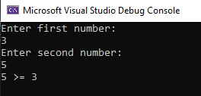

Detyra 7.

Kodi:

int a, b, c, d, e;

bool parseSucceed = false;

do

{

Console.Write("Enter first number: ");

parseSucceed = Int32.TryParse(Console.ReadLine(), out a);

Console.WriteLine(parseSucceed);

} while (!parseSucceed);

do

{

Console.Write("Enter second number: ");

parseSucceed = Int32.TryParse(Console.ReadLine(), out b);

Console.WriteLine(parseSucceed);

} while (!parseSucceed);

do

{

Console.Write("Enter third number: ");

parseSucceed = Int32.TryParse(Console.ReadLine(), out c);

Console.WriteLine(parseSucceed);

} while (!parseSucceed);

do

{

Console.Write("Enter fourth number: ");

parseSucceed = Int32.TryParse(Console.ReadLine(), out d);

Console.WriteLine(parseSucceed);

} while (!parseSucceed);

do

{

Console.Write("Enter fiffth number: ");

parseSucceed = Int32.TryParse(Console.ReadLine(), out e);

Console.WriteLine(parseSucceed);

} while (!parseSucceed);

Rezultati: 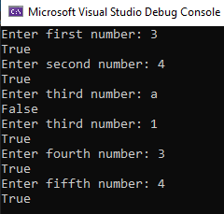

Detyra 8.

Kodi:

Console.Write("Numri i pare: ");

int a = Int32.Parse(Console.ReadLine());

Console.Write("Numri i dyte: ");

int b = Int32.Parse(Console.ReadLine());

Console.Write("Numri i tret: ");

int c = Int32.Parse(Console.ReadLine());

Console.Write("Numri i katert: ");

int d = Int32.Parse(Console.ReadLine());

Console.Write("Numri i peste: ");

int e = Int32.Parse(Console.ReadLine());

if (b > a) a = b;

if (c > a) a = c;

if (d > a) a = d;

if (e > a) a = e;

Console.WriteLine("The greater number is {0}", a);

Rezultati:

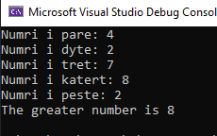

Detyra 9.

Kodi:

int sum = 0;

Console.Write("Enter number count: ");

int length = Int32.Parse(Console.ReadLine());

for (int i = 0; i < length; i++)

{

Console.Write("Enter {0} number: ", i + 1);

sum += Int32.Parse(Console.ReadLine());

}

Console.WriteLine("Sum of all numbers is {0}.", sum);

Rezultati:

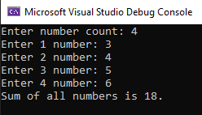

Detyra 10.

Kodi:

int sum = 0;

Console.Write("Enter number: ");

int length = Int32.Parse(Console.ReadLine());

for (int i = 1; i <= length; i++)

{

Console.WriteLine(i);

}

Rezultati:

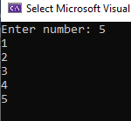

Detyra 11.

Kodi:

uint numri1 = 0;

uint numri2 = 1;

uint shuma = 1;

uint count = 0;

Console.Write(" " + numri1);

while(count < 100)

{

shuma = numri1 + numri2;

numri1 = numri2;

numri2 = shuma;

Console.Write(numri2 + " ");

count++;

}

Rezultati:



Detyra 12.

Kodi:

Console.Write("Enter last number: ");

int length = Int32.Parse(Console.ReadLine());

double sum = 1.0;

for (int i = 2; i <= length; i++)

{

sum += (1.0 / i);

}

Console.WriteLine("{0:F3}", sum);

Rezultati:

