Detyra 1.

Kodi:

Console.Write("Shkruaj nje numer: ");

int length = Int32.Parse(Console.ReadLine());

for (int i = 1; i < length; i++)

Console.WriteLine(i);

Rezultati:

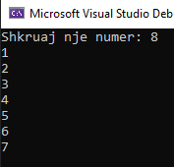

Detya 2.

Kodi:

Console.Write("Enter N: ");

int length = Int32.Parse(Console.ReadLine());

for (int i = 1; i < length; i++)

{

if (i % (3 \* 7) != 0) Console.WriteLine(i);

}

Rezultati:

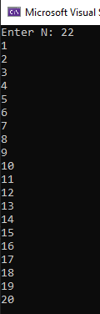

Detyra 3.

Kodi:

int lowest = 0, highest = 0, input;

Console.Write("Enter numbers length: ");

int lenght = Int32.Parse(Console.ReadLine());

for (int i = 0; i < lenght; i++)

{

Console.Write("Enter number: ");

input = Int32.Parse(Console.ReadLine());

if (i == 0) lowest = highest = input;

else

{

if (lowest > input) lowest = input;

if (highest < input) highest = input;

}

}

Console.WriteLine("Lowest - {0}, Highest - {1}", lowest, highest);

Rezultati:

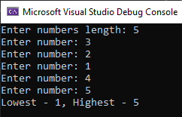

Detyra 4.

Kodi:

for (int i = 0; i < 4; i++)

{

if (i != 0) Console.WriteLine();

for (int j = 0; j < 13; j++)

{

switch (i)

{

case 0: Console.Write("Zemer "); break;

case 1: Console.Write("Diamant "); break;

case 2: Console.Write("Flete "); break;

case 3: Console.Write("Rrush "); break;

}

switch (j)

{

case 0: Console.WriteLine("A"); break;

case 1: Console.WriteLine("2"); break;

case 2: Console.WriteLine("3"); break;

case 3: Console.WriteLine("4"); break;

case 4: Console.WriteLine("5"); break;

case 5: Console.WriteLine("6"); break;

case 6: Console.WriteLine("7"); break;

case 7: Console.WriteLine("8"); break;

case 8: Console.WriteLine("9"); break;

case 9: Console.WriteLine("10"); break;

case 10: Console.WriteLine("J"); break;

case 11: Console.WriteLine("Q"); break;

case 12: Console.WriteLine("K"); break;

}

}

}

Console.ReadLine();

Rezultati:

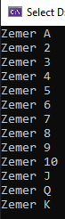 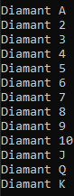 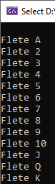 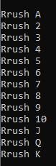

Detyra 5.

Kodi:

int nr1 = 0;

int nr2 = 1;

int nr3 = 0;

Console.Write("N: ");

int length = Int32.Parse(Console.ReadLine());

Console.Write("0, 1,");

for (int i = 2; i < length; i++)

{

nr3 = nr1 + nr2;

Console.Write(" {0},", nr3);

nr1 = nr2;

nr2 = nr3;

}

Console.ReadKey();

Rezultati:

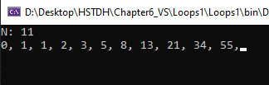

Detyra 6.

Kodi:

Console.WriteLine("Enter N: (1<K<N) ");

int n = Int32.Parse(Console.ReadLine());

Console.WriteLine("Enter K: (1<K<N) ");

int k = Int32.Parse(Console.ReadLine());

for (int i = n - 1; i > 0; i--)

{

n \*= i;

}

for (int i = k - 1; i > 0; i--)

{

k \*= i;

}

n /= k;

Console.WriteLine("Result is {0}", n);

Rezultati:

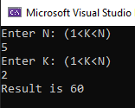

Detyra 7.

Kodi:

Console.WriteLine("Enter N: (1<K<N) ");

int n = Int32.Parse(Console.ReadLine());

Console.WriteLine("Enter K: (1<K<N) ");

int k = Int32.Parse(Console.ReadLine());

int nMinusK = n - k;

for (int i = n - 1; i > 0; i--) n \*= i;

for (int i = k - 1; i > 0; i--) k \*= i;

for (int i = nMinusK - 1; i > 0; i--) nMinusK \*= i;

Console.WriteLine("Result is {0}", n \* k / nMinusK);

Rezultati:

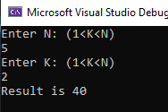

Detyra 8.

Kodi:

Console.Write("Enter N: (N >=0) ");

int n = Int32.Parse(Console.ReadLine());

int fact2N = 2 \* n, factNplus1 = n + 1;

for (int i = fact2N - 1; i > 0; i--) fact2N \*= i;

for (int i = factNplus1 - 1; i > 0; i--) factNplus1 \*= i;

for (int i = n - 1; i > 0; i--) n \*= i;

Console.WriteLine("The result is {0}", fact2N / (factNplus1 \* n));

Rezultati:

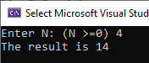

Detyra 9.

Kodi:

Rezultati: