**Flow Control and conditional statements**

**1) If statement**

KODI:

using System;

namespace If_statement

{

class Program

{

static void Main(string[] args)

{

Int32 value = 11;

if(value<10)

{

Console.WriteLine("Value is less than 10");

}

else

{

Console.WriteLine("Value is greater than 10");

}

Console.ReadKey();

}

}

}

Rezultati:

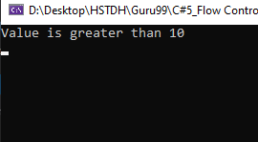

## 2) Switch statement

Kodi;

using System;

namespace If_statement

{

class Program

{

static void Main(string[] args)

{

Int32 value = 11;

switch(value)

{

case 1: Console.WriteLine("Value is 1");

break;

case 2: Console.WriteLine("Value is 2");

break;

default: Console.WriteLine("value is different");

break;

}

}

}

}

Rezultati:

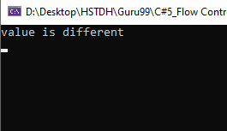

## 3) While loop

Kodi:

using System;

namespace while_loop

{

class Program

{

static void Main(string[] args)

{

Int32 value = 3, i = 0;

while(i<value)

{

Console.WriteLine(i);

i = i + 1;

}

}

}

}

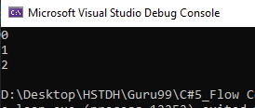

## 4) For loop

## Kodi;

for(Int32 i = 0; i < 3; i++)

{

Console.WriteLine(i);

}

