1. Variables

Kodi:

using System;

namespace DemoApplication

{

class Program

{

static void Main(string[] args)

{

String message=”The value is “;

Int32 val=30;

Console.Write(message+val);

Console.ReadKey();

}

}

}

Rezultati:

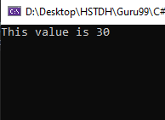

1. Operators

Kodi:

using System;

namespace DemoApplication

{

class Program

{

static void Main(string[] args)

{

Int32 val1 = 10, val2 = 20;

Bool status = true;

Console.WriteLine(val1 + val2);

Console.WriteLine(val1 < val2);

Console.WriteLine(!(status));

Console.ReadKey();

}

}

}

Rezultati:

