1. Integer

KODI:

using System;

namespace DemoApplication

{

class Program

{

static void Main(string[] args)

{

Int32 num=30;

Console.Write(num);

}

}

}

Rezultati:

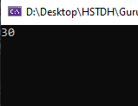

1. **Double**

KODI:

using System;

namespace DemoApplication

{

class Program

{

static void Main(string[] args)

{

Double num=30.33;

Console.Write(num);

Console.ReadKey();

}

}

}

Rezultati:

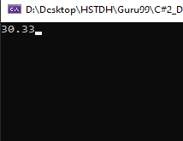

1. **Boolean**

Kodi:

using System;

namespace DemoApplication

{

class Program

{

static void Main(string[] args)

{

Boolean status=true;

Console.Write(status);

Console.ReadKey();

}

}

}

}

Rezultati:

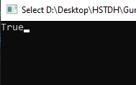

1. **String**

Kodi:

using System;

namespace DemoApplication

{

class program

{

static void Main(string[] args)

{

String message=”Hello”;

Console.Write(message);

Console.ReadKey();

}

}

}

Rezultati:

