Queue

1)

Kodi:

using System;

using System.Collections;

using System.Collections.Generic;

using System.Linq;

using System.Text;

using System.Threading.Tasks;

namespace Que

{

class Program

{

static void Main(string[] args)

{

Queue qt = new Queue();

qt.Enqueue(1);

qt.Enqueue(2);

qt.Enqueue(3);

foreach (Object obj in qt)

{

Console.WriteLine(obj);

}

Console.WriteLine(); Console.WriteLine();

Console.WriteLine("The number of elements in the Queue " + qt.Count);

Console.WriteLine("Does the Queue contain " + qt.Contains(3));

}

}

}

Rezultati:

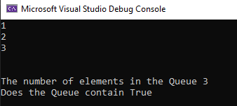

2)

Kodi:

using System;

using System.Collections;

using System.Collections.Generic;

using System.Linq;

using System.Text;

using System.Threading.Tasks;

namespace Que2

{

class Program

{

static void Main(string[] args)

{

Queue qt = new Queue();

qt.Enqueue(1);

qt.Enqueue(2);

qt.Enqueue(3);

qt.Dequeue();

foreach (Object obj in qt)

{

Console.WriteLine(obj);

}

}

}

}

Rezultati:

