setwd("C:/Masters/TDDE01-Machine Learning/Lab/Lab2")  
library(tree)  
library(rpart)  
  
bank_data=read.csv(file="bank-full.csv",header =TRUE,sep =";")  
bank_data <- bank_data[, !names(bank_data) %in% c("duration")]  
  
for(i in c(2,3,4,5,7,8,9,11,15,16)){  
 bank_data[,i]=as.factor(bank_data[,i])  
}  
  
  
#####Task1#####  
#dividing the data into training/validation/test  
n <- dim(bank_data)[1]  
set.seed(12345)  
id <- sample(1:n, floor(n*0.4))  
training <- bank_data[id,]  
  
id1 <- setdiff(1:n, id)  
set.seed(12345)  
id2 <- sample(id1, floor(n*0.3))  
validation <- bank_data[id2,]  
  
id3 <- setdiff(id1,id2)  
test <- bank_data[id3,]  
  
####Task2#####  
  
#Fit  
#A: Decision Tree With Default Settings  
default_tree <- tree(y~., data = training)  
  
#Prediction with training and validation data(default tree).  
  
prediction_deafult_train = predict(default_tree, newdata = training, type = "class")  
prediction_deafult_valid = predict(default_tree, newdata = validation, type = "class")  
  
#B: Decision Tree with smallest allowed node size equal to 7000  
smallest_tree <- tree(y~., data = training, control = tree.control(nobs = nrow(training), minsize = 7000))  
  
#Prediction with training and validation data(Smallest Allowed Node tree).  
  
prediction_smallest_train = predict(smallest_tree, newdata = training, type = "class")  
prediction_smallest_valid = predict(smallest_tree, newdata = validation, type = "class")  
  
#C: Decision Trees minimum deviance to 0.0005.  
mindev_tree <- tree(y~., data = training, control = tree.control(nobs = nrow(training), mindev = 0.0005))  
  
#Prediction with training and validation data(Minimum deviance tree).  
  
prediction_mindev_train = predict(mindev_tree, newdata = training, type = "class")  
prediction_mindev_valid = predict(mindev_tree, newdata = validation, type = "class")  
  
# function to calculate misclassifications rate  
missclass_error <- function(X,Y){  
 len <- length(X)  
 return(1 - sum(diag(table(X,Y)))/len)  
}  
  
#Calculating misclassification on training data  
  
miss_default <- missclass_error(training$y, prediction_deafult_train)  
miss_small <- missclass_error(training$y, prediction_smallest_train)  
miss_mindev <- missclass_error(training$y, prediction_mindev_train)  
  
# calculate misclassification on validation data  
  
miss_default_1 <- missclass_error(validation$y, prediction_deafult_valid)  
miss_small_1 <- missclass_error(validation$y, prediction_smallest_valid)  
miss_mindev_1 <- missclass_error(validation$y, prediction_mindev_valid)  
  
missclass_rate <- data.frame("Default_Tree" = c(miss_default, miss_default_1),  
 "Smallest_Node" = c(miss_small,miss_small_1),   
 "Minimum_Deviance" = c(miss_mindev,miss_mindev_1))  
rownames(missclass_rate) <- c("Training","Validation")  
  
missclass_rate

## Default_Tree Smallest_Node Minimum_Deviance  
## Training 0.1048441 0.1048441 0.09372926  
## Validation 0.1092679 0.1092679 0.11192214

####Task3####  
  
train_score <- rep(0,50)  
valid_score <- rep(0,50)  
  
for(i in 2:50)  
{  
 pruned_training <- prune.tree(mindev_tree, best = i)  
 predict_pTree <- predict(pruned_training, newdata = validation, type = "tree")  
 train_score[i] <- deviance(pruned_training)  
 valid_score[i] <- deviance(predict_pTree)  
}  
  
plot(2:50, train_score[2:50], type = "b", col="red", ylim = c(0, 13000))  
points(2:50, valid_score[2:50], type = "b", col="green")

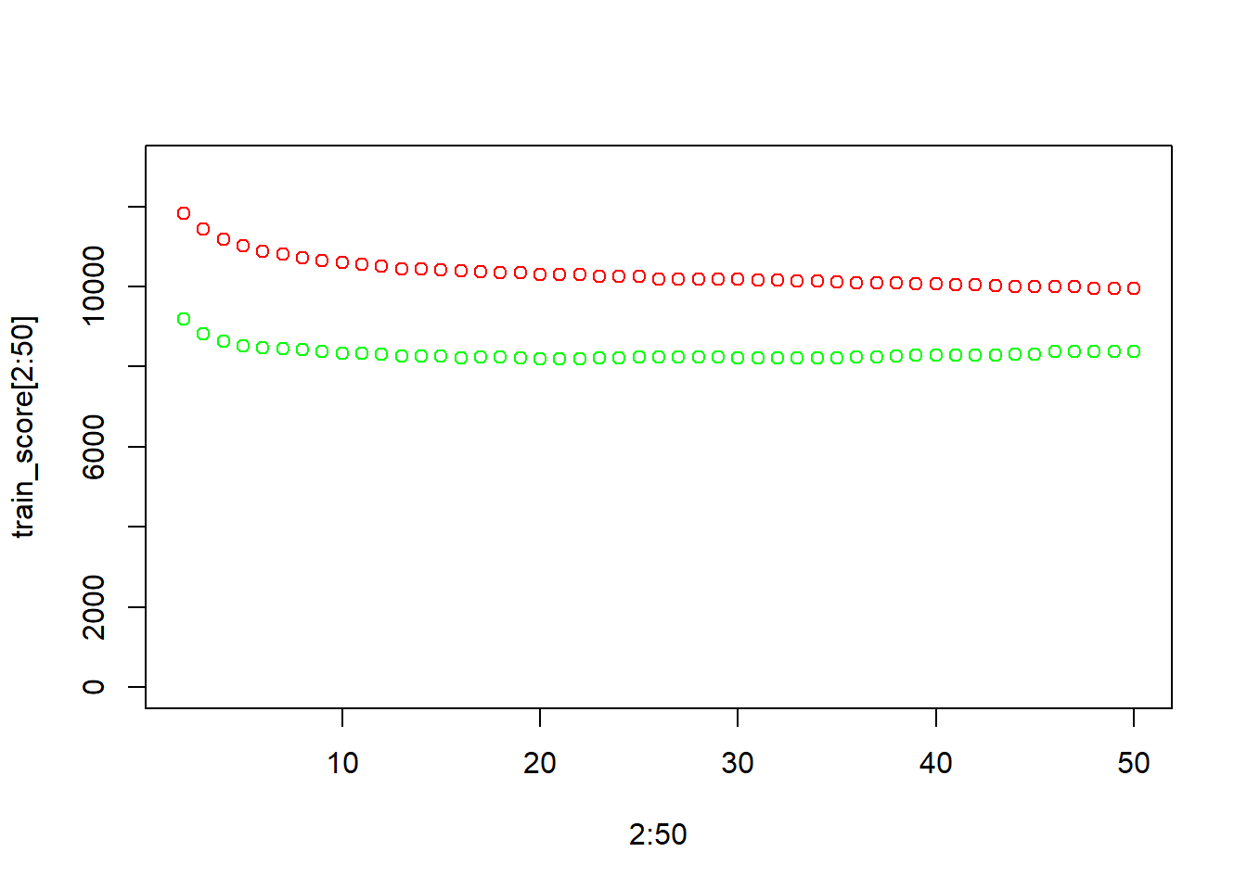

The above graph shows the dependence of deviances for the training and the validation data on the number of leaves for the model of 0.0005 minimum deviance. The lesser the terminal nodes(simple model), then the model has high bias and low variance which leads to underfitting and the greater the terminal nodes(more complex model), then the model has low bias and high variance which leads to overfitting

#optimal amount of leaves  
  
optimal_leaf <- which.min(valid_score[-1])  
  
optimal_tree <- prune.tree(mindev_tree, best = optimal_leaf)  
summary(optimal_tree)

##   
## Classification tree:  
## snip.tree(tree = mindev_tree, nodes = c(581L, 17L, 577L, 79L,   
## 37L, 77L, 576L, 153L, 580L, 6L, 1157L, 16L, 5L, 1156L, 156L,   
## 152L, 579L, 7L))  
## Variables actually used in tree construction:  
## [1] "poutcome" "month" "contact" "pdays" "age" "day" "balance"   
## [8] "housing"   
## Number of terminal nodes: 21   
## Residual mean deviance: 0.5706 = 10310 / 18060   
## Misclassification error rate: 0.1041 = 1882 / 18084

plot(optimal_tree)  
text(optimal_tree, pretty = 1)

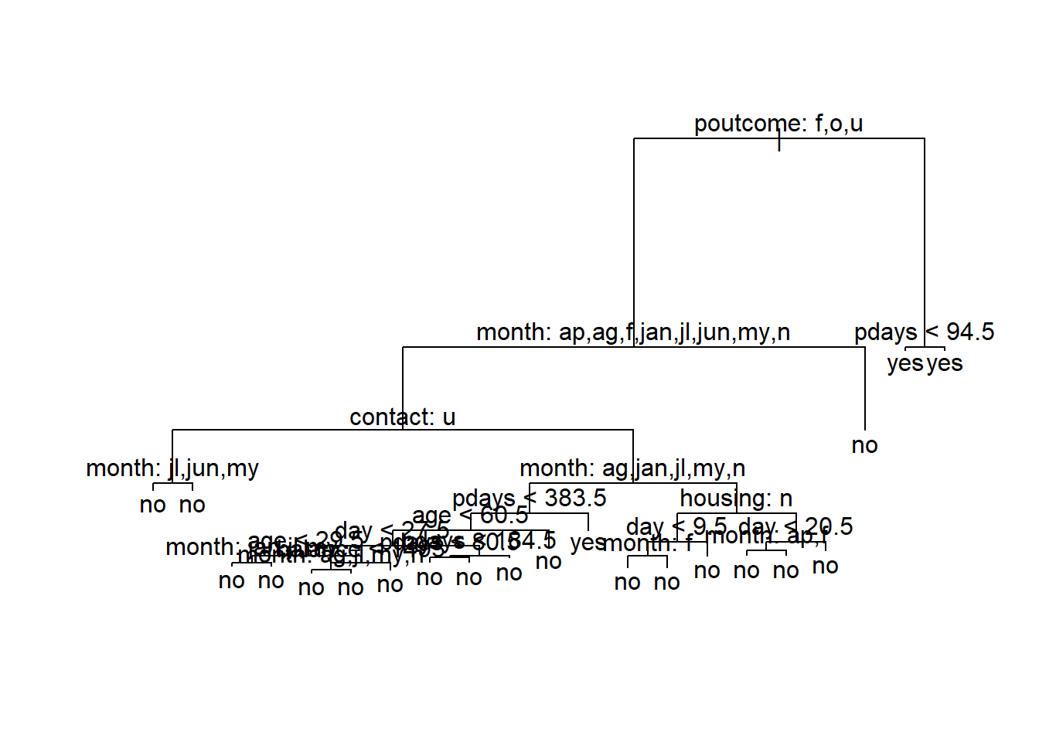

The optimal number of leaves is 23. The following features seem to be most important for decision making in the tree. “poutcome” “month” “contact” “day” “age” “pdays” “job” “campaign” “housing”.From the decision tree, the first three features (the features poutcome, month, contact) are the most decisive and the most of the data points are classified to the flatter side. The first split is out of “poutcome” which indicates the outcome of previous marketing campaign is crucial in predicting the current outcomes. As the “poutcome” is success, majority of data points seem to fall under it. Within the success branch, the next split is based on the “month” indicating different month show varying effects in customers responses, who participated inn previous campaign. Another split is based on the “contact” indicating the mode of contact plays an crucial role in reaching customers with past successful outcomes in particular months. As said eariler, the features “poutcome”, “month”, “contact” seem to be most important for decision making in the above tree.

####Task4####  
  
# test data prediction with optimal tree  
  
prediction_test <- predict(optimal_tree, newdata = test, type = "class" )  
  
#confusion matrix   
test_confusionMatrix <- table(true=test$y,prediction_test)  
test_confusionMatrix

## prediction_test  
## true no yes  
## no 11812 167  
## yes 1294 291

#Test Accuracy  
test_cm_diag = sum(diag(test_confusionMatrix))  
test_cm_sum = sum(test_confusionMatrix)  
  
test_accuracy = test_cm_diag/test_cm_sum  
  
test_accuracy

## [1] 0.8922884

#F1 Score  
  
test_recall <- test_confusionMatrix[2,2]/sum(test_confusionMatrix[2,])  
test_precision <- test_confusionMatrix[2,2] / sum(test_confusionMatrix[,2])  
  
F1_score <- 2*test_precision*test_recall / (test_precision+test_recall)  
F1_score

## [1] 0.2848752

**Estimate the confusion matrix, accuracy and F1 score for the test data by using the optimal model from step 3. Comment whether the model has a good predictive power and which of the measures (accuracy or F1-score) should be preferred here.**

Since the data has uneven class distribution, F1 score shoul be used to determine the predictive power of the model. The F1 score of our model is 0.315 which means our classifier has high number of false positives. From this we can say that our model has no good predictive power

####Task5####  
  
loss_matrix <- matrix(c(0,5,1,0), nrow = 2)  
  
lost_tree_model <- rpart(y~., data = training, method = "class", parms = list(loss= loss_matrix))  
  
loss_predict_tree <- predict(lost_tree_model, newdata = test, type = "class")  
  
#Confusion Matrix of Tree with Loss Matrix  
loss_confusionMatrix <- table(true=test$y, predicted=loss_predict_tree)  
  
loss_confusionMatrix

## predicted  
## true no yes  
## no 10880 1099  
## yes 807 778

# Accuracy  
loss_cm_diag = sum(diag(loss_confusionMatrix))  
loss_cm_sum = sum(loss_confusionMatrix)  
  
loss_accuracy = loss_cm_diag/loss_cm_sum  
loss_accuracy

## [1] 0.859481

#F1 score  
  
loss_recall <- loss_confusionMatrix[2,2]/sum(loss_confusionMatrix[2,])  
loss_precision <- loss_confusionMatrix[2,2] / sum(loss_confusionMatrix[,2])  
  
loss_F1_score <- 2*loss_precision*loss_recall / (loss_precision+loss_recall)  
loss_F1_score

## [1] 0.4494512

**Perform a decision tree classification of the test data with the following loss matrix, and report the confusion matrix for the test data. Compare the results with the results from step 4 and discuss how the rates has changed and why?**

In comparison with the results with step 4, the accuracy of the model has decreased to 85.95% and F1 score is increased to 0.440 from 0.315. Here the loss matrix is used to to penalize for each misclassifications.We have penalized false positives five times more than the false negatives which leads to the loss of making incorrect prediction.

####Task6####  
  
optimal_final_tree <- prune.tree(mindev_tree, best = optimal_leaf)  
optimal_tree_predection <- predict(optimal_final_tree, newdata = test, type = "vector")  
  
#logistics regression  
logistics <- glm(y~., data = training, family = "binomial")  
logistics_prediction <- predict(logistics, newdata = test, type = "response")  
  
#computing TPR and FPR with different thresholds  
  
tree_TPR <- c()  
tree_FPR <- c()  
logistics_TPR <- c()  
logistics_FPR <- c()  
  
k <- 1  
  
for(i in seq(0.05, 0.95, 0.05)){  
 t_tree <- ifelse(optimal_tree_predection[,2]>i,"yes","no")  
 t_logistics <- ifelse(logistics_prediction>i, "yes","no")  
 t1 <- table(test$y, t_tree)  
 if(dim(t1)[2]>1){  
 tree_TPR[k] <- t1[2,2] / sum(t1[2,])  
 tree_FPR[k] <- t1[1,2] / sum(t1[1,])  
 }  
   
 t2 <- table(test$y, t_logistics)  
 if(dim(t2)[2]>1){  
 logistics_TPR[k] <- t2[2,2] / sum(t2[2,])  
 logistics_FPR[k] <- t2[1,2] / sum(t2[1,])  
 }  
 k=k+1  
}  
  
#plotting ROC curves  
  
plot(tree_FPR, tree_TPR, type = "l", col= "green",  
 lwd=2,xlab = "False Positive rate",ylab = "True Positive rate", main = "ROC Curves")  
lines(logistics_FPR, logistics_TPR, type = "l", col= "red", lwd=2)  
legend("bottomright", c("Optimal Tree", "Logistics Regression"), fill= c("green","red"))

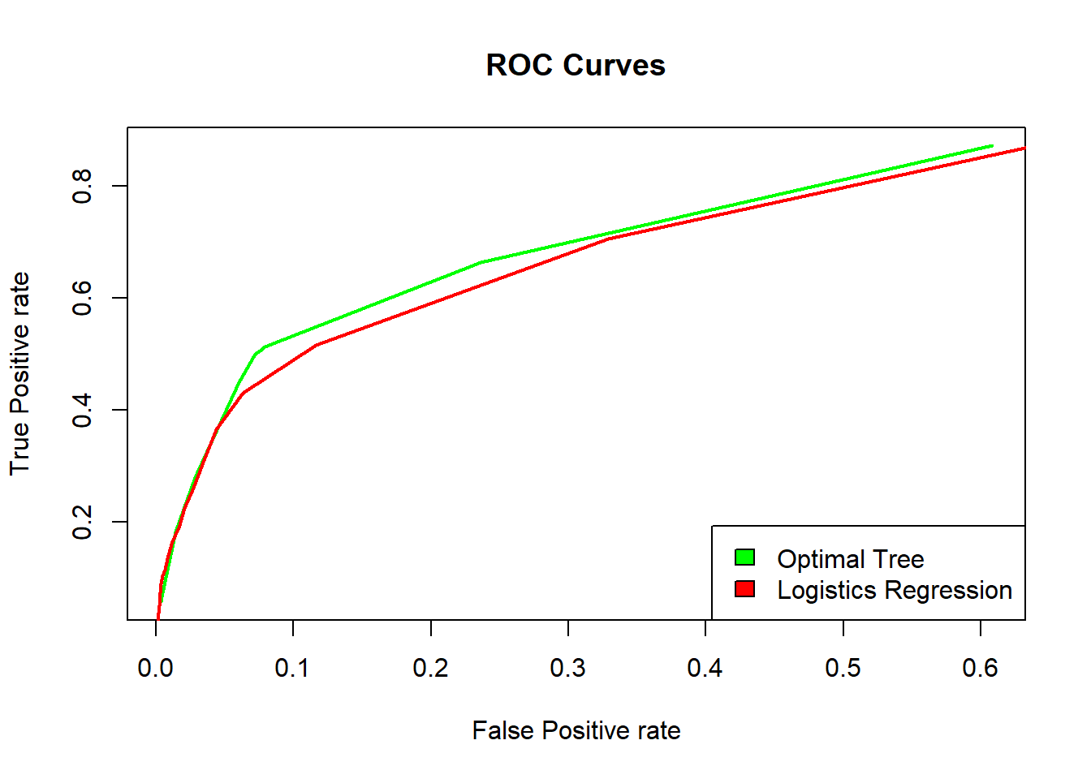

**Use the optimal tree and a logistic regression model to classify the test data by using the following principle: Y_hat= yes if p(Y=yes|X)>𝜋,otherwise Y_hat = no where 𝜋=0.05,0.1,0.15, … 0.9,0.95. Compute the TPR and FPR values for the two models and plot the corresponding ROC curves. Conclusion? Why precision recall curve could be a better option here**

From the above graph, can observe that the area under the curve is more for optimal tree model than logistic regression model. We can come to a conclusion that use of optimal tree model is the best choice here. Precision-recall curve could be a better option here since the data has unbalanced classes.