Packet size= 128

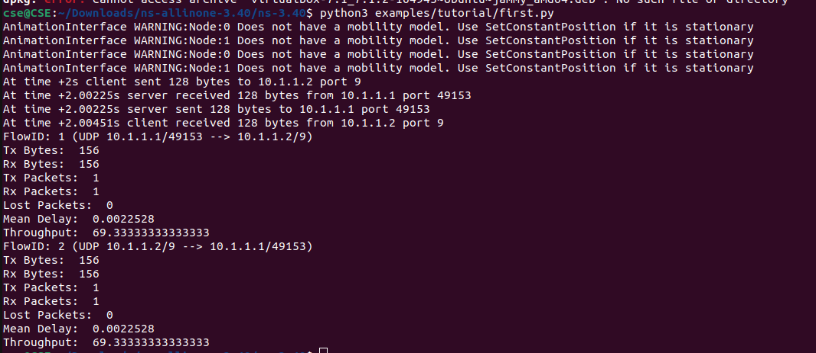

Packet size= 256

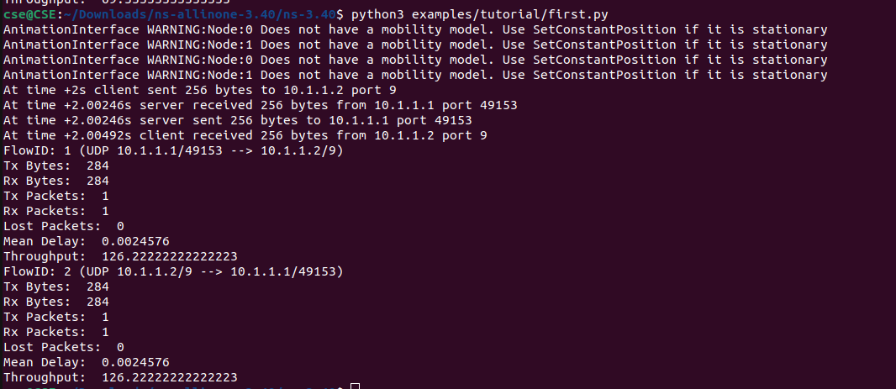

Packet size= 512

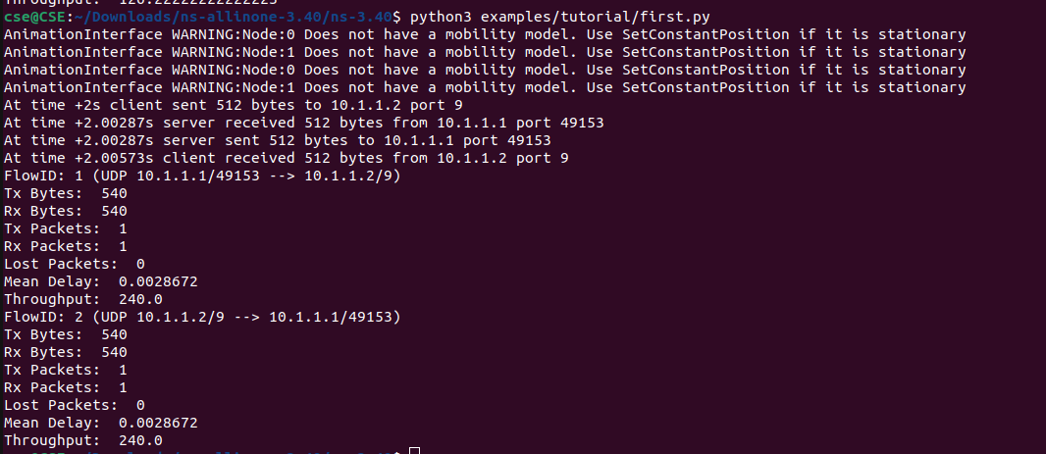

Packet size= 1024

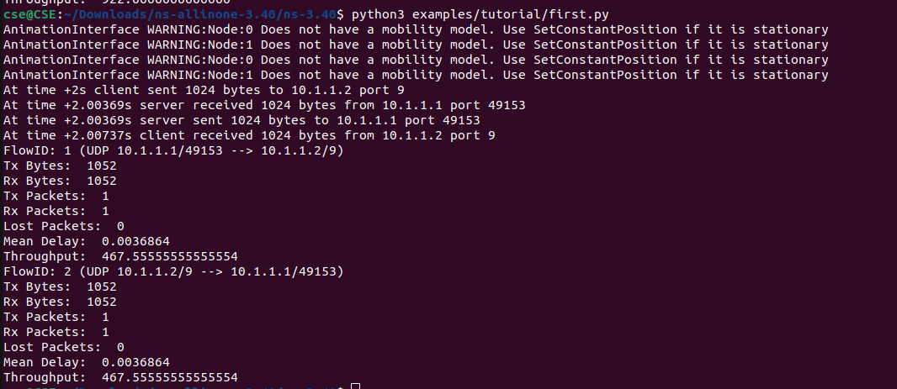

Packet size= 2048

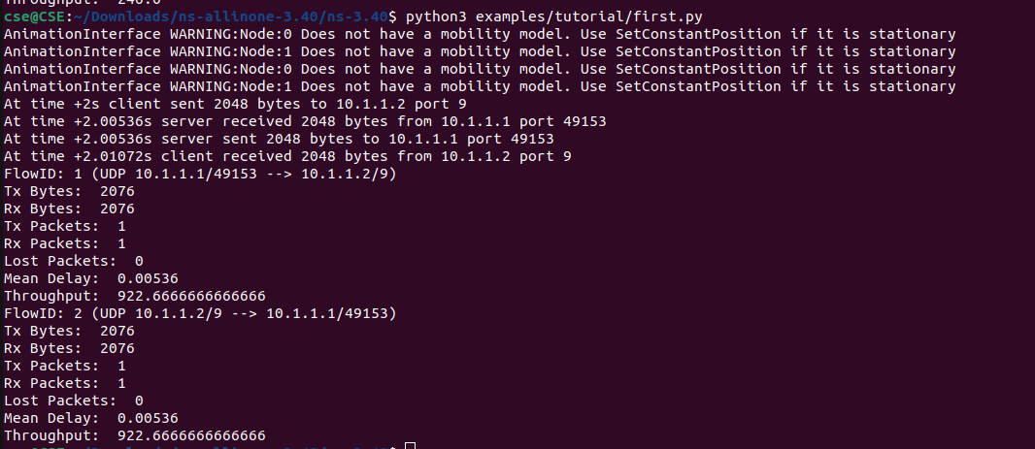

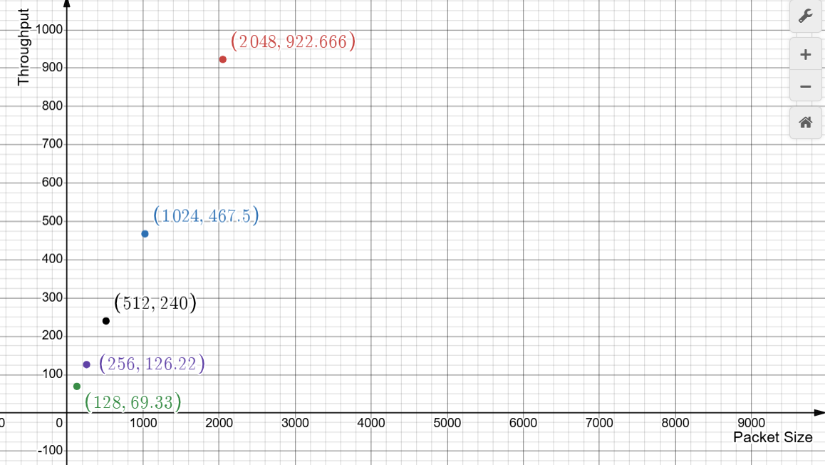

The graph indicates that throughput increases with Packet size, demonstrating a linear relationship. However, when the data size is doubled, the throughput does not double proportionally. But it is a straight line graph.