**Request**

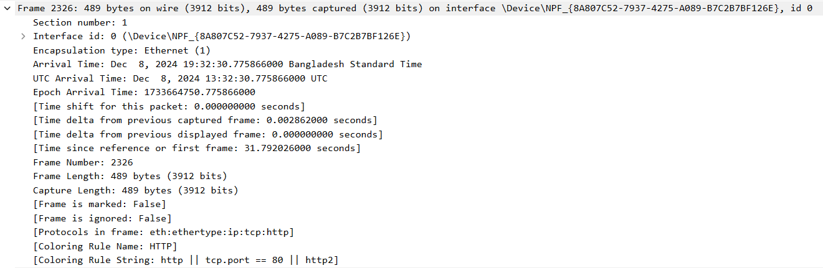

**Frame:** Frame is the PDU for the data link layer.

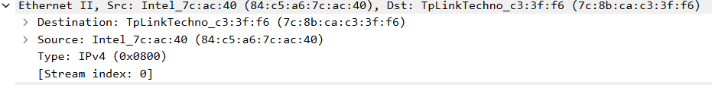

**Ethernet:** It is in the data link layer. Ethernet is responsible for framing, addressing, and error detection in data transmission within a LAN.

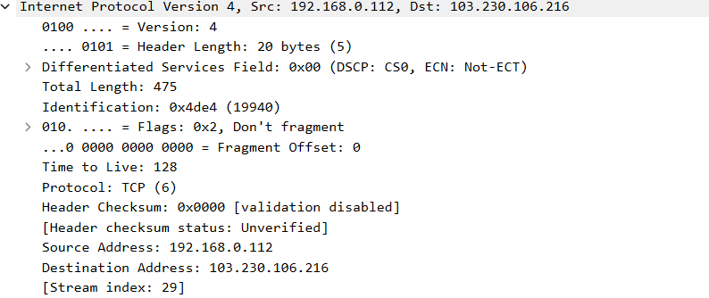

**IPv4:** IP is used in the Network layer. Here, IP version, source and destination IP, header length, protocol, checksum information is mentioned. For request, source IP is my PC and destination IP is the website.

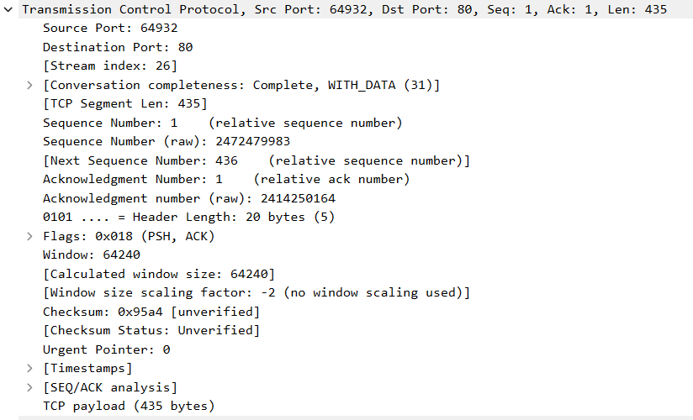

**Transmission Control Protocol:** It is in the transport layer. Here, Source and destination port, sequence number, acknowledgement number is mentioned.

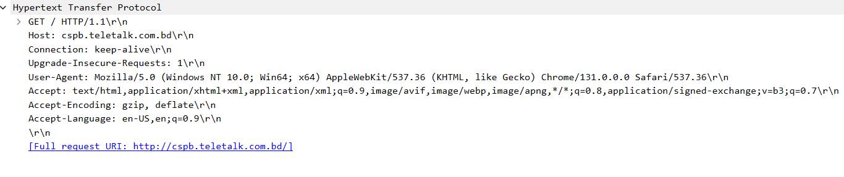

**Hypertext Transfer Protocol:** It is an application layer protocol. From this we can understand that the get method is used to access the website, HTTP version is 1.1, the host is the website we are trying to access. Browsers like Mozilla, Chrome etc are the clients making requests. CRLF(\r\n) is denoted for the end of the line and the accepted language is english. HTTP connection persistent.

**Response**

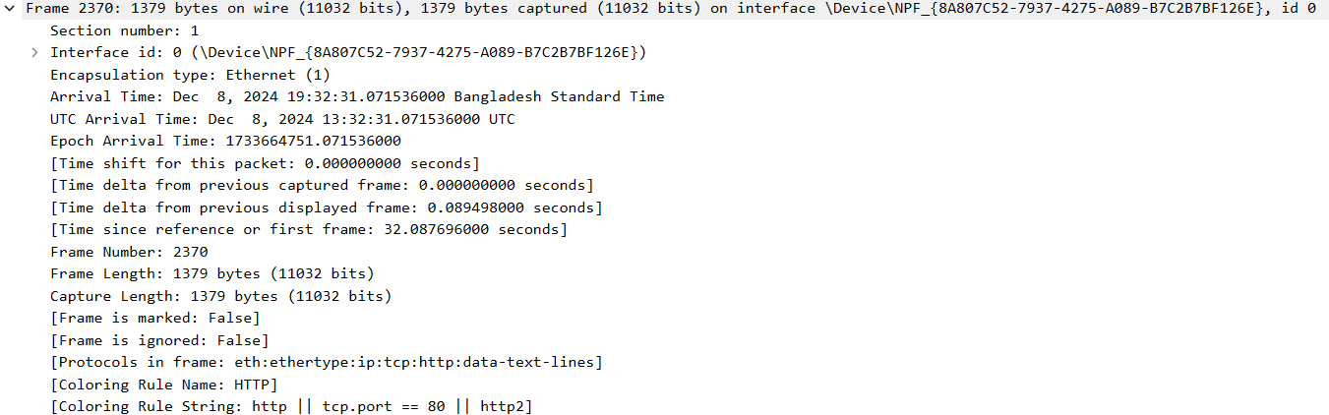

**Frame:** Frame is the PDU for the data link layer.

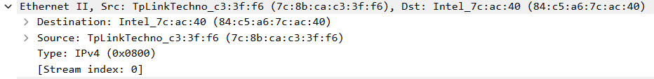

**Ethernet:** It is in the data link layer. Ethernet is responsible for framing, addressing, and error detection in data transmission within a LAN.

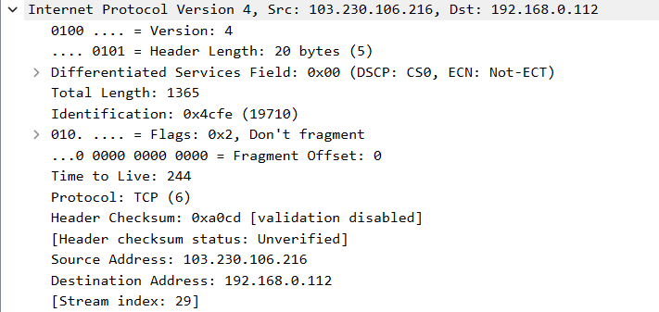

**IPv4:** IP is used in the Network layer. Here, IP version, source and destination IP, header length, protocol, checksum information is mentioned. For response, source IP is the website and destination IP is my PC.

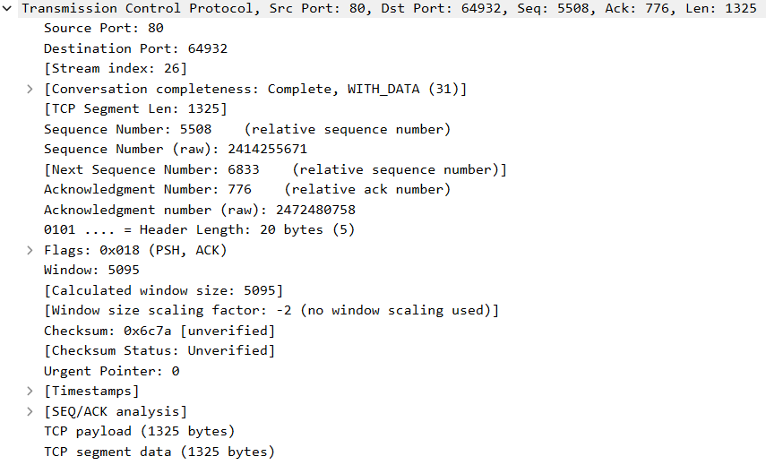

**Transmission Control Protocol:** It is in the transport layer. Here, Source and destination port, sequence number, acknowledgement number is mentioned.

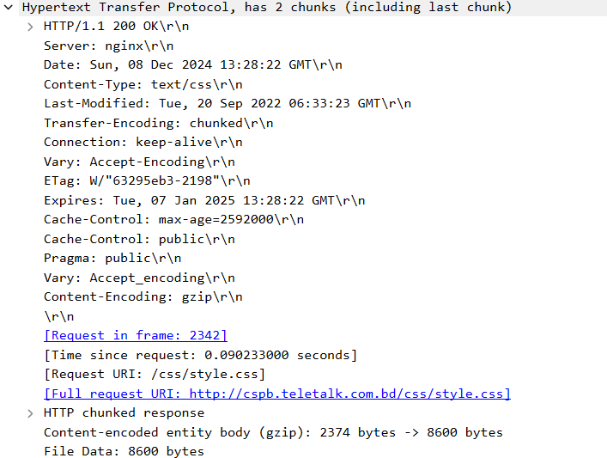

**Hypertext Transfer Protocol:** The Content-Type header indicates that the response body includes Text or CSS content. The last-modified field indicates the last updated date. It also shows that the client intends to keep the TCP connection open after the current transaction, enabling the client to send more requests over the same connection. This makes the HTTP connection persistent.