**Part-a**

touch 24141259_1.txt

touch 24141259_2.txt

touch 24141259_3.txt

touch 24141259_4.txt

mkdir QuaziFarihaFairooz1

mkdir QuaziFarihaFairooz2

mv 24141259_1.txt 24141259_2.txt 24141259_3.txt QuaziFarihaFairooz1/

cp 24141259_1.txt 24141259_2.txt /home/fariha/Desktop/cse321/Assignment_1/QuaziFarihaFairooz2

mkdir QuaziFarihaFairooz3

cp -r mkdir QuaziFarihaFairooz1 mkdir QuaziFarihaFairooz3

cd QuaziFarihaFairooz3

ls -l

chmod 755 QuaziFarihaFairooz1

mv QuaziFarihaFairooz2 QuaziFarihaFairooz3 QuaziFarihaFairooz1

mv QuaziFarihaFairooz3 root

cd /

rm -r -f QuaziFarihaFairooz1

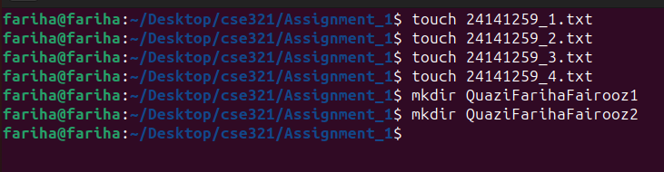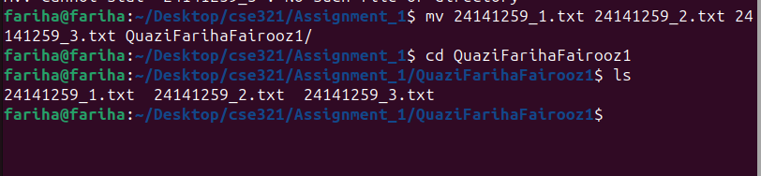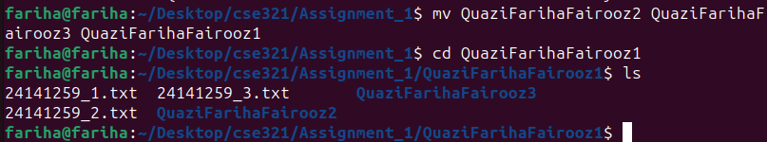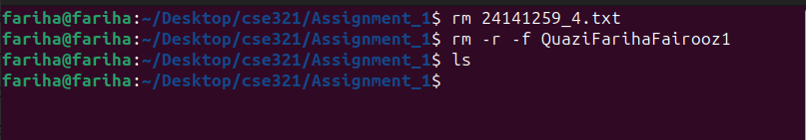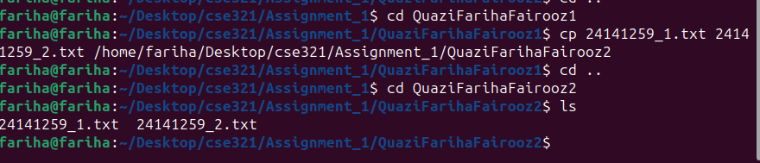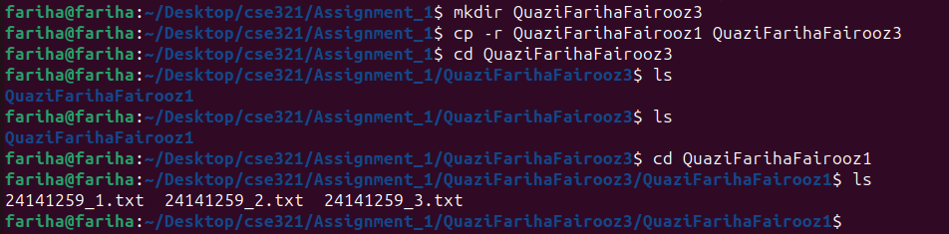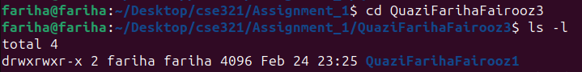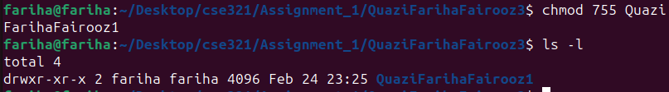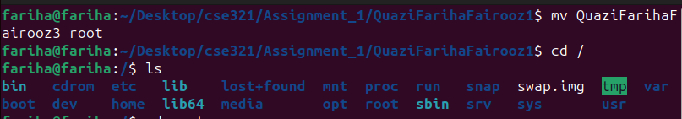

**Part-b**

touch course.txt

cat>>course.txt

CSE321,Operating system,4

CSE470,Software Engineering,13

CSE471, System Analysis and Design,4

ECO101, Introduction of economics,7

cat course.txt

grep -p CSE course.txt

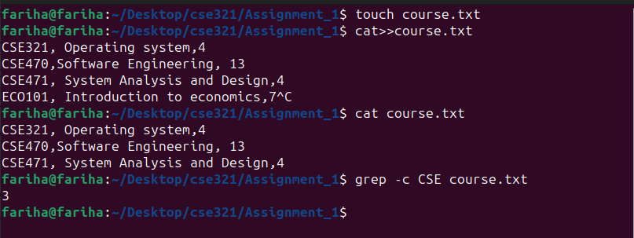

**Part-c**

ls -a /

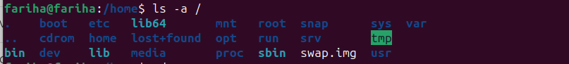

**Part-d**

cat new.txt

sed -n 5,17p new.txt

