Through the bubble plot, I found out urban areas have the largest number of drivers and rides while rural areas have smallest number of drivers and rides. However, the average ride fare in rural areas (ranging from $24 to 48) seems higher than urban areas ($20 to $30).

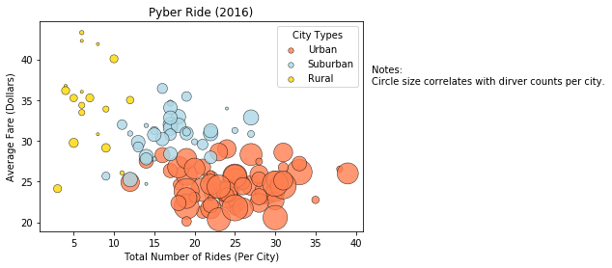

Urban areas gain most of the profit (62.7%), even though the average fare is low for each ride. Suburban areas gain 30.5% of the total profit. Rural areas gain the lowest, 6.8% of the total profit.

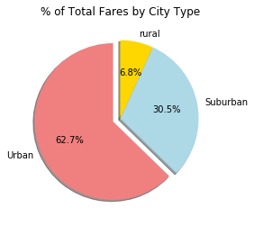

Urban cities have the largest number of rides, 68.4% of the total rides, while rural cities only has 5.3% of the total rides.

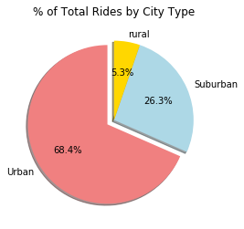

The majority drivers are in urban cities (80.9% of total drivers), while there are only 2.6% drivers in the rural areas.

