**Hr labs**

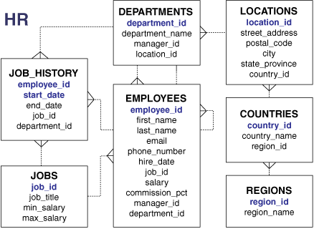

Question 1

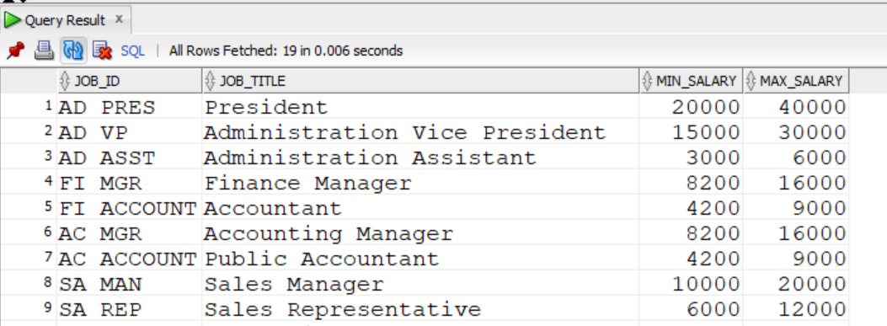

Question 2

Question 3

Question 4

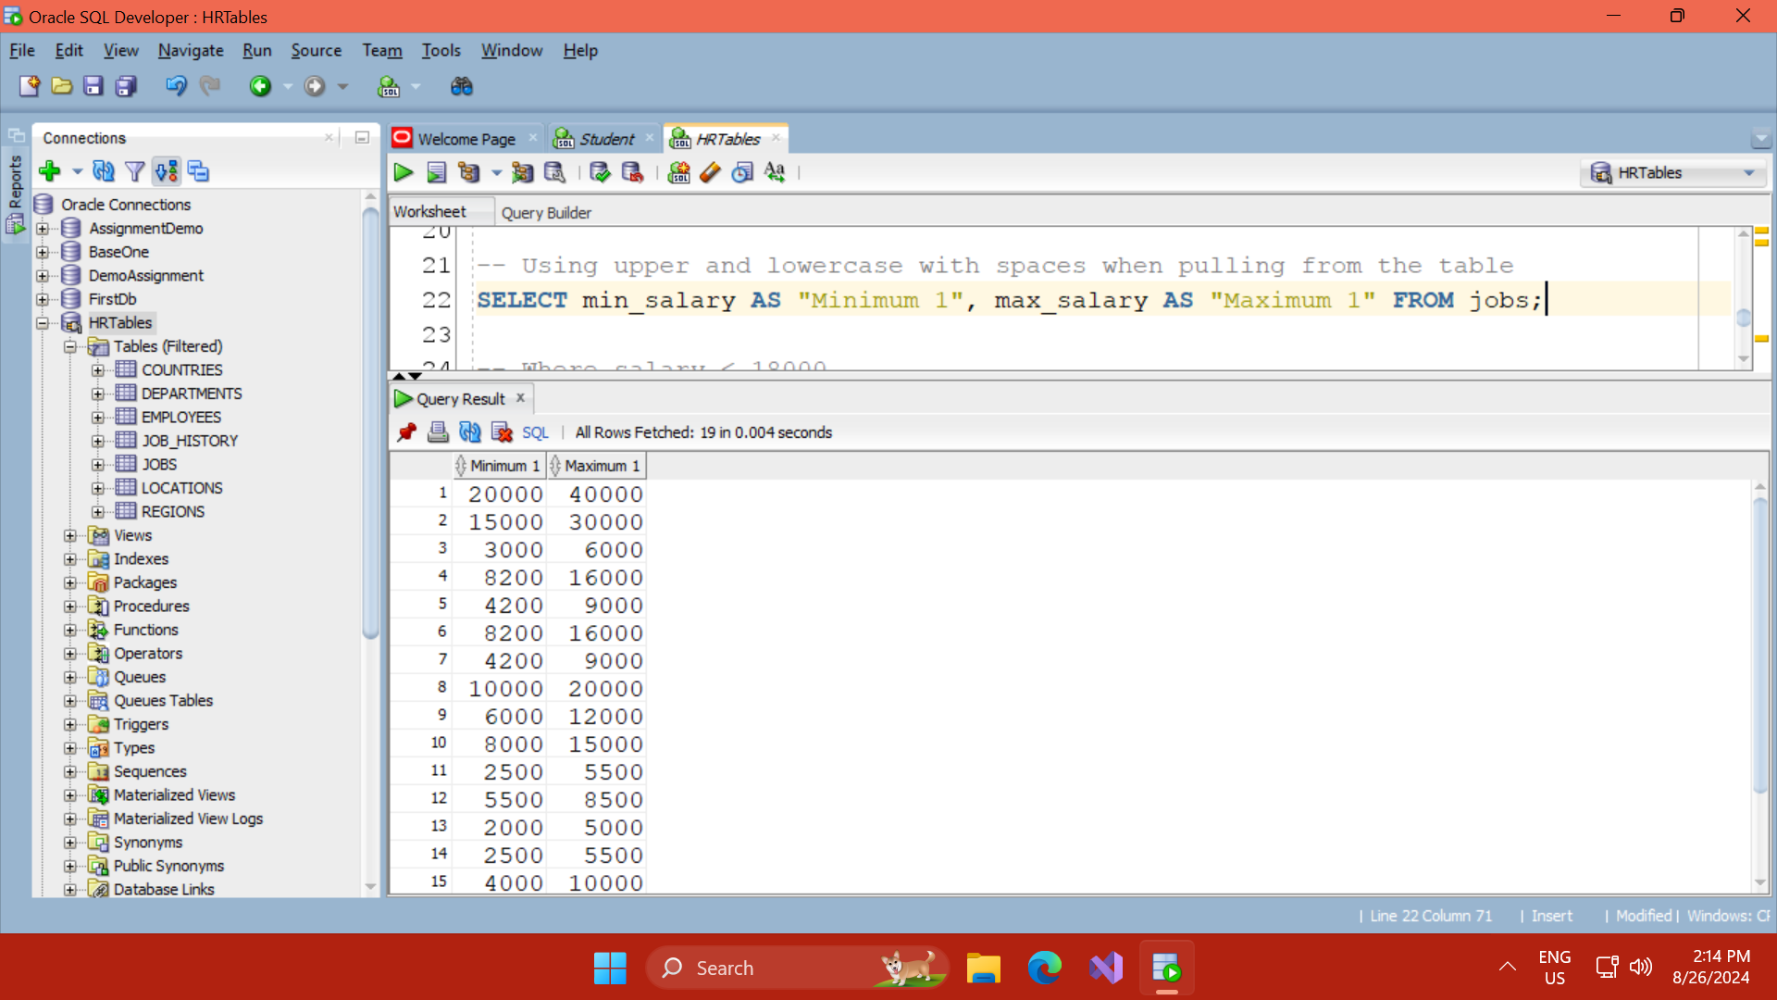

Question 5

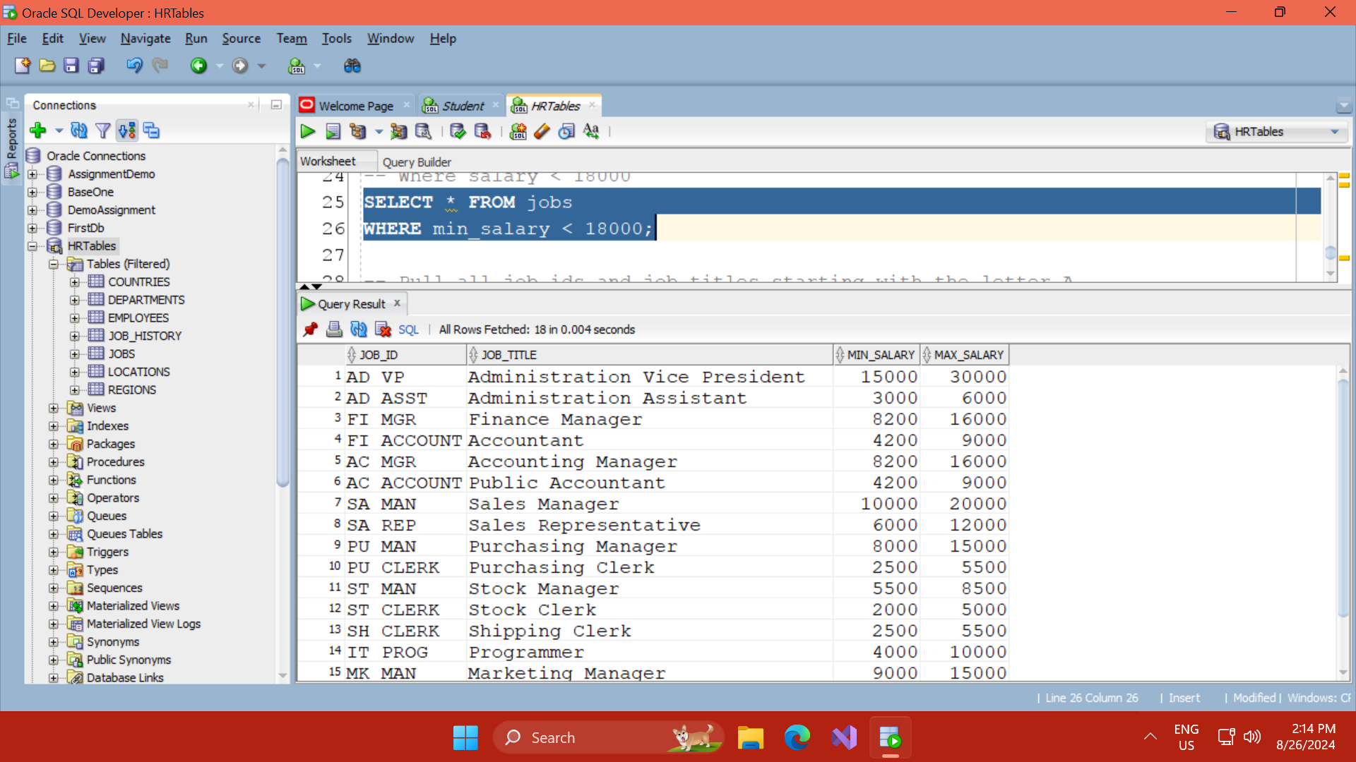

Questin 6

