GSTAT Report

MESHAL ALQAHTANI

Contents

# 1. Introduction

This report presents an analysis of population trends in Saudi Arabia from 2010 to 2022 using statistical summaries and geospatial data.

# 2. Data Overview

## 2.1 Summary Statistics

| Region | Nationality | 2010 | 2011 | 2012 | 2013 | 2014 | 2015 | 2016 | 2017 | 2018 | 2019 | 2020 | 2021 | 2022 |
| --- | --- | --- | --- | --- | --- | --- | --- | --- | --- | --- | --- | --- | --- | --- |
| Al Bahah | Non Saudi | 75,238 | 80,820 | 85,602 | 92,585 | 93,094 | 100,009 | 104,279 | 100,457 | 90,911 | 85,861 | 91,410 | 82,332 | 87,886 |
| Al Bahah | Saudi | 187,219 | 191,134 | 195,599 | 200,827 | 206,792 | 212,549 | 217,713 | 222,322 | 227,599 | 233,396 | 239,895 | 245,501 | 251,288 |
| Al Jawf | Non Saudi | 105,073 | 115,102 | 124,319 | 137,105 | 140,555 | 153,954 | 163,674 | 160,824 | 148,459 | 143,038 | 155,398 | 142,855 | 155,558 |
| Al Jawf | Saudi | 339,599 | 346,085 | 353,499 | 362,102 | 372,075 | 381,457 | 389,853 | 397,228 | 405,546 | 414,341 | 424,048 | 432,039 | 440,264 |
| Al Madinah Al Munawwarah | Non Saudi | 604,882 | 651,693 | 693,513 | 754,814 | 766,550 | 828,156 | 870,531 | 849,602 | 778,051 | 743,202 | 801,253 | 730,127 | 785,837 |
| Al Madinah Al Munawwarah | Saudi | 1,016,601 | 1,037,556 | 1,061,715 | 1,089,763 | 1,122,069 | 1,152,683 | 1,180,128 | 1,204,341 | 1,231,833 | 1,261,628 | 1,294,821 | 1,323,113 | 1,352,146 |
| Al Qaseem | Non Saudi | 340,192 | 366,388 | 389,063 | 421,864 | 425,190 | 457,868 | 478,547 | 462,170 | 419,294 | 397,004 | 423,833 | 382,850 | 409,689 |
| Al Qaseem | Saudi | 694,563 | 708,993 | 725,612 | 744,872 | 767,117 | 788,220 | 807,053 | 823,666 | 842,541 | 863,265 | 886,335 | 906,182 | 926,490 |
| Ar Riyadh | Non Saudi | 2,918,903 | 3,175,586 | 3,409,614 | 3,741,661 | 3,827,446 | 4,167,823 | 4,412,776 | 4,335,807 | 3,998,452 | 3,846,530 | 4,177,290 | 3,834,296 | 4,152,538 |
| Ar Riyadh | Saudi | 3,305,130 | 3,376,149 | 3,458,239 | 3,553,092 | 3,662,353 | 3,765,888 | 3,858,350 | 3,939,731 | 4,032,222 | 4,132,732 | 4,245,118 | 4,341,082 | 4,439,210 |
| Aseer | Non Saudi | 383,930 | 420,863 | 455,121 | 502,747 | 516,265 | 566,739 | 603,906 | 594,210 | 549,269 | 529,950 | 576,247 | 530,388 | 579,597 |
| Aseer | Saudi | 1,085,911 | 1,108,194 | 1,133,777 | 1,163,522 | 1,197,499 | 1,230,126 | 1,259,150 | 1,284,979 | 1,314,421 | 1,346,378 | 1,382,430 | 1,413,144 | 1,444,688 |
| Eastern Region | Non Saudi | 1,449,596 | 1,588,249 | 1,716,377 | 1,894,616 | 1,944,992 | 2,132,483 | 2,270,102 | 2,234,065 | 2,065,149 | 1,992,280 | 2,167,134 | 1,994,582 | 2,175,400 |
| Eastern Region | Saudi | 2,198,314 | 2,245,170 | 2,299,455 | 2,362,331 | 2,434,902 | 2,503,812 | 2,565,462 | 2,619,725 | 2,681,465 | 2,747,955 | 2,822,193 | 2,885,380 | 2,949,854 |
| Hail | Non Saudi | 131,078 | 145,068 | 158,324 | 176,443 | 182,819 | 202,286 | 217,262 | 215,628 | 200,986 | 195,481 | 214,305 | 198,779 | 218,521 |
| Hail | Saudi | 397,348 | 405,527 | 414,907 | 425,836 | 438,429 | 450,344 | 461,046 | 470,430 | 481,125 | 492,755 | 505,682 | 516,643 | 527,885 |
| Jazan | Non Saudi | 310,938 | 335,068 | 356,529 | 387,919 | 393,831 | 425,175 | 446,583 | 435,796 | 399,006 | 381,050 | 410,867 | 374,348 | 402,218 |
| Jazan | Saudi | 751,557 | 767,174 | 785,113 | 805,976 | 829,893 | 852,717 | 873,097 | 891,118 | 911,672 | 934,067 | 959,274 | 980,751 | 1,002,779 |
| Makkah Al Mukarramah | Non Saudi | 3,273,031 | 3,496,610 | 3,689,803 | 3,982,721 | 4,016,237 | 4,298,604 | 4,479,534 | 4,345,243 | 3,952,581 | 3,748,709 | 4,015,960 | 3,633,037 | 3,867,740 |
| Makkah Al Mukarramah | Saudi | 3,077,186 | 3,143,642 | 3,220,353 | 3,309,457 | 3,411,883 | 3,509,532 | 3,597,076 | 3,674,514 | 3,762,757 | 3,858,847 | 3,966,569 | 4,059,151 | 4,153,723 |
| Najran | Non Saudi | 122,323 | 134,774 | 146,466 | 162,607 | 168,105 | 185,160 | 198,172 | 196,546 | 182,982 | 177,695 | 194,707 | 180,350 | 197,324 |
| Najran | Saudi | 301,508 | 307,487 | 314,336 | 322,269 | 331,415 | 340,041 | 347,786 | 354,626 | 362,338 | 370,542 | 379,637 | 387,183 | 394,976 |
| Northern Borders | Non Saudi | 62,713 | 69,281 | 75,443 | 83,871 | 86,758 | 95,687 | 102,472 | 101,638 | 94,658 | 91,954 | 100,807 | 93,422 | 102,219 |
| Northern Borders | Saudi | 207,384 | 211,450 | 216,161 | 221,596 | 227,856 | 233,788 | 239,060 | 243,709 | 248,972 | 254,571 | 260,800 | 265,989 | 271,358 |
| Tabuk | Non Saudi | 154,426 | 170,236 | 185,141 | 205,650 | 212,395 | 234,367 | 251,048 | 248,389 | 230,847 | 223,874 | 244,712 | 226,348 | 248,435 |
| Tabuk | Saudi | 483,844 | 493,568 | 504,780 | 517,758 | 532,753 | 546,914 | 559,538 | 570,591 | 583,145 | 596,694 | 611,785 | 624,511 | 637,601 |

# 3. Population Trends

## 3.1 Population Comparison by Region (2010 vs. 2022)

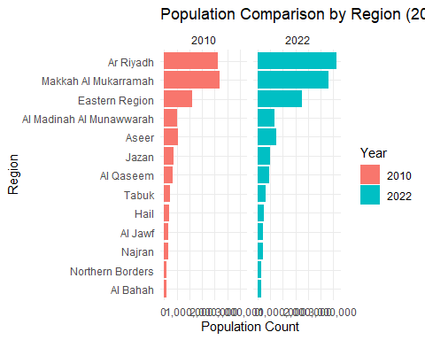

# 4. Geospatial Population Map

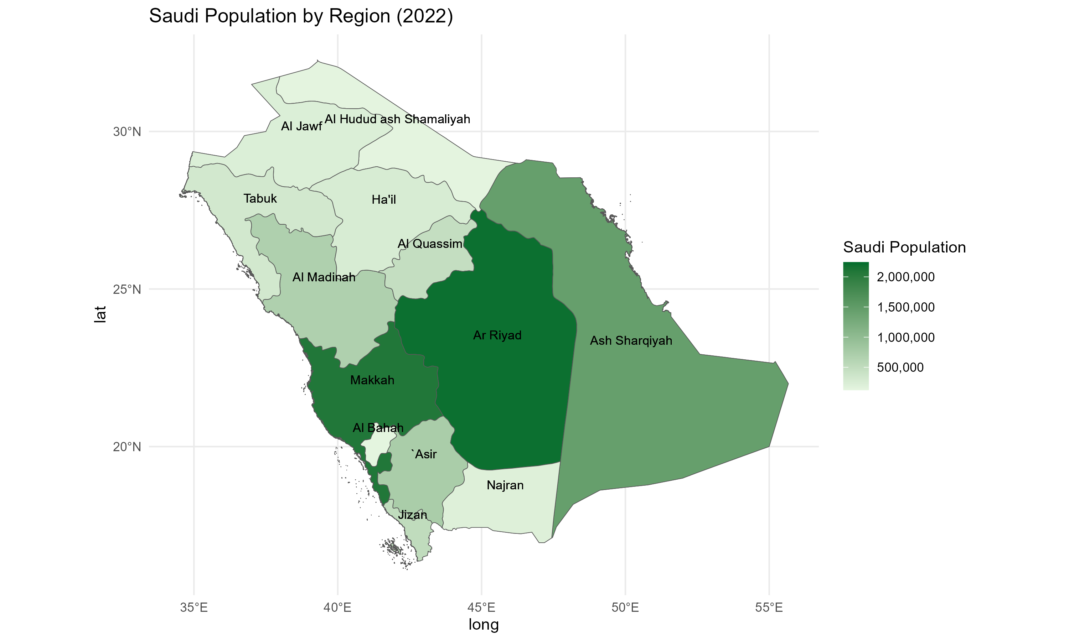

map

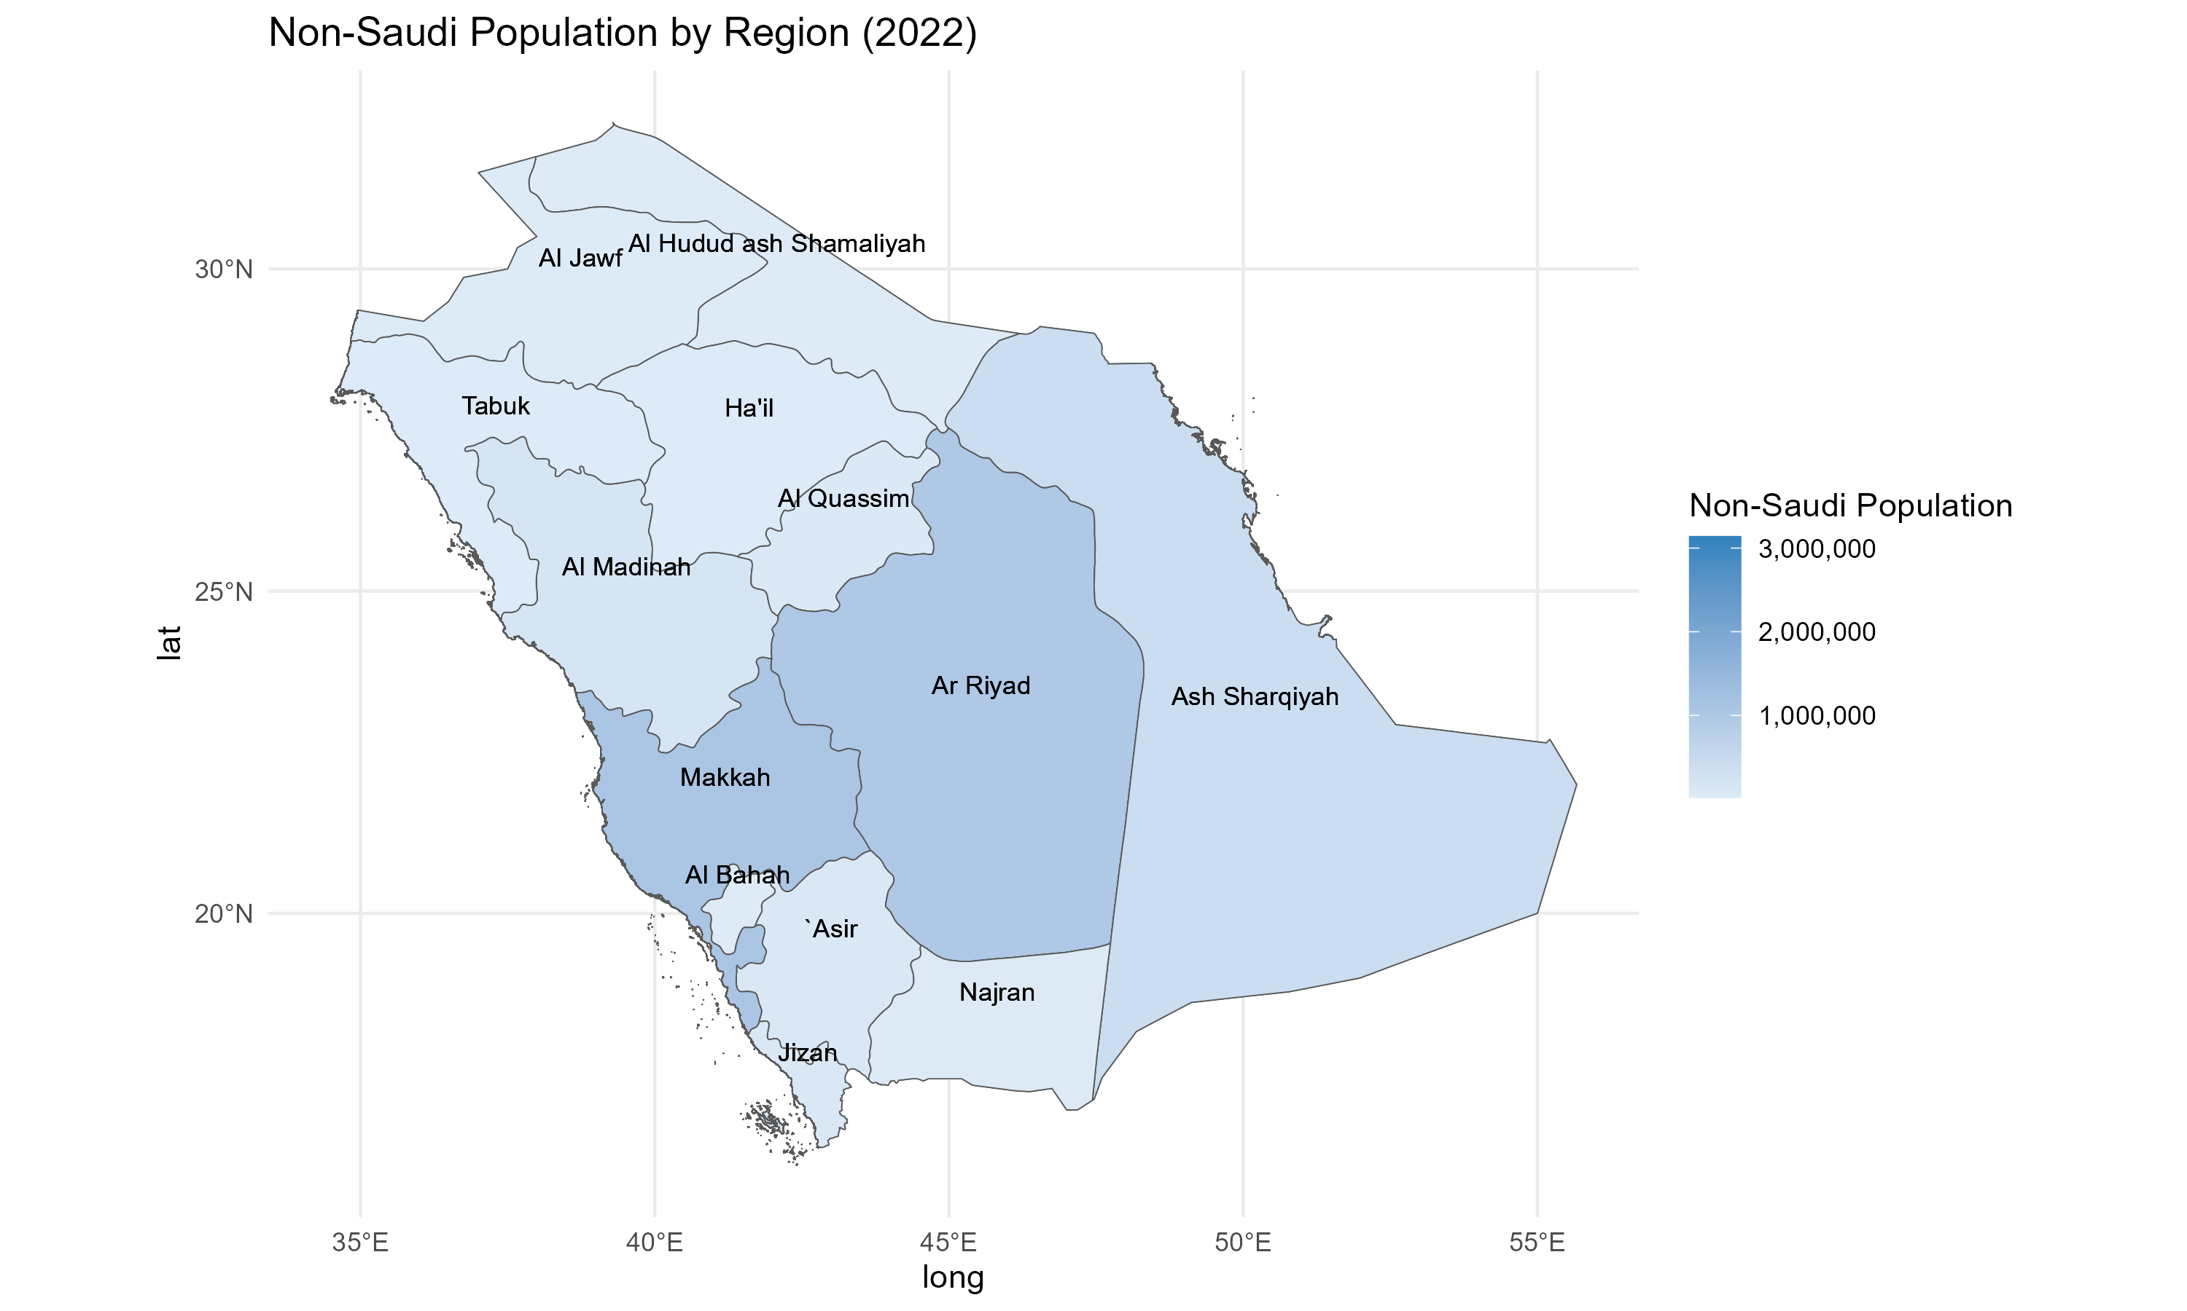  
# Conclusion This report provides insights into Saudi Arabia’s population changes and trends over time using statistical and geospatial analyses.

**Data Source:** [GSTAT Official Website](https://www.stats.gov.sa/en)