GSTAT Report

MESHAL ALQAHTANI

Contents

# 1. Introduction

This report presents an analysis of population trends in Saudi Arabia from 2010 to 2022 using statistical summaries and geospatial data.

# 2. Data Overview

## 2.1 Summary Statistics

Table 1: Population Change by Region (2010 vs. 2022)

| Region | Population (2010) | Population (2022) | Change | % Change | Trend |
| --- | --- | --- | --- | --- | --- |
| Al Bahah | 262,457 | 339,174 | 76,717 | 29.2 | 🟢▲ |
| Al Jawf | 444,672 | 595,822 | 151,150 | 34.0 | 🟢▲ |
| Al Madinah Al Munawwarah | 1,621,483 | 2,137,983 | 516,500 | 31.9 | 🟢▲ |
| Al Qaseem | 1,034,755 | 1,336,179 | 301,424 | 29.1 | 🟢▲ |
| Ar Riyadh | 6,224,033 | 8,591,748 | 2,367,715 | 38.0 | 🟢▲ |
| Aseer | 1,469,841 | 2,024,285 | 554,444 | 37.7 | 🟢▲ |
| Eastern Region | 3,647,910 | 5,125,254 | 1,477,344 | 40.5 | 🟢▲ |
| Hail | 528,426 | 746,406 | 217,980 | 41.3 | 🟢▲ |
| Jazan | 1,062,495 | 1,404,997 | 342,502 | 32.2 | 🟢▲ |
| Makkah Al Mukarramah | 6,350,217 | 8,021,463 | 1,671,246 | 26.3 | 🟢▲ |
| Najran | 423,831 | 592,300 | 168,469 | 39.7 | 🟢▲ |
| Northern Borders | 270,097 | 373,577 | 103,480 | 38.3 | 🟢▲ |
| Tabuk | 638,270 | 886,036 | 247,766 | 38.8 | 🟢▲ |

# 3. Population Trends

## 3.1 Population Comparison by Region (2010 vs. 2022)

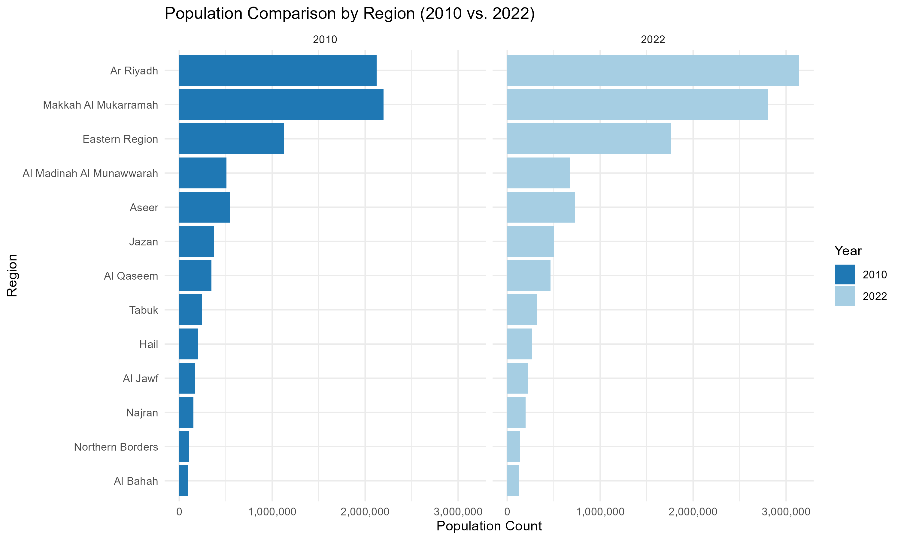

population

# 4. Geospatial Population Map

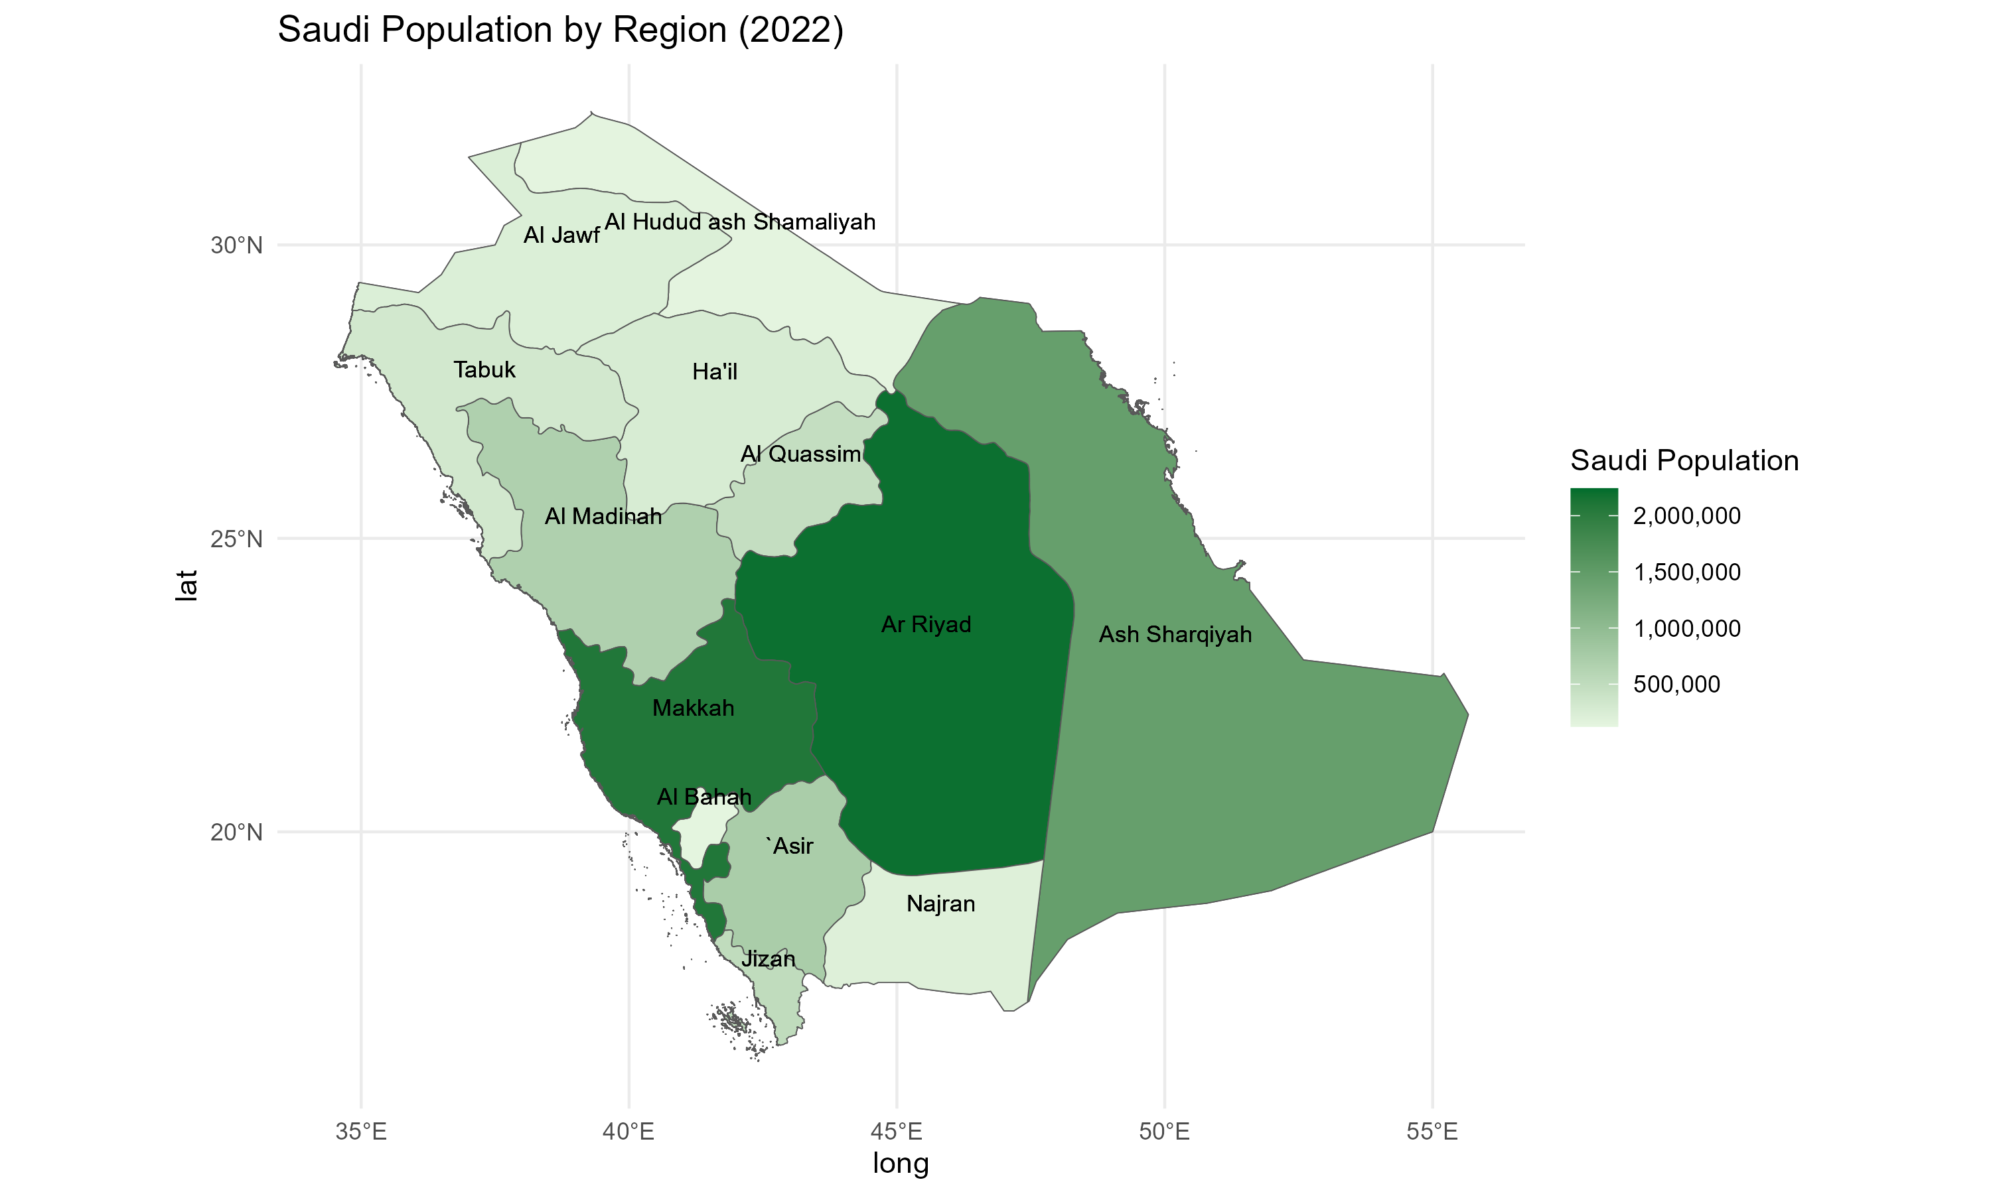

map

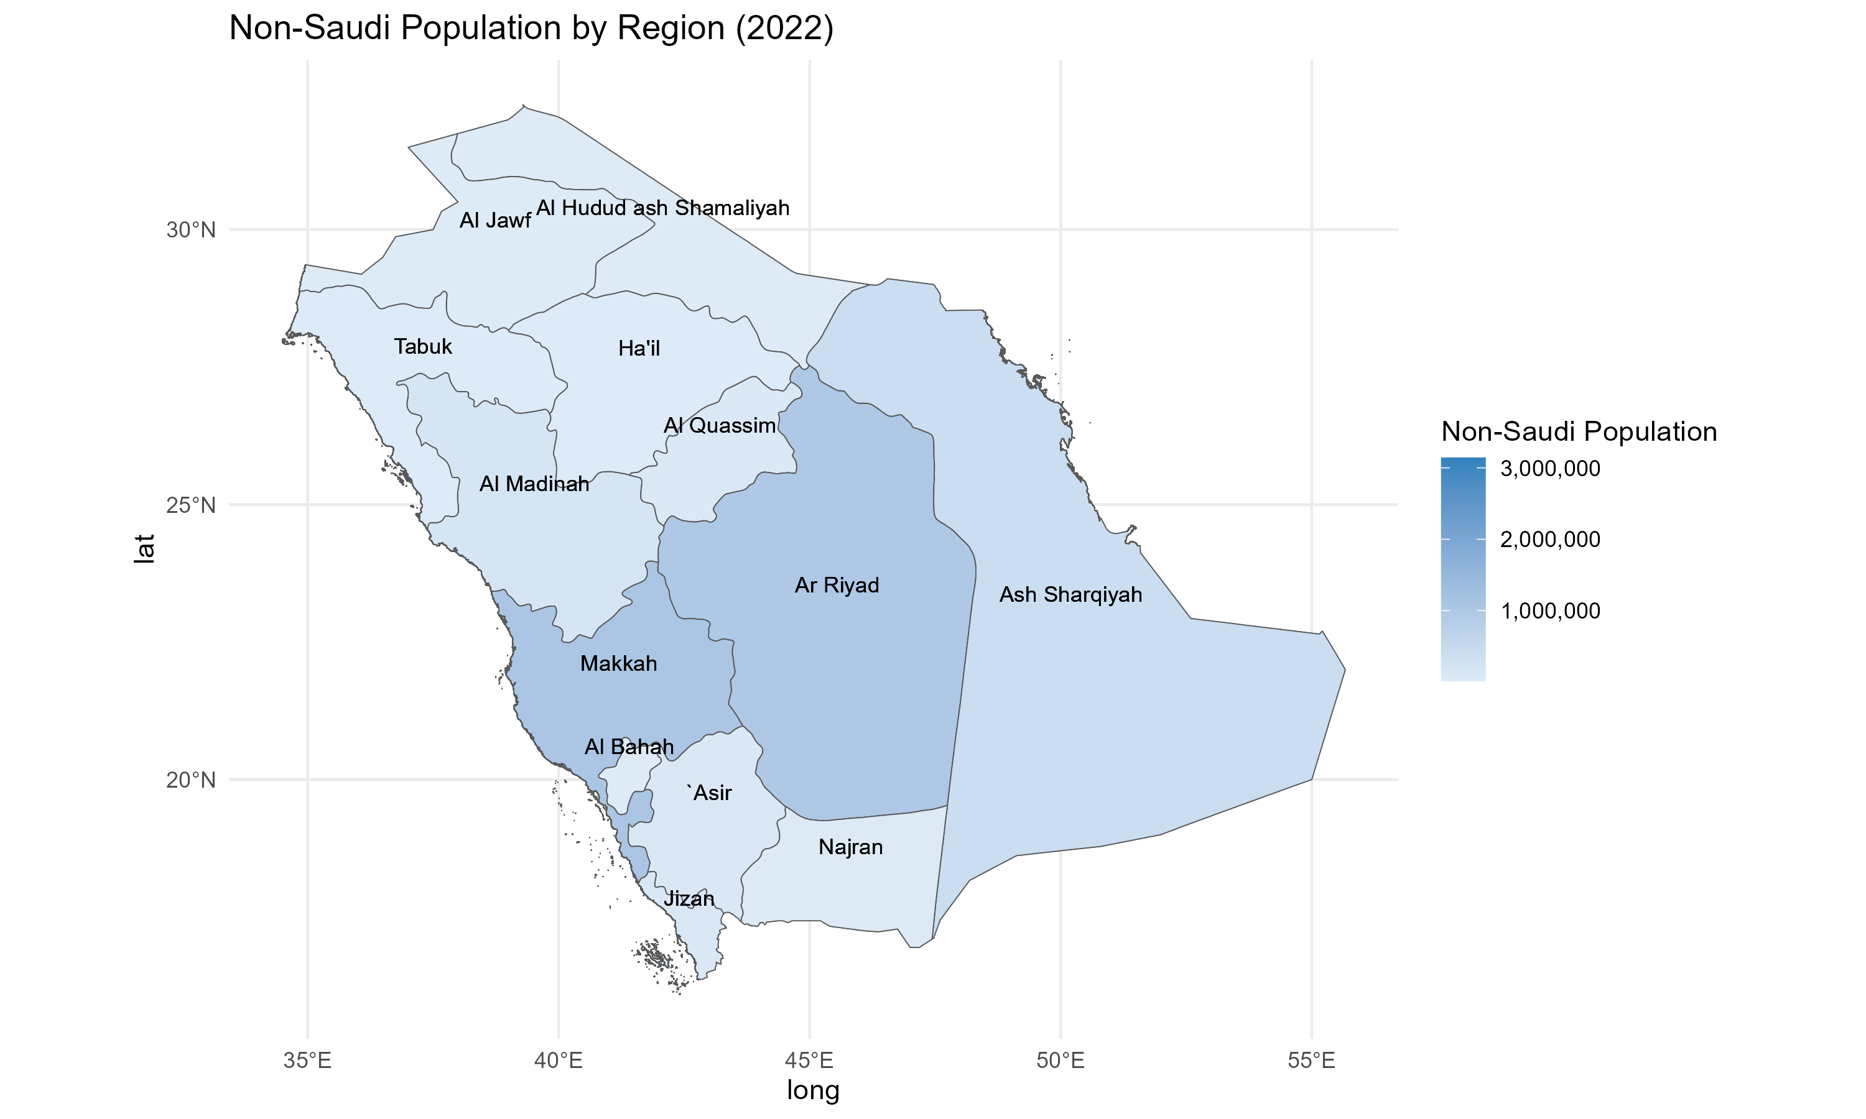  
# Conclusion This report provides insights into Saudi Arabia’s population changes and trends over time using statistical and geospatial analyses.

**Data Source:** [GSTAT Official Website](https://www.stats.gov.sa/en)