# README

QL2465 Qianhuang Li

## Perceptron:

The perceptron learning algorithm (PLA).

Alpha = 1

The weight is [-5, -2, 39]

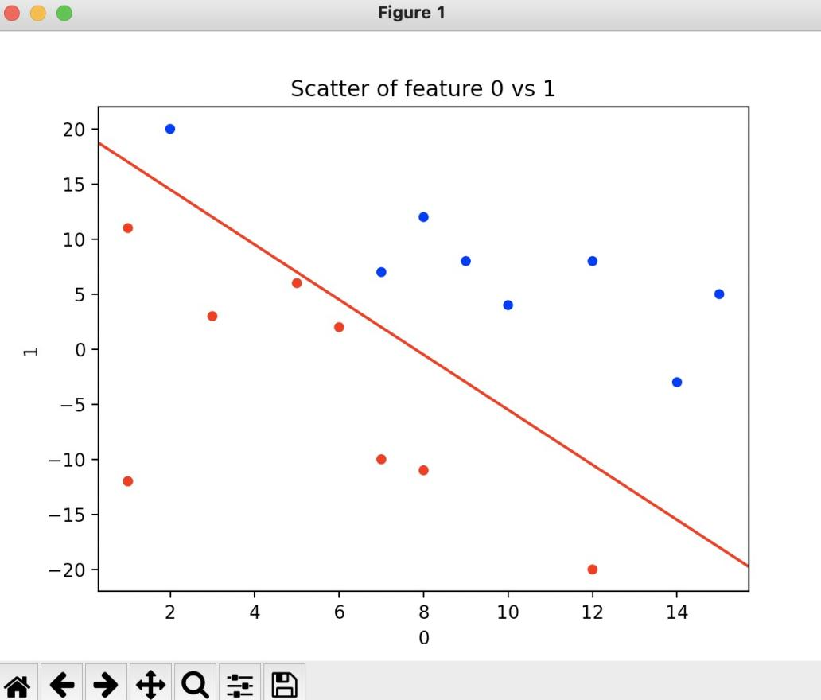

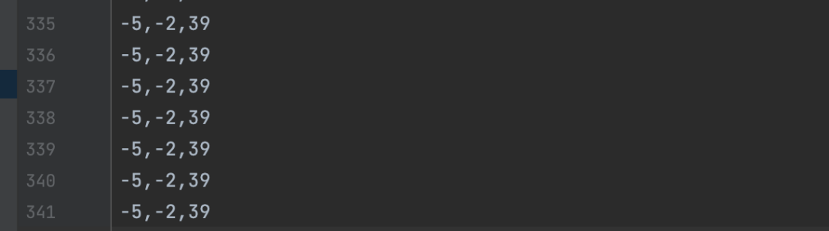

The final decision boundary

**Linear Regression**

Implement linear regression with gradient descent.

The result of ten given alphas after 100 iterations, and calculate starting and final error by the least square method:

Alpha = 0.001, 0.005, 0.01, 0.05, 0.1, 0.5, 1, 5, 10, 0.8

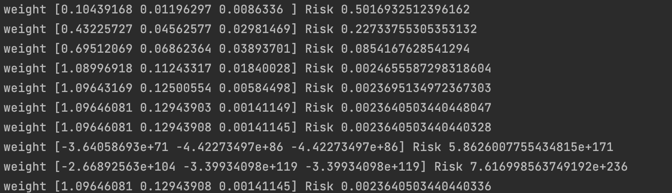

I chose the alpha 0.8 and the iteration of 100

For learning rate, if the learning rate is too small, the converge speed will be slow and can not converge to the optima in 100 iterations. While when the learning rate is too large like alpha= 5 or 10, the step is too big and will jump over the optima and ignore the optima.

For iterations, I think 100 iterations is enough, if the iteration number is too large, there will be over-fitting.

As we can see from above, the Error stay when alpha=0.5 and 1. So I chose alpha = 0.8

And get the Error of 0.0023640

CSV output:

Alpha Iterations w0 w1 w2

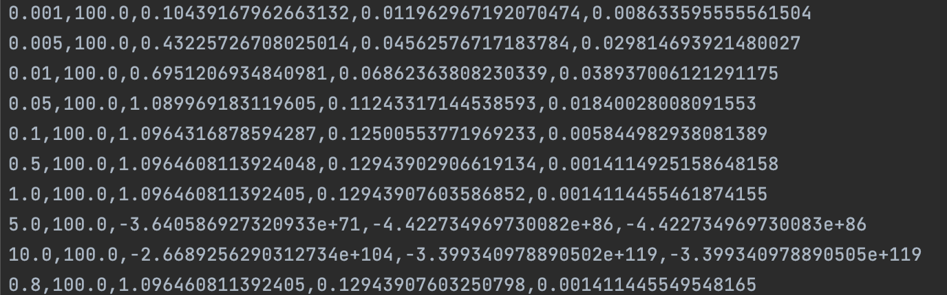

The 3D plots for different alphas (on the next page):

