**Assignment 4**

Qi Le 5674954

**Slp_linear**

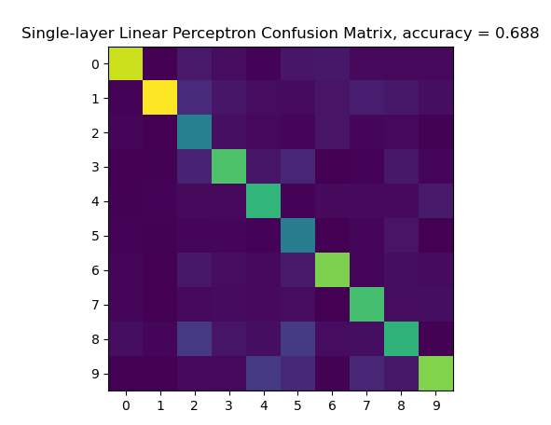

*Figure 1 shows confusion matrix of Single-layer Linear Perceptron.*

We used 4 parameters: learning rate = 0.03, decay rate = 0.8, iterations = 2001, batch size = 32. The learning rate decays per 1000 iterations. The accuracy is 68.8%.

**Slp**

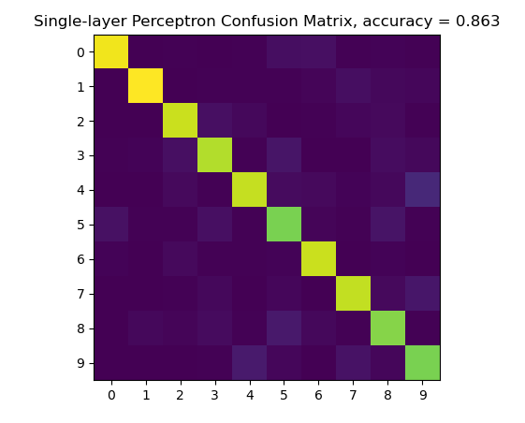

*Figure 2 shows confusion matrix of Single-layer Perceptron*

We used 4 parameters: learning rate = 0.2, decay rate = 0.9, iterations = 2001, batch size = 32. The learning rate decays per 1000 iterations. The accuracy is 86.3%.

**Mlp**

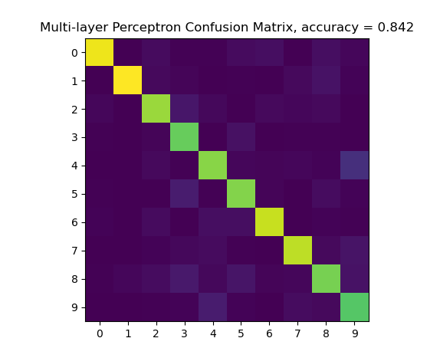

*Figure 3 shows the confusion matrix of Multi-layer Perceptron*

We used 4 parameters: learning rate = 0.23, decay rate = 0.9, iterations = 2500, batch size = 32. The learning rate decays per 1000 iterations. The accuracy is 84.2%

**Cnn**

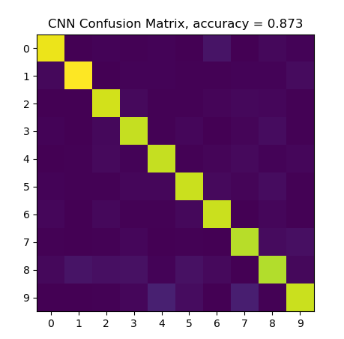

*Figure 4 shows the confusion matrix of Convolutional Neural Network*

We used 4 parameters: learning rate = 0.28, decay rate = 0.9, iterations = 2200, batch size = 32. The learning rate decays per 1000 iterations. The accuracy is 87.3%