**Assignment 5**

Qi Le 5674954

**Sift Feature Matching**

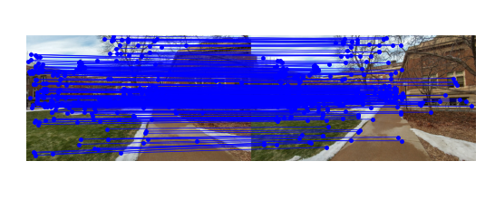

The ratio test is set to 0.7.

**Fundamental Matrix Computation**

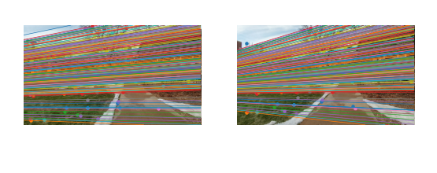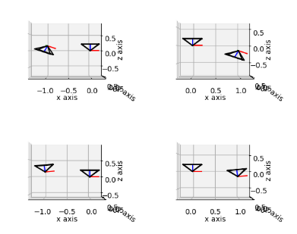

Iterations are 800, and the threshold is 0.1.

**Triangulation**

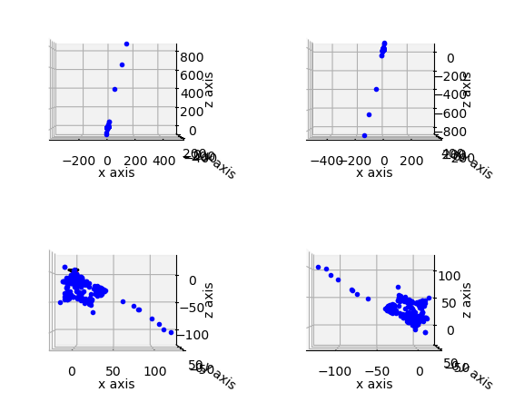

**Pose Disambiguation**

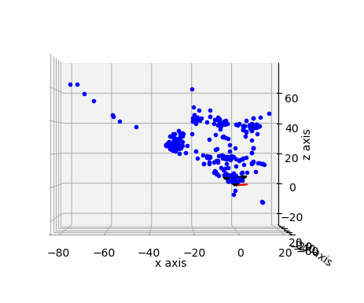

**Stereo**

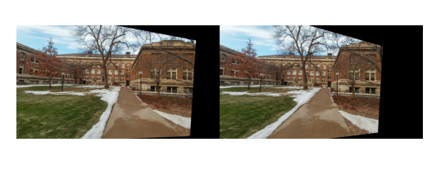

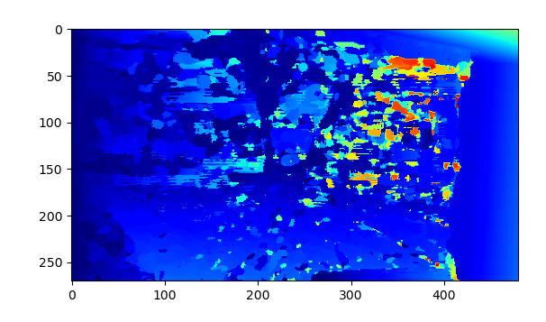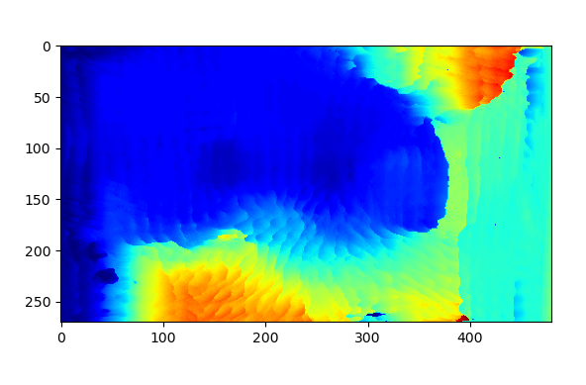

The 2 bottom pictures are the two rectified images. Left picture has keypoint size as 2 and right picture has size 10.