The document about a website illustration , this website is designed to allow clients can book food by requesting servers and servers can response back then deliver it to clients address.

**Functions**:

First there are two types of user, clients are able to register an account and then they can pick whatever they want into menu , and that will be send to sever and saved into databases. Server can check databases update and give an order to restaurants

The website be implemented by Java Server Faces in Eclipse and it connect databases by wampsever software, apache build server . There are multi-webpages that clients search information, change user details and other functions. It will contain Java language and HTML or XAML technical. The databases is constructed by MySql and clients operation will be stored into database tables.

**Information** **of Website**

To make sure website work success, computer should have wampsever and origin database table

Wampsever can be download from [here](http://www.wampserver.com/en/download-wampserver-32bits/) and in case it can’t run ,check your computer to install [vcredist.64](https://www.microsoft.com/en-us/download/details.aspx?id=14632)

Then open cmd and access into Mysql folder : cd 

And import database by typing mysql -u root -p <”database path\database name.sql”

If users want to create own database they can use code like this 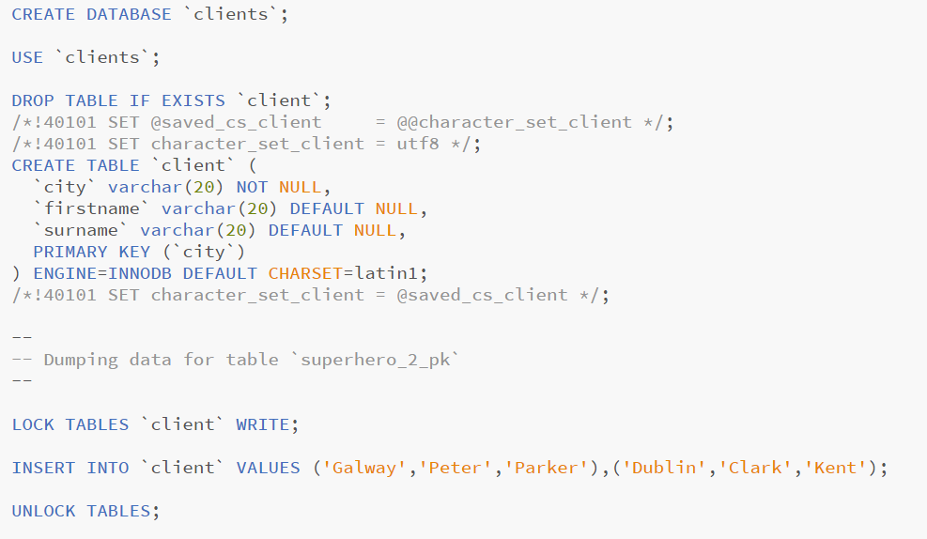

Just remember open wampsever before launch website.

**Details:**

This should be a multi-user system, clients can access it and operate in their devices

All of data will be output as web pages.

This website ask sever create databases previously and clients information will be stored inside