**Application description**

These websites are personal information management system for users to register, delete and other managements

--------Now there are four pages of all project. First is Login page, user can type information into database or create an account to do next steps like update, delete and so on. These values would be stored in databases as a table form. Another page is Purchase page, user input their request such as favourite Book name and author to record in personal information and they would receive delivery of their order from shop if this system apply in business of book sell. One page is User detail present about user like what kind of book their want to have, where their live to make delivery can come true and other information like name, phone and so on. The last page is edit user information like delete or update to make sure data update all the time.

When Login page be opened, it shows a web with four rows about two text labels and input labels, one row is command link to view all user’s details. Last row with two buttons that allows users can login or register into system

--------

Customer page represent all of database from table and it also shows data as a form table type with Username, City, First name, Book name, Book author and action on first row inside table. And all of values will be output according to the column type. Action column contains two command: Delete and Information update. Delete allows delete current row values and if it success would refresh and update current page. Information update make a new page to users input values and save then change it on database.

On Update page, there are five values can be input but only four values can be changed. The last value is confirming username, if this value equal to table value of username then it execute update otherwise keep current values.

**Note**

This is a jsf application, I learned it from course: Data Centric Rad on second semester of 2016-2017

This course assignment was create a jsf project and achieve add, delete and update function but I haven’t finished it before so I want to continue it and try to make new functions like login

To do that I search reference like: http://www.journaldev.com/7068/jsf-database-example-mysql-jdbc and http://www.journaldev.com/7252/jsf-authentication-login-logout-database-example

**Architecture**

The development environment is Eclipse -java EE.Eclipse is an [integrated development environment](https://en.wikipedia.org/wiki/Integrated_development_environment) (IDE) used in [computer programming](https://en.wikipedia.org/wiki/Computer_programming), and is the most widely used Java IDE.[[6]](https://en.wikipedia.org/wiki/Eclipse_(software)#cite_note-6) It contains a base [workspace](https://en.wikipedia.org/wiki/Workspace) and an extensible [plug-in](https://en.wikipedia.org/wiki/Plug-in_(computing)) system for customizing the environment. Eclipse is written mostly in [Java](https://en.wikipedia.org/wiki/Java_(programming_language)) and its primary use is for developing Java applications, but it may also be used to develop applications in other [programming languages](https://en.wikipedia.org/wiki/Programming_language) via plug-ins, including: [Ada](https://en.wikipedia.org/wiki/Ada_(programming_language)), [ABAP](https://en.wikipedia.org/wiki/ABAP), [C](https://en.wikipedia.org/wiki/C_(programming_language)), [C++](https://en.wikipedia.org/wiki/C%2B%2B), [COBOL](https://en.wikipedia.org/wiki/COBOL), [D](https://en.wikipedia.org/wiki/D_(programming_language)), [Fortran](https://en.wikipedia.org/wiki/Fortran), [Haskell](https://en.wikipedia.org/wiki/Haskell_(programming_language)), [JavaScript](https://en.wikipedia.org/wiki/JavaScript), [Julia](https://en.wikipedia.org/wiki/Julia_(programming_language)),[[7]](https://en.wikipedia.org/wiki/Eclipse_(software)#cite_note-7) [Lasso](https://en.wikipedia.org/wiki/Lasso_(programming_language)), [Lua](https://en.wikipedia.org/wiki/Lua_(programming_language)), NATURAL, [Perl](https://en.wikipedia.org/wiki/Perl), [PHP](https://en.wikipedia.org/wiki/PHP), [Prolog](https://en.wikipedia.org/wiki/Prolog), [Python](https://en.wikipedia.org/wiki/Python_(programming_language)), [R](https://en.wikipedia.org/wiki/R_(programming_language)), [Ruby](https://en.wikipedia.org/wiki/Ruby_(programming_language)) (including [Ruby on Rails](https://en.wikipedia.org/wiki/Ruby_on_Rails) framework), [Rust](https://en.wikipedia.org/wiki/Rust_(programming_language)), [Scala](https://en.wikipedia.org/wiki/Scala_(programming_language)), [Clojure](https://en.wikipedia.org/wiki/Clojure), [Groovy](https://en.wikipedia.org/wiki/Groovy_(programming_language)), [Scheme](https://en.wikipedia.org/wiki/Scheme_(programming_language)), and [Erlang](https://en.wikipedia.org/wiki/Erlang_(programming_language)). It can also be used to develop documents with [LaTeX](https://en.wikipedia.org/wiki/LaTeX) (via a TeXlipse plug-in) and packages for the software [Mathematica](https://en.wikipedia.org/wiki/Mathematica). Development environments include the Eclipse Java development tools (JDT) for Java and Scala, Eclipse CDT for C/C++, and Eclipse PDT for PHP, among others.

——reference from WIKIPEDIA

This project is designed as Java Server Faces type. It use java language to program on java files and present it at xhtml files. Xhtml is familiar with html they have same form, layout and widget

There are two packages with three java files and four xhtml pages in this whole application

MySQL play databases role on the whole time. It is an [open-source](https://en.wikipedia.org/wiki/Open-source) [relational database management system](https://en.wikipedia.org/wiki/Relational_database_management_system) (RDBMS).Its name is a combination of "My", the name of co-founder [Michael Widenius](https://en.wikipedia.org/wiki/Michael_Widenius)' daughter,[[8]](https://en.wikipedia.org/wiki/MySQL#cite_note-8) and "[SQL](https://en.wikipedia.org/wiki/SQL)", the abbreviation for [Structured Query Language](https://en.wikipedia.org/wiki/Structured_Query_Language). The MySQL development project has made its [source code](https://en.wikipedia.org/wiki/Source_code) available under the terms of the [GNU General Public License](https://en.wikipedia.org/wiki/GNU_General_Public_License), as well as under a variety of [proprietary](https://en.wikipedia.org/wiki/Proprietary_software) agreements. MySQL was owned and sponsored by a single [for-profit](https://en.wikipedia.org/wiki/Business) firm, the [Swedish](https://en.wikipedia.org/wiki/Sweden) company [MySQL AB](https://en.wikipedia.org/wiki/MySQL_AB), now owned by [Oracle Corporation](https://en.wikipedia.org/wiki/Oracle_Corporation).[[9]](https://en.wikipedia.org/wiki/MySQL#cite_note-sunacquire-9) For proprietary use, several paid editions are available, and offer additional functionality. ——reference from WIKIPEDIA

Programmers use it to build tables in databases for storing data. One database can have several tables inside, and one table also has multiple rows and columns to store information. Every table basic has primary key and only one for one table, it also has foreign key to connect another tables primary key

Apache Tomcat make a bridge between Eclipse and MySQL databases. **Apache Tomcat**, often referred to as **Tomcat Server**, is an open-source [Java Servlet Container](https://en.wikipedia.org/wiki/Servlet_container) developed by the [Apache Software Foundation](https://en.wikipedia.org/wiki/Apache_Software_Foundation) (ASF). Tomcat implements several [Java EE](https://en.wikipedia.org/wiki/Java_Platform,_Enterprise_Edition) specifications including [Java Servlet](https://en.wikipedia.org/wiki/Java_Servlet), [JavaServer Pages](https://en.wikipedia.org/wiki/JavaServer_Pages) (JSP), [Java EL](https://en.wikipedia.org/wiki/Unified_Expression_Language), and [WebSocket](https://en.wikipedia.org/wiki/WebSocket), and provides a "pure [Java](https://en.wikipedia.org/wiki/Java_(programming_language))" [HTTP](https://en.wikipedia.org/wiki/Hypertext_Transfer_Protocol) [web server](https://en.wikipedia.org/wiki/Web_server) environment in which [Java](https://en.wikipedia.org/wiki/Java_(programming_language)) code can run.

In jsf project, Tomcat be used at here to connect sever

**Issues**

√:means issues has solved

This project functions first contain add, delete and update values management on table.

1. Eclipse connect database failed √
2. Delete part had some problems cause data can’t be delete as usual

On java control file, it has method<**public** **void** deleteCustomer(Customer customer)> to control DAO file and it also be control by xhtml command link action =”#{customerControl.deleteCustomer(c)}”.If method of <**public** **void** deleteCustomer(Customer customer)> name “customer” same as action =”#{customerControl.deleteCustomer(c)} value(c), it can’t have right to access databases and change it. √

1. Update value into has some problems in DAO file about <**public** **void** updateCustomer(Customer c)>

Actually no problems in DAO file, the reason of update failed because the action has some mistake, the value inside brackets shouldn’t be “c” C:\Users\Me\AppData\Roaming\Tencent\Users\1441170266\QQ\WinTemp\RichOle\JZUBAP%83ZS[F@UN(OVPHP3.png

On previous xhtml file, delete action is (c) C:\Users\Me\AppData\Roaming\Tencent\Users\1441170266\QQ\WinTemp\RichOle\A%E9NM}T(VAZYH~7[}4DZYC.png

Because it has already set table values as “c” 

But on other pages it keep default setting so correct execute should like this

C:\Users\Me\AppData\Roaming\Tencent\Users\1441170266\QQ\WinTemp\RichOle\)L5U1Q}75SLQEUHQD%KE1]J.png√

1. Login function can not be tested when click login event even it has correct values

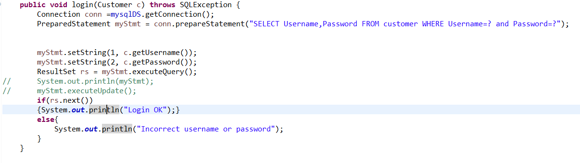

Add a if statement to judge, if values exist then show “Login OK”. If not will show “Incorrect username or password”√

1. Update page one can not display original values on textbox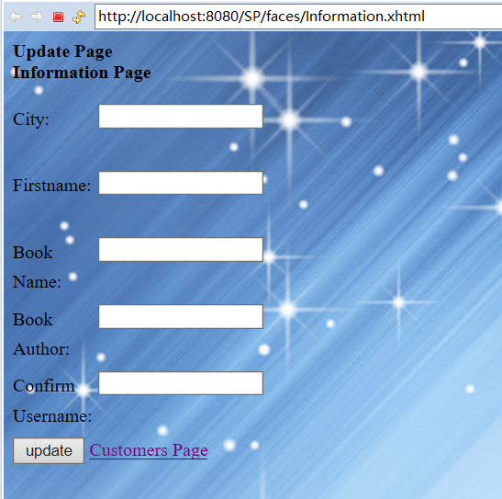

Update page two can show original values when update values but can’t update new values to database

**Data Flow Diagram**

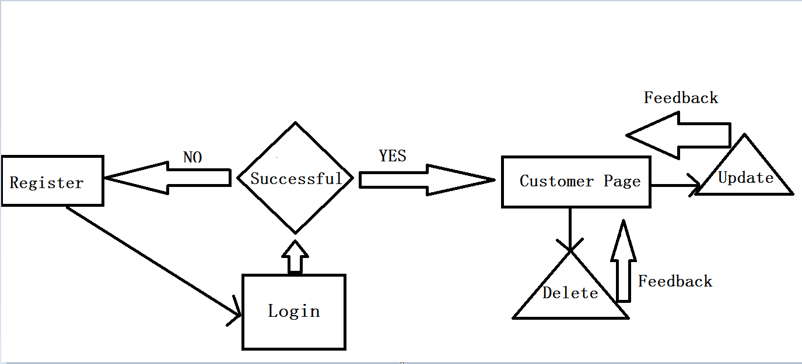

**Data Model**

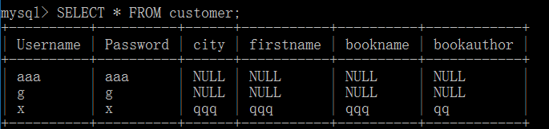

Username is primary key

**Installation guide**

To make sure website work success, computer should have software like

Download [jre file](https://java.com/en/download/help/windows_manual_download.xml) and install, after that [configure environment values](https://www.tutorialspoint.com/java/java_environment_setup.htm)

wampsever and origin database table

Wampsever can be download from [here](http://www.wampserver.com/en/download-wampserver-32bits/) and in case it can’t run ,check your computer to install [vcredist.64](https://www.microsoft.com/en-us/download/details.aspx?id=14632)

Then open cmd and access into Mysql folder : cd 

And import database by typing mysql -u root -p <”database path\database name.sql”

If users want to create own database they can use code like this 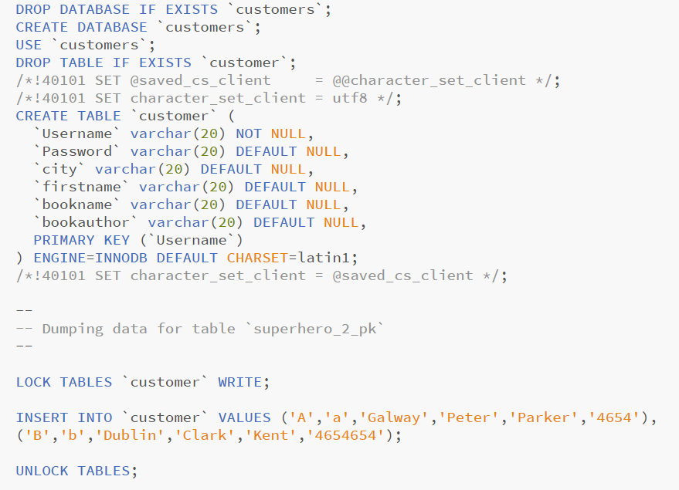

Just remember open wampsever before launch website.

**User Guide**

Open Eclipse and open project, right click Login.xhtml file under web folder and click run on server, then click finish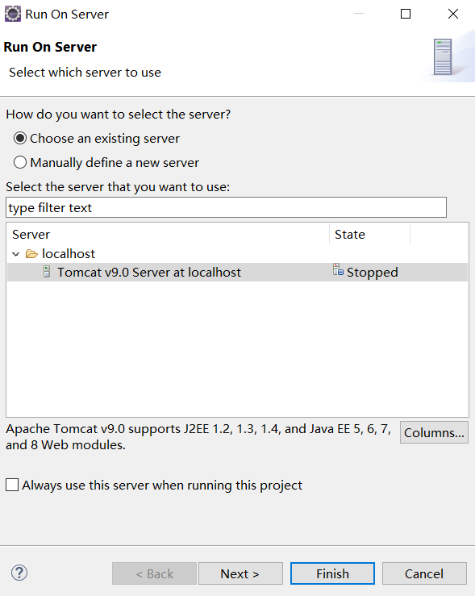

By clicking button and command link can go to new page, edit textbox and click command button to execute operation

GitHub link: https://github.com/QiFuChina/Semester-Project