**Our Interests:** Neural Dynamics, Decision Making, Behavior, Network Modeling, Deep Learning, Reinforcement Learning, Cross-Frequency Coupling

**Our Project (tentatively):** project 7 in *Some Possible Projects.pdf*

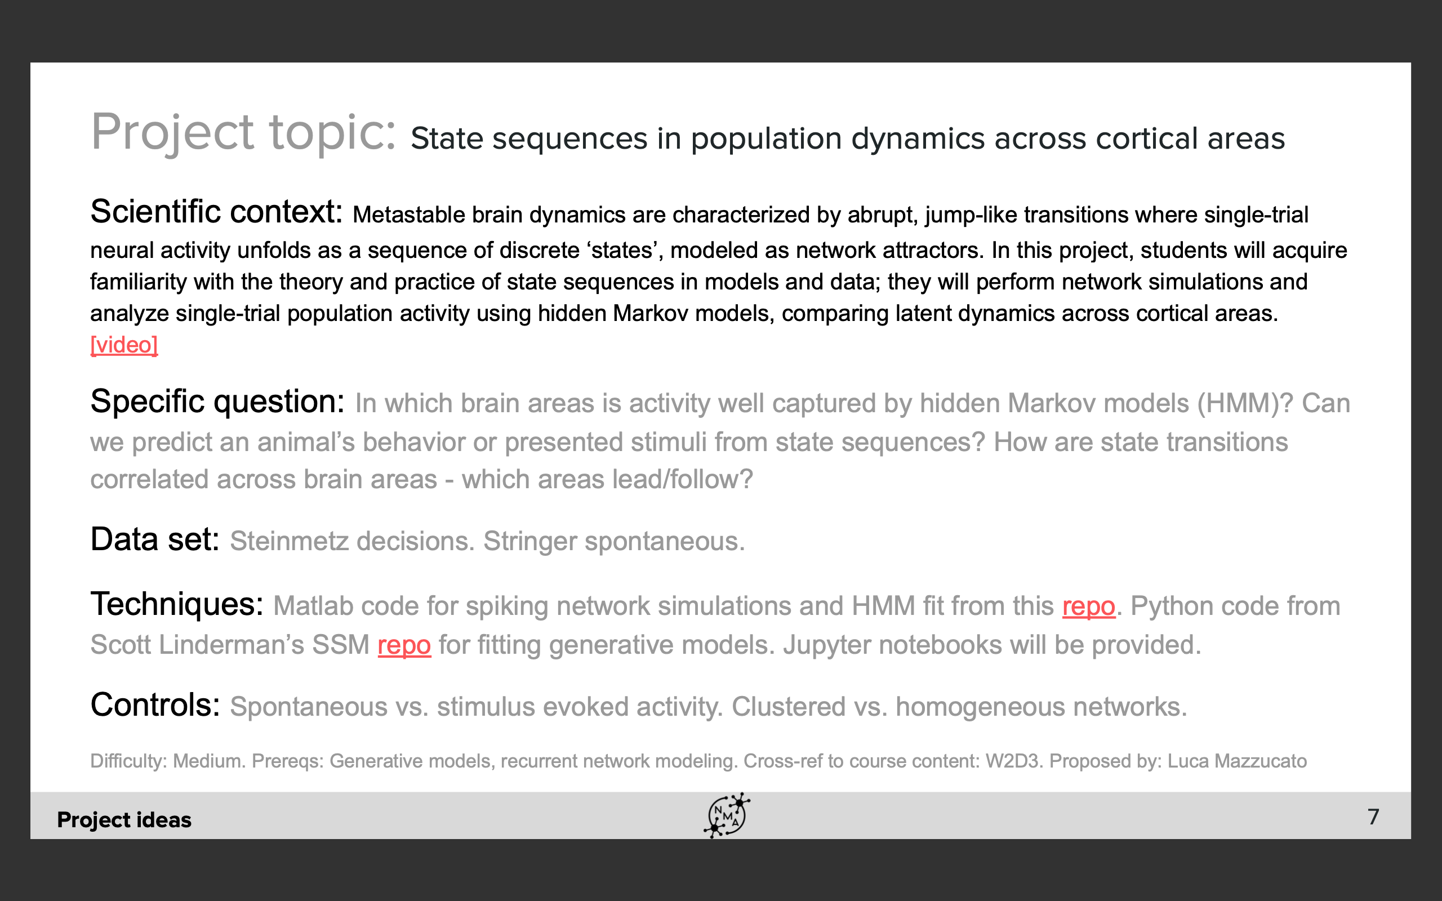

**Background:**

Metastable brain dynamics are characterized by abrupt, jump-like transitions where single-trial neural activity unfolds as a sequence of discrete ‘states’. Metastable activity has been found in many electrophysiological recordings, which resonates with our intuition that our thoughts and actions proceed along a sequence of distinct episodes. Metastable activity can be well analyzed with a hidden Markov model (HMM), and the different state sequences are reliable in different behavior tasks.

**Our Goal:**

1. Found the spikes data with metastable activities.
2. Distinguishing each state (according to the frequency or amplitude characteristics of spikes) and determining the number of states.
3. Determine the state transition sequences (Markov chains) and the state transition probability matrix.
4. Use our Markov chains to predict behavior patterns, comparing them with real data and calculate our model accuracy.