Volunteering Peel Team 2018-2019 Application

|  |  |
| --- | --- |
| **Name** |  |
| **Primary Phone #** |  |
| **Secondary Phone #** |  |
| **E-mail Address** |  |
| **School** |  |
| **Grade** |  |

**Please answer each question below in 150 words or less unless otherwise stated.**

1. In under 5 words, describe what volunteering means to you.
2. What does a typical week in your life look like? (i.e. Monday’s and Thursday’s I have band practice from 3pm-4pm. On Saturday mornings I go to Saturday school from 9am-1pm). Please list all activities in **point form**.
3. Describe a volunteering experience you’ve had in the past. If you haven’t, what kind of teamwork experience have you had in the past (volunteer, clubs, sports etc.)? Briefly describe what you enjoyed and what could be improved.
4. What skills can you bring towards Volunteering Peel?

(Optional) Please answer **one** of the two following questions:

**5a)** There has been a murder! Use the clues from the following picture to explain who you think is the murderer and explain your thought process.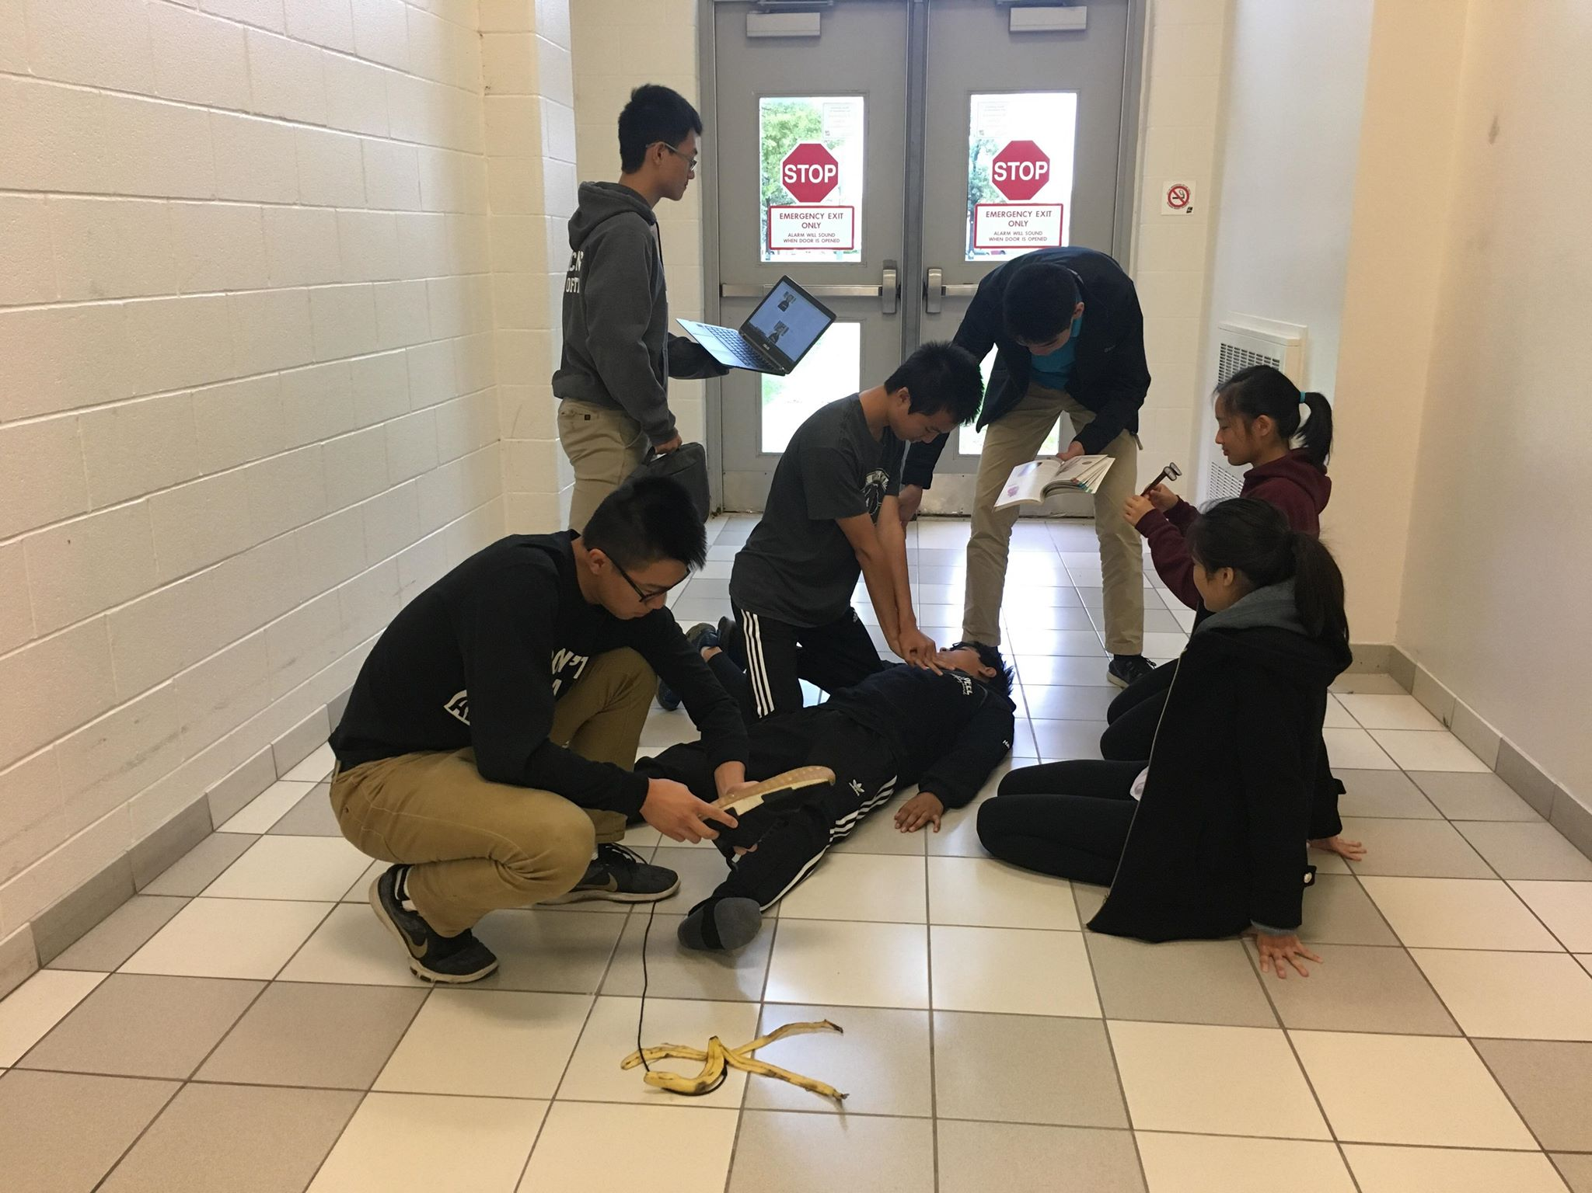

**5b)** What would you tell your 10 year old self?

**About Us:**

Volunteering Peel is a student-run, non-profit organization. Our mission is to provide the students of Peel Region a fun way to volunteer, and earn their community service hours. As a Volunteering Peel Executive, you need to **commit 3-5 hours per week minimum**. Due to a long training process from being committee member to an executive member, **Volunteering Peel accepts applications from only Grade 9 and Grade 10 high school students. We also expect you to remain in the Executive Team with an active leadership role for the rest of high school.**

**\*NOTE**: All applications are to be emailed to [info@volunteeringpeel.org](mailto:info@volunteeringpeel.org) with your **“First Name Last Name”** in PDF format, as the subject matter by 11:59PM on OCTOBER 27th, 2018. Please leave it as size 12 Cambria font. **LATE APPLICATIONS WILL NOT BE ACCEPTED!\***

Thank you very much for your application! We will be emailing all applicants in early November regarding the status of your application. If you have any questions, please don’t hesitate to contact us.

Be updated on Volunteering Peel by “liking” us on Facebook (<https://www.facebook.com/VolunteeringPeel>) or following us on Twitter (@VolunPeel)!