DSM2 Time-Varying Input

The usage of DSM2 Time-Varying (time series) input is determined by DSM2 Fixed Input files. The fixed input files determine which data sets are used, and where they are used in the model grid. The user should not assume that all time series data sets are used by every study.

The following DSM2 input identifies the input files that determine how the DSM2 time-varying input data sets are used by the model:

HYDRO_TIME_SERIES  
${DSM2INPUTDIR}/boundary_flow_delta_historical.inp       #20090715  
${DSM2INPUTDIR}/source_flow_delta_historical.inp         #20121214 #CCWP intake starting from 08/01/2010 - Lan  
${DSM2INPUTDIR}/boundary_stage_delta_historical.inp      #20090715  
${DSM2INPUTDIR}/source_flow_dcd_historical_daily.inp     #20130111 replaced by DCD daily values 5/20/2014  
${DSM2INPUTDIR}/source_flow_jones_hydro.inp              #20090806  
${DSM2INPUTDIR}/source_flow_scd_historical_daily.inp     #20190717 suisun marsh CD daily  
END

Note: **${DSM2INPUTDIR}** is an environment variable that points to the **common_input/** folder.

|  |  |  |
| --- | --- | --- |
|  | Content | File |
| Target | Observed salinity at key stations in Delta | ec_postpro_merged.dss |
| **Input** | Major boundary upstream flows and downstream stages | hist201912.dss |
| Facilities operations | gates-v8-201912.dss |
| Consumptive usage (flow and salinity)  DCD: Delta east of Chipps  SMCD: Suisun marsh | Delta_DCD_Sep2020_Lch5.dss |
| dicuwq_3vals_extended.dss |
| SMCD_hist_Sep2020.dss |
| SMCD_wq_ec_hist_plan.dss |
| Events not occurring every year* | events.dss |

As of 9/2021, the only event represented by the data in the events.dss file is the [Jones Tract levee breach](https://baydeltalive.com/assets/c5f67c17ca965d44d6e39c3bc257f5c8/application/pdf/2005Ch3.pdf), which occurred in 2004. This resulted in the flooding, and eventual repair and draining of Jones Tract.

**Boundary Input Data**

DSM2-Hydro is the DSM2 hydrodynamics model.

Boundary inputs to Hydro are flow rates at upstream locations and stage (water level) at the downstream boundary at Martinez (see Fig. 1).

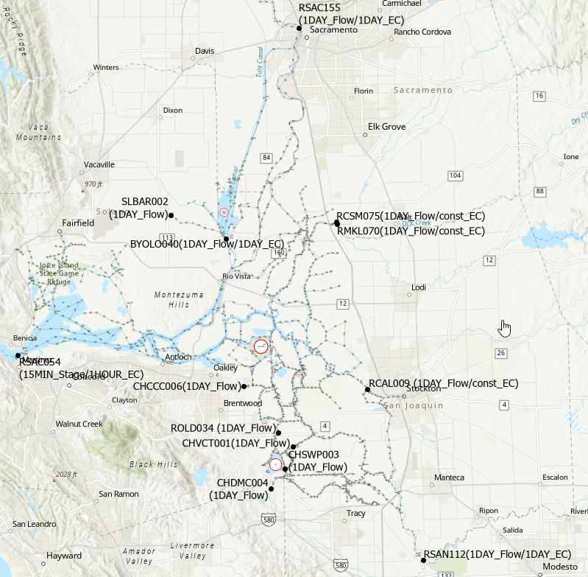Figure 1: Map of Delta showing DSM2 boundary input locations and data types

Hydro creates a tidefile (HDF5 format), which is used as input for Qual and GTM, the DSM2 water quality models. Hydro can also write output to HEC-DSS files.

**Consumptive Use**

Agriculture on Delta islands affects both hydrodynamics and water quality. DSM2 uses output from the following consumptive use models:

* DICU (Delta Island Consumptive Use),
* DCD (Delta Channel Depletion), and
* SMCD (Suisun Marsh Channel Depletion). Consumptive use models simulate the transfers of water from the river channels to Delta islands and back, based upon weather and land use (crop type) data.

Consumptive use model output flow rates are categorized as follows:

* Diversions (DIV): Water pumped from the channel onto an island for irrigation.
* Drainages (DRAIN): Water drained from the island back to the river channel. This quality of this water typically has higher levels of water quality constituents, including salts.
* Seepages (SEEP): Water that seeps into the soil from the river channel.

Diversions and seepages can be added together before being input into Hydro. However, drainage flows must be kept separate because they are used by water quality models.

Hydro applies the consumptive use flows to nodes in the model grid.

**Gate Operation**

Gates are structures that partially or completely restrict flow in a body of water. There are different types of DSM2 input that control the operation of gates. The types of input used for each gate can vary, depending upon the type of study. The configuration and operation of gates are determined by the following types of inputs:

* DSS: for time series data. The file gates-v8-201912.dss is used by DSM2 v8.2.1, historical version.
* Operating Rules: rules that determine when gates are installed and how they operate (change their configuration with time).
* Fixed gate input files
  + The fixed gate input files in the DSM2 v8.2.1 historical setup are:
    - common_input/oprule_historical_gate.inp
    - common_input/gate_std_delta_grid.inp