Assignment1

Zhiqi Qi

2017年4月26日

# Climate Research on Month or Year

clim=read.table("clim.txt", header = TRUE)  
  
# Monthly Average Temperature Boxplot  
View(clim)  
Aggdat <- aggregate(clim,by=list(clim$month,clim$year),FUN="mean")  
Aggdat$mean <- (Aggdat$tmin+Aggdat$tmax)/2  
  
boxplot(Aggdat$mean~Aggdat$month,  
 ylab="Average Temperature from 1942 to 2016",  
 xlab="Month", col="orange")

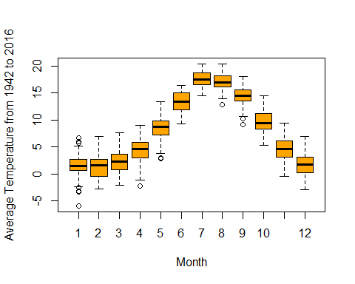

# Monthly Precipitation Boxplot   
clim2 <- clim[,2:7]  
Agg2 <- aggregate(clim2, by=list(clim2$month,clim2$year), FUN="sum")  
  
boxplot(Agg2$rain~Aggdat$month,  
 ylab="Precipitation from 1942 to 2016",  
 xlab="Month", col="blue")

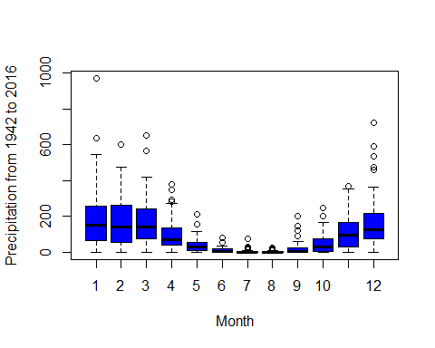

# Aggregate precipitation by year  
Agg3<- aggregate(clim2, by=list(clim2$year), FUN="sum")  
  
#Wettest Year  
wettest=which.max(Agg3$rain)  
Agg3[wettest,]

## Group.1 tmin tmax rain year month day  
## 41 1982 542.4546 4389.394 2135.378 723430 2382 5738

Agg3[wettest,c("Group.1","rain")]

## Group.1 rain  
## 41 1982 2135.378

Agg3$year=as.integer(Agg3$Group.1)  
Agg3$rain=as.integer(Agg3$rain)  
Agg3[wettest,c("year","rain")]

## year rain  
## 41 1982 2135

#Driest Year  
driest=which.min(Agg3$rain)  
Agg3[driest,]

## Group.1 tmin tmax rain year month day  
## 72 2013 1063.958 5699.356 263 2013 2382 5738

Agg3[driest,c("Group.1","rain")]

## Group.1 rain  
## 72 2013 263

Agg3$year=as.integer(Agg3$Group.1)  
Agg3$rain=as.integer(Agg3$rain)  
Agg3[driest,c("year","rain")]

## year rain  
## 72 2013 263

## Scenery in Wet Year

## Scenery in dry year

```

# Climate Research on Season

#Season  
clim2$Season <- ifelse(clim2$month <= 5 & clim2$month >= 3, 1, ifelse(clim2$month <= 8, 2,(ifelse(clim2$month <= 11, 3, 4))))  
  
#Wettest Season  
Agg4<- aggregate(clim2,by=list(clim2$Season,clim2$year),FUN="sum")  
  
wet=which.max(Agg4$rain)  
Agg4[wet,]

## Group.1 Group.2 tmin tmax rain year month day Season  
## 110 2 1969 607.7778 2316.667 1507.998 297319 732 2359 302

Agg4[wet,c("Group.1","Group.2","rain")]

## Group.1 Group.2 rain  
## 110 2 1969 1507.998

Agg4$Season=as.integer(Agg4$Group.1)  
Agg4$year=as.integer(Agg4$Group.2)  
Agg4$rain=as.integer(Agg4$rain)  
Agg4[wet,c("Season","year","rain")]

## Season year rain  
## 110 2 1969 1507

#Driest Year  
dry=which.min(Agg4$rain)  
Agg4[dry,]

## Group.1 Group.2 tmin tmax rain year month day Season  
## 84 4 1962 4.444444 307.7778 0 1962 372 496 4

Agg4[dry,c("Group.1","Group.2","rain")]

## Group.1 Group.2 rain  
## 84 4 1962 0

Agg4$Season=as.integer(Agg4$Group.1)  
Agg4$year=as.integer(Agg4$Group.2)  
Agg4$rain=as.integer(Agg4$rain)  
Agg4[dry,c("Season","year","rain")]

## Season year rain  
## 84 4 1962 0

## Relationship between Precipitation and Temperature   
Agg5 <- aggregate(clim2, by=list(clim2$Season, clim2$year), FUN="mean")  
Agg5$Temperature <- (Agg5$tmax + Agg5$tmin)/2  
SummerT <- subset(Agg5, Season == 2)  
ST <- SummerT[,c(2,10)]  
colnames(ST) <- c("Year", "Temperature")  
WinterP <- subset(Agg5, Season == 4)  
WP <- WinterP[,c(2,5)]  
colnames(WP) <- c("Year", "Precipitation")  
Relation <- merge(ST, WP,by="Year")  
  
library(ggplot2)  
ggplot(Relation, aes(Temperature, Precipitation))+  
 geom_point(size=1, aes(color=Temperature))+  
 geom_smooth(data=Relation,aes(Temperature, Precipitation,color=Temperature),method=lm,se=FALSE)+  
 xlab("Temperature")+  
 ylab("Precipitation")+  
 ggtitle("Relationship between Winter Precipitation and Summer Temperature \n1942-2016")+  
 theme_bw()+  
 theme(text=element_text(family="Times", size=14),panel.grid.major=element_blank(),panel.grid.minor=element_blank(), axis.title.x=element_text(size=12), axis.title.y=element_text(size=12))+  
 theme(legend.position=c(0.1,0.7),legend.box=NULL, legend.key=element_blank(), legend.text=element_text(size=9), legend.title=element_blank())

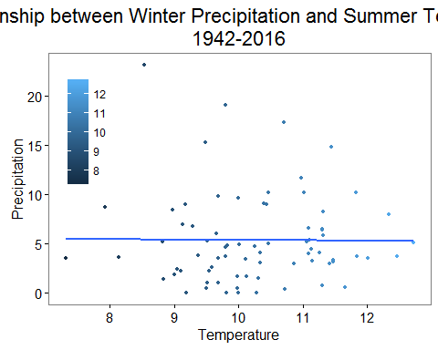

#Figure Comment   
#Graph shows that there is not too obvious relation between winter precipitation and summer temperature. The regression line shows a flat curve so it means the winter precipitation cannot be affected no matter how summer temperature changes.Better understand this relationship between summer temperature and winter precipitation can help scientist forecast climte and response to the unexpected climate change.