Project Proposal

Clinical Trials - Lung Cancer
Prepared for: Lakeridge Health - Natascha

Durham college Contemporary web design students
Prepared by: Qian Ma, Caleb Bathurst, Prabhjot Singh, Sophie Quan, Abhay Vincent
January 13, 2020

LUNG CANCER CLINICAL TRAILs

Objective
The purpose of this project is to create an interface application for physicians determine the eligible of the patients. The concept will base on the pre-screening process in other to determine initial eligibility for and interest in study. All of the input information and data will base on the Lakeridge Health research data.

Goals
- For Tablets or desktop devices use
- Responsive for all devices.
- Design concept: colour scheme will be based on Lakeridge health official website.
- Ensure to meet accessibility requirements from layout, colour scheme, font size, and so on…
- Create a friendly, easy to use, responsive and usable app.

Layout
The application includes 4 main components:
Splash screen
Where the Lakeridge Health logo appears with some basic animations to attract the users.
Input screen
Where the users/physicians input patients name and age to start the research study
Main screen
Where the Lung cancer flow chart will be implemented into buttons, users/physicians would tap/ touch to go to the next options that applicable to the research they are looking for.
Output screen/ closing screen:
There are 2 options for this screen
- Prints out a report: a report will print out as a pdf file.
- Use database connect to the server to stored the information
*as the timing consideration, the database options may need more time to implement. A hosting server or cloud storage can also be used to archive data.

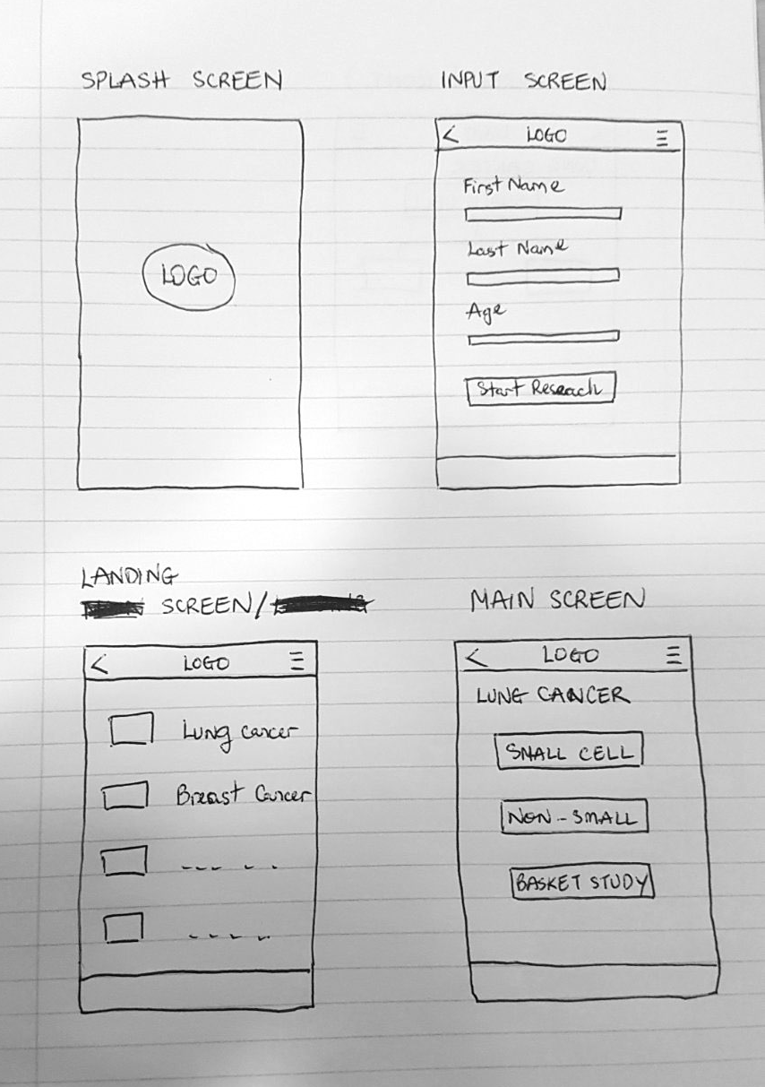
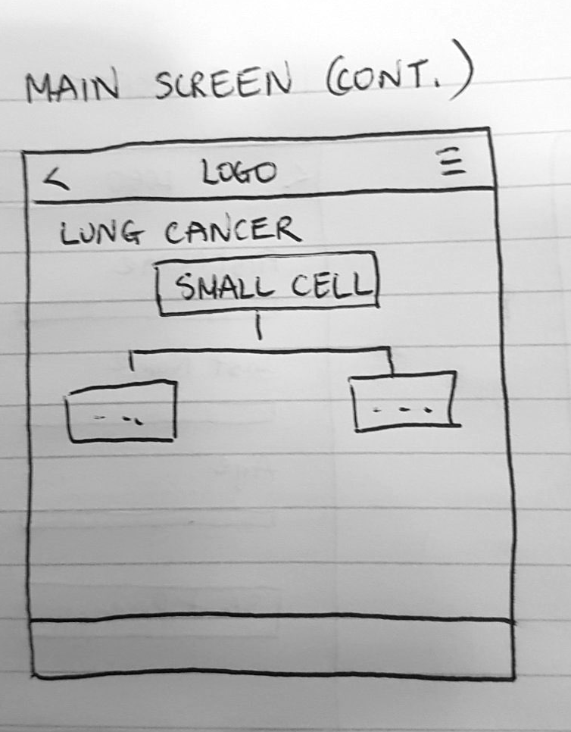
Rough Layout

Timeline
Week | Process/ goal achievements
Week 2 (Jan 13) | Design comp and layout
Week 3 (Jan 20) | Design comp and layout
Week 4 (Jan 27) | Logical Coding
Week 5 (Feb 3) | Logical Coding
Week 6 (Feb 10) | Logical Coding
Week 7 (Feb 17) | Animation
Week 8 (Feb 24) | Animation
Week 9 (Mar 2) | Animation
Week 10 (Mar 9) | Testing
Week 11 (Mar 16) | Final finalize

- Testing is mandatory for the whole process to ensure the app work out for all target devices.

Clinical Trials Proposal

