*Nom _________

*Phone_________

*Email ________

*Date ________

Ville de depart _______

Ville de destination ______

Submit**Additional info**

**Workers _____**

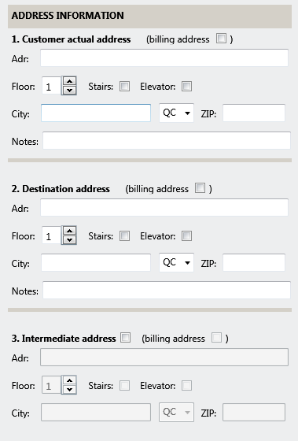

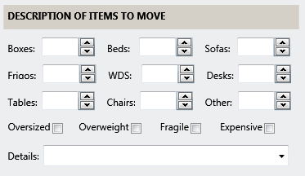

Message_______________________

**Attach photo**

Submit

Contact

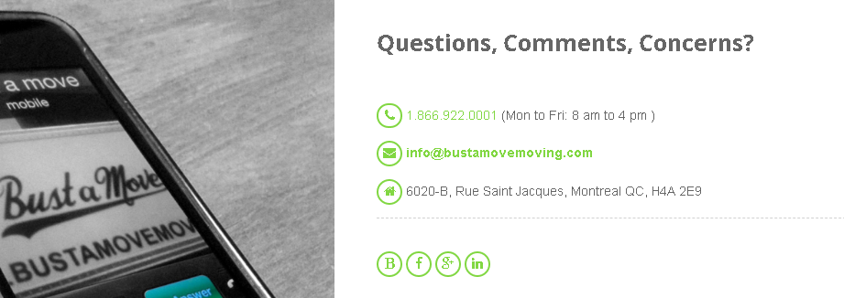

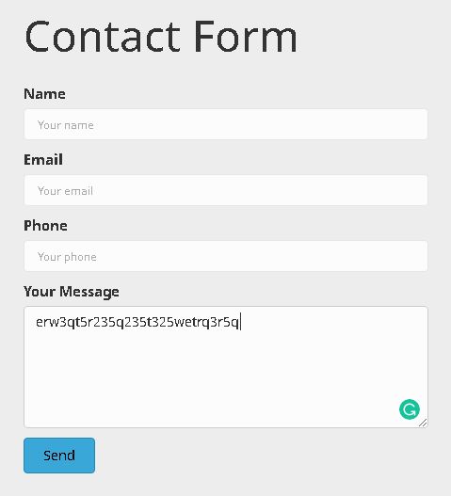

**Easy Move**

