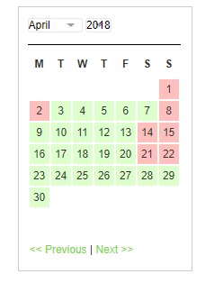2 – languages

Google + Facebook + In?

Slogan - ???

Logo +++

Get your free estimate now

User can see available dates (data will be taken from database)

# Home

## Header

### Picture

### Insurance

### Google rewiews (API maybe)

## Footer

# Moving

# Storage

OR

# (Services)

# Contact

# About