Schema – easy move 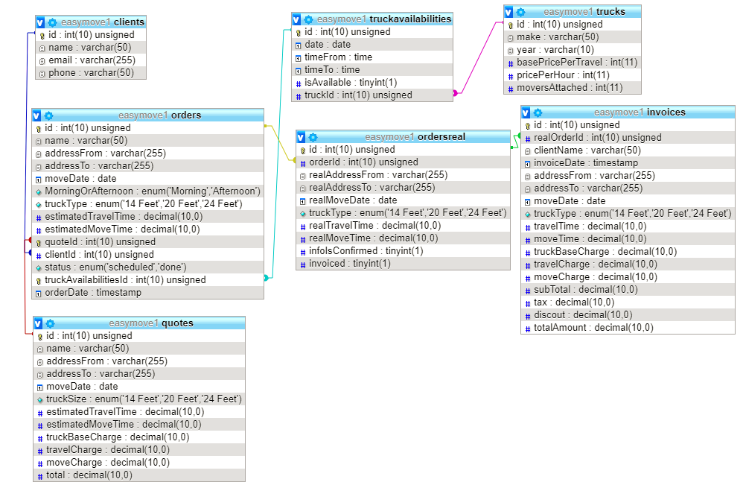

**Price structure domestic**

|  |  |  |  |
| --- | --- | --- | --- |
| Truck type | Truck base price | Truck travel price by hour | Movers by hour |
| 14 Feet | $50 | $50 | $60 *2 |
| 20 Feet | $100 | $60 | $60 *2 |
| 24 Feet | $120 | $80 | $60 *2 |

Assume this company has each type one truck and by default, there will be two movers to work with one truck.

**Quote total** = truck base price + travel price by hour * estimated hours + $120 * estimated move hours

**Business logic**

Prospect client can ask quote, quote will be saved to database.

At this point, prospect client can choose continue to place order based on quote or choose not to do anything.

When they choose to place order, the quote details will be showed on order, which can be modified by client before submit the order. Also the client details will be asked at this stage, and order will be saved to order table, client details will be saved to clients table.

If a client place an order without ask for quote, the quote will be generated once the order is placed.

Order has two status : scheduled, done.

When order status is done, this should trigger the entry to table ordersreal which basically takes all the information from order. But certain fields need to be updated and verified to reflect the reality such as travel time and move time. And if everything is confirmed, the ordersreal infos confirmed field will be set to true and invoice can be generated. When invoice is generated, in ordersreal the invoiced field will be set to true.

When clients place order, ideally they can see the calendar or table with available dates.

Truck availability, will be entered in the database, each truck will have two availabilities as morning session, afternoon session for each day.

Truck availability to order is one to one relation, once an availability is taken, field isAvailable is set to false.