    Joint Collaborative Team on Video Coding (JCT-VC)  of ITU-T SG16 WP3 and ISO/IEC JTC1/SC29/WG11  8th Meeting: San José, CA, USA, 1–10 February, 2012 | Document: JCTVC-H1001

Title: | HEVC software guidelines
Status: | Input Document to JCT-VC
Purpose: | Guideline
Author(s) or  Contact(s): | Karsten Sühring (Fraunhofer HHI)  David Flynn (BBC)  Frank Bossen (DOCOMO Innovations) | Email: | karsten.suehring@hhi.fraunhofer.de  davidf@rd.bbc.co.uk  bossen@docomoinnovations.com
Source: | AHG chairs
_____________________________

Software guidelines for the HEVC reference software

The use of the following rules is mandatory for all software implementation work. Changes that don’t comply with these rules will not be accepted by the software coordinators.

License

Copyright/License statements

Copyright disclaimers shall not be altered. When adding a file, the same copyright disclaimer, as reproduced below, shall be included at the beginning of the file.
/* The copyright in this software is being made available under the BSD
* License, included below. This software may be subject to other third party
* and contributor rights, including patent rights, and no such rights are
* granted under this license.
*
* Copyright (c) 2010-2012, ITU/ISO/IEC
* All rights reserved.
*
* Redistribution and use in source and binary forms, with or without
* modification, are permitted provided that the following conditions are met:
*
* * Redistributions of source code must retain the above copyright notice,
* this list of conditions and the following disclaimer.
* * Redistributions in binary form must reproduce the above copyright notice,
* this list of conditions and the following disclaimer in the documentation
* and/or other materials provided with the distribution.
* * Neither the name of the ITU/ISO/IEC nor the names of its contributors may
* be used to endorse or promote products derived from this software without
* specific prior written permission.
*
* THIS SOFTWARE IS PROVIDED BY THE COPYRIGHT HOLDERS AND CONTRIBUTORS "AS IS"
* AND ANY EXPRESS OR IMPLIED WARRANTIES, INCLUDING, BUT NOT LIMITED TO, THE
* IMPLIED WARRANTIES OF MERCHANTABILITY AND FITNESS FOR A PARTICULAR PURPOSE
* ARE DISCLAIMED. IN NO EVENT SHALL THE COPYRIGHT HOLDER OR CONTRIBUTORS
* BE LIABLE FOR ANY DIRECT, INDIRECT, INCIDENTAL, SPECIAL, EXEMPLARY, OR
* CONSEQUENTIAL DAMAGES (INCLUDING, BUT NOT LIMITED TO, PROCUREMENT OF
* SUBSTITUTE GOODS OR SERVICES; LOSS OF USE, DATA, OR PROFITS; OR BUSINESS
* INTERRUPTION) HOWEVER CAUSED AND ON ANY THEORY OF LIABILITY, WHETHER IN
* CONTRACT, STRICT LIABILITY, OR TORT (INCLUDING NEGLIGENCE OR OTHERWISE)
* ARISING IN ANY WAY OUT OF THE USE OF THIS SOFTWARE, EVEN IF ADVISED OF
* THE POSSIBILITY OF SUCH DAMAGE.
*/

Syntax usage

Language

Use C++.

Templates

Do not make excessive usage of templates. Use them only for simple functions like min() or max() which are easy to understand and where code duplication can be avoided.

Pre-processor macros

Do not use #define for function definitions. Use (static or static inline) functions instead. They are much less prone to logical errors and compilers can even better optimize them.

Do not use #define to encapsulate bug fixes. If bug fixes ever need to be removed again, they can be tracked back using the revision control system (see paragraph 7.1).

Avoid using #define for simply enabling or disabling a tool. Use a config file option instead unless the check would significantly slow down the code.

Header multiple include safety

All header files will include a mechanism to prevent multiple inclusion by using a #define. The name of the #define is created using the prefix '_HM_', the header file name in capital letters and a trailing underscore. All special characters in the file name are replaced by underscores.
For a header file named myheader.h the structure would be the following:
#ifndef _HM_MYHEADER_H_
#define _HM_MYHEADER_H_
<content of header file>
#endif

private and protected

Make member variables and methods as private as possible. Only methods that have to be called from outside should be public. Member variables should always be private.

Data types

Use the basic types defined in TypeDef.h (e.g., Char, Int, etc.)

Use the Int type for integer variables unless there is a good reason not to (e.g., excessive memory usage). Avoid using unsigned types as they can be a source of bugs (e.g., when comparing signed with unsigned integers).

Do not use the Long type as its width is not machine-independent (may be 32 or 64 bits wide). If a 64-bit variable is required, use type Int64.

Unused code

Unused code will be completely removed from the source code. Commenting out (or using #defines that evaluate to false) is not allowed. Old revisions are still available in the revision control system.

Code duplication

Avoid duplication of code. Define functions where appropriate, and localize the scope of #defines as much as possible.

Optimizations

Do not try to do the compiler’s work by trying to optimize the code. Make the code easy to read and maintain.

Avoid usage of explicit function inlining (__inline), and define functions and methods in .cpp files unless they are really short.

Naming

General

Classes, methods, functions and variables shall be given descriptive and meaningful names describing their functionality and purpose.

All type names (classes, structs, enums, unions, typedefs) shall be named using nouns and have an initial upper-case letter.

Methods and functions shall be named using verbs describing the activity and have an initial lower-case letter.

Variable names must have an initial lower-case letter.

Do not use type prefixes (like iVar, uiVar, etc.) on new variable names. These tend to be confusing if the data type changes and the variable is not renamed (e.g. if it is used differently depending on different macros).

In all cases, “Camel Case” shall be used to connect multiple words, where each subsequent word in a name starts with an upper-case letter.
Example:
class CodingTool
{
Void doSomething()
{
<code here>
}

Void* m_privateMember;
};

const Int[] g_someTable = { 1, 2, 3, 4 };

Global variables shall be named using the prefix ‘g_’.

Member variables shall be named using the prefix ‘m_’.
Example:
UInt g_globalVariable;

struct Foo
{
Int m_memberVariable;
}

Formatting

Indentation

All code blocks that are included into braces have to be indented by two (2) space characters. Tabulator (TAB) characters are never used.
Example:
Void doSomething()
{
<code here>
}

Usage and placement of braces

Code following conditionals (e.g. if, else, do, while) shall always be enclosed in braces, even if it is only a single statement.

The opening brace is placed on a new line on the same indentation level as the defining keyword (e.g. void, if, for, while, etc.). The included code block starts at the following line and is indented. The closing brace is placed on the same indentation level as the opening brace.
Example:
Void doSomething ()
{
if (<expression>)
{
<code here>
}
}

Code comments

General

Do not use comments or other means to mark code as yours. The revision control system allows tracking back who submitted which code. (see paragraph 7.2.1)

Use comments to explain the intent (or implementation detail) of code sections that are not obvious. Note that obvious may have a different meaning for users who are reading this section for the first time.

Documentation system

A common style of comments will be achieved by the use of the documentation system doxygen. The system provides a special set of documentation commands that are used to extract the information for the external documentation. Therefore a unified documentation structure is enforced by these comments. As an additional feature we will get a complete project documentation in a clearly arranged format.
For a further description of doxygen see document VCEG-N47 and the author’s homepage at http://www.doxgen.org.
Example:
/*! A documentation comment (in C style) */
//! Another documentation comment (in C++ style)
//! Documenting the following variable
Int variable1;
Char variable2; /*!< Documenting the variable before */
Char variable3; //!< Documenting the variable before

File and function headers

A comment header will be placed at the beginning of each file and in front of each function definition. Use the following templates and fill in appropriate information:
File header:
/*!
*************************************************************************************
* \file <filename>
*
* \brief
* <short description>
*
*************************************************************************************
*/

\file | Name of source file
\brief | Short description

Function header:
/** Short one sentence description, eg counts number of apples in a FruitList.
* \param fruit pointer to list of fruit to examine
* \returns number of apples
*
* Long description
*/
Int countApples(const FruitList *fruit)

\param | Parameter description
\returns | Description of return values (should be used only for functions that return a value)
\note | Notes (optional)

Compiler warnings

Contributed code must not produce compiler warnings when compiled with the following compilers and flags:
g++-4.1 | -Wall
MS Visual C++ 2008 | as provided in the workspace

Version control system

General

All software is managed through version control.

Commits and patches should be for a single logical “change”, i.e. a single feature, single bug fix, etc.

If refactoring, try to provide a refactor commit first, before any changes that required the refactor. This allows the SW AHG to determine that the refactor has not broken anything.

The preferred way of providing larger software changes is directly checking them in into the version control server. Patches shall only be used for small changes or when checking in is not possible. Full software packages are not accepted.

Please notify the software coordinators at the beginning of the implementation cycle, if the patch is going to be larger than 1000 lines of code (including refactoring).

Log messages

To illustrate the true author of a commit, append the following to the commit message:
From: Author Name <author@email.address>

Commit log messages must contain a good description of what the commit contains. If appropriate, they should reference any trac (bug tracker) tickets.

After the final check-in of an implementation task, please send a message to the JCT-VC email reflector announcing the availability of the code in the implementation branch. More people might check-out the code and check it before it is merged into the main branch.

Some recommendations for a better coding style

Variable declaration

Variables that are not declared inside of functions (global or file local) should be declared at the beginning of the corresponding file preceding all function definitions.

Variables should be declared as near as possible to the lexical scope of their first usage.

Global variables should not be used without good reason.

Switch

The code following a case label should be terminated with a break statement. If it's necessary to handle multiple cases, there should be a comment explaining the reason.

Every switch statement should contain a default branch that handles unexpected cases.

Technical hints (informative)

MS Visual Studio
The following settings for MS Visual Studio will assist you using the formatting rules. This menu can be found in
Tools->Options.
Go to Text Editor-> C/C++
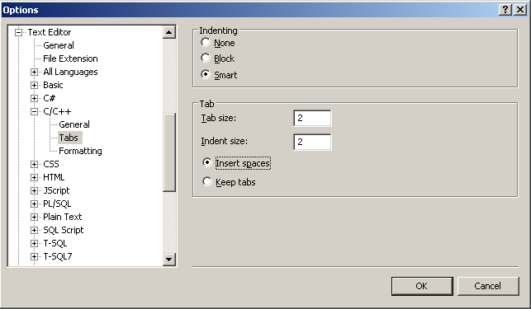

After applying these setting you can use
Edit->Advanced->Untabify Selection
to remove TAB characters and
Edit->Advanced->Format Selection
to format the selected section.
Note: There is a bug in MS Visual Studio 6.0 that leads to a wrong indentation if nested ‘for’-loops are used without braces.

Xcode
For setting up Xcode to properly format the source code, go to Prefences->Indentation and make the following changes:
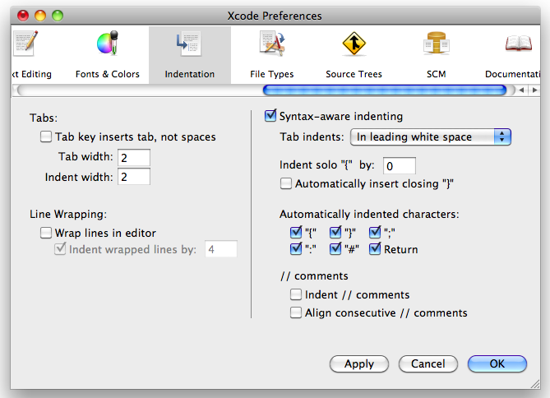

VIM
For setting up the proper indentation in VIM add the following lines to your .vimrc file
" set indentation of two tabs
set sts=2 sw=2 ts=8 et

Eclipse
For setting up the proper indentation in Eclipse go to Windows->Preferences->C++->Code Style->Edit and set the following options:
Tab Policy: Spaces only
Indentation Size: 2
Tab size: 2

