Appendix for Chapter 48: Medical Image Reconstruction with the FFT
Thilaka Sumanaweera and Donald Liu

In this section, we will derive Equations 13 and 14 of Chapter 48. The following convention is used here. Let 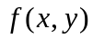 be a 2D function. The 1D Fourier transform of  with respect toor would be 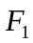. The 2D Fourier transform of would be .
An ultrasonic pulse, such as the one shown in Figure 48-5(b) typically contains a wide spectrum of frequencies. For the sake of explanation, let us assume that we only insonify the object with a single tone, . In this case, the received signal would be 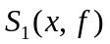, the 1D Fourier transform of 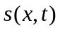 with respect to , evaluated at . Using the theory of wave propagation:
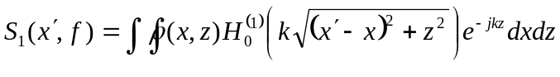 (15)
where, 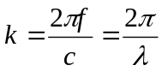, the wave number, , the wavelength, , the speed of sound, and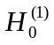, the Hankel’s function of the first kind and also the Green’s function for the 2D wave Equation (Morse and Ingard 1968). Note that:
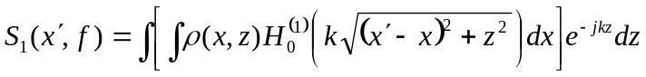. (16)
As can be seen, what is inside the first integral is a convolution, which becomes multiplication in the Fourier domain. Taking the 1D Fourier transform with respect to on both sides:
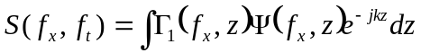, (17)
where,
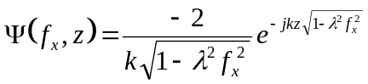. (18)
Therefore:
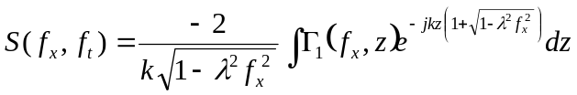. (19)
What is inside the integral is once again a 1D Fourier transform. Hence:
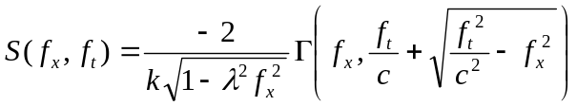. (20)
Or,
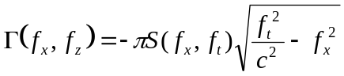, (21)
where,
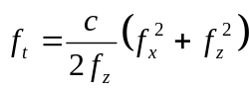 (22)
The above derivation also holds true if the transmit pulse contains a wide range of frequencies, as is the case with the pulse shown in Figure 48-5(b). See (Liu 2002) for more details on this method.
References
Morse, P. M., and K. U. Ingard. 1968. Theoretical Acoustics. McGraw-Hill Inc.
Liu, Donald. 2002. Pulse Wave Scanning Reception and Receiver. U.S. Patent 6,685,641, filed Feb. 1, 2002, and issued Feb. 3, 2004.

