v2.2 版本更新日志
v2.2 Release Notes
无限暖暖相册管理工具 | Infinity Nikki Gallery Manager

v2.2 版本发布说明
我们很高兴发布 无限暖暖相册管理工具 v2.2！这一版本聚焦于"连接与可靠性"——让你的截图不仅能被精心管理，还能便捷分享；同时大幅提升了应用在各种 Windows 环境下的适配能力与运行稳定性。

新功能

一键分享至社交应用
v2.2 新增分享功能，支持一键将截图分享至微信、QQ 和 vivo 办公套件。应用会智能检测目标应用的安装状态与运行状态：
- 若应用正在运行，直接唤起并引导粘贴分享
- 若应用已安装但未运行，提供一键启动引导
- 若应用未安装，显示友好提示并给出下载建议
检测逻辑采用四层回退链：注册表候选位置、卸载项枚举、常用安装目录扫描、进程路径反向查找，确保在不同 Windows 环境中都能可靠定位目标应用。
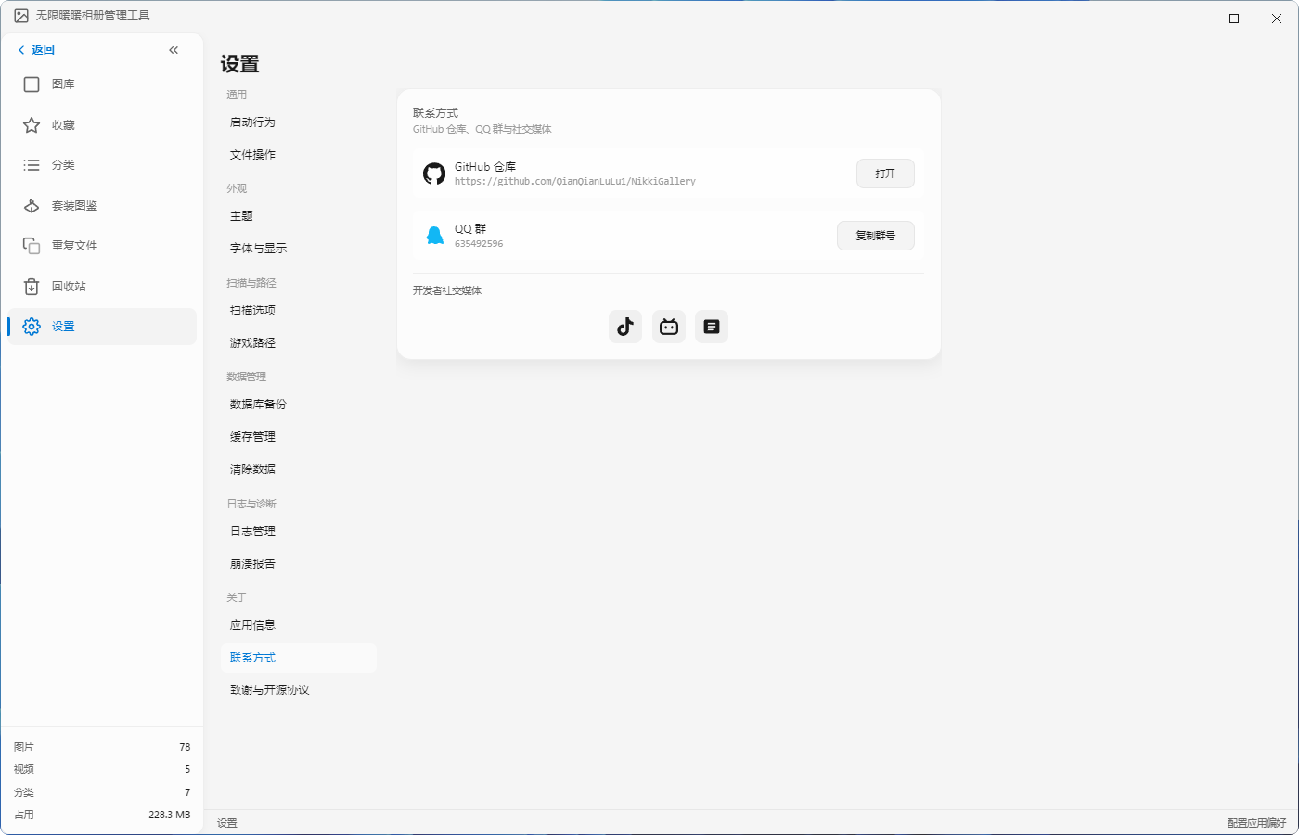

日志与诊断系统
全新的日志与诊断模块为问题排查提供了专业工具：
- 日志管理：独立页面查看运行日志，支持按日期筛选与清理。日志采用 JSONL 格式存储，自动滚动，总大小限制在 5GB 以内
- 崩溃报告：自动收集崩溃时的堆栈与环境信息，限制保留最近 20 份报告，便于开发者快速定位问题
日志写入采用异步文件操作与节流大小检查，避免阻塞主线程影响用户体验。

数据管理工具
设置页面新增数据管理模块，让你对本地数据拥有完全掌控：
- 数据库备份：一键导出当前图库数据库，防止数据意外丢失
- 缓存管理：查看并清理应用生成的缩略图与视频缓存
- 清除数据：彻底重置应用数据，恢复到初始状态

社区入口整合
设置页新增"联系方式"板块，将社区资源集中呈现：
- GitHub 仓库：一键打开项目源码仓库
- QQ 交流群：一键复制群号，快速加入玩家社区
- 开发者社交媒体：直达开发者的抖音、B站、小红书主页


优化与改进

视频播放体验
视频服务现在支持 HTTP Range 请求（206 Partial Content），在播放器中拖动进度条时响应更加流畅。视频缩略图渲染逻辑独立优化，浏览大量视频时界面更加顺滑。

扫描性能与稳定性
- 视频元数据提取增加 15 秒超时保护，防止因个别异常文件导致整个扫描进程挂起
- 扫描完成后自动发送 scanner:complete 事件，确保 UI 状态正确更新
- 自定义并发控制替代外部依赖，避免 ESM-only 模块在 CommonJS 环境中引发的兼容性问题

设置页面重构
设置页全面重构为六大模块，结构更加清晰：通用、外观、扫描与路径、数据管理、日志与诊断、关于。外观模块新增"柔粉轻奢"主题，与默认简约主题满足不同审美需求。
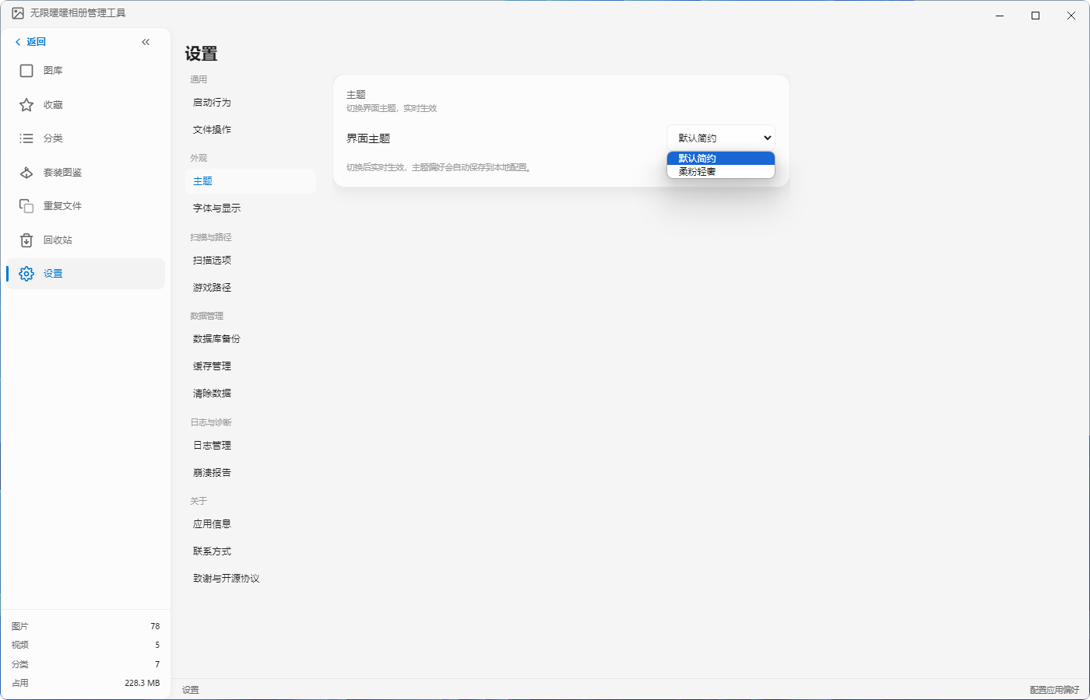

修复内容
- 修复了 asar 打包后二进制依赖（ffmpeg、ffprobe、better-sqlite3、sharp 等）无法执行的问题，通过 asarUnpack 配置与运行时路径修正确保功能正常
- 修复了单实例锁被残留进程占用导致新实例无法启动的问题
- 修复了 wmic / PowerShell 进程检测中因通配符自动转义导致的匹配失败问题，改用精确进程名查询
- 修复了 koa-connect 包装 Express 中间件导致的上下文泄漏问题，采用原生 Koa 重写

下载
安装包：无限暖暖相册管理工具 Setup 2.2.0.exe
前往 Releases 页面下载最新版本。

反馈与支持
如有问题或建议，欢迎通过以下方式反馈：
- GitHub Issues：https://github.com/QianQianLuLu/NikkiGallery/issues
- QQ 交流群：635492596
感谢大家的持续支持，祝游戏愉快！

v2.2 Release Notes
We are pleased to release Infinity Nikki Gallery Manager v2.2! This version focuses on "Connection & Reliability"—making it easier to share your screenshots while significantly improving compatibility and stability across diverse Windows environments.

New Features

One-Click Share to Social Apps
v2.2 introduces sharing functionality, enabling one-click sharing of screenshots to WeChat, QQ, and the vivo Office Suite. The app intelligently detects the target application's installation and running status:
- If the app is running, it is brought to the foreground with paste-sharing guidance
- If installed but not running, a one-click launch guide is provided
- If not installed, a friendly prompt with download suggestions is shown
Detection uses a four-layer fallback chain: registry candidate locations, uninstall entry enumeration, common installation directory scanning, and process path reverse lookup, ensuring reliable app discovery across different Windows environments.


Logs & Diagnostics System
A brand-new logs and diagnostics module provides professional tools for troubleshooting:
- Log Management: A dedicated page to view runtime logs, filter by date, and clean up. Logs are stored in JSONL format with automatic rolling, capped at 5GB total
- Crash Reports: Automatically collects stack traces and environment information on crashes, retaining the most recent 20 reports to help developers diagnose issues quickly
Log writes use asynchronous file operations and throttled size checks to avoid blocking the main thread and impacting user experience.

Data Management Tools
The settings page now includes a Data Management module, giving you full control over local data:
- Database Backup: One-click export of the current gallery database to prevent accidental data loss
- Cache Management: View and clean up thumbnails and video caches generated by the app
- Clear Data: Completely reset app data to its initial state

Community Hub Integration
A new "Contact" section in Settings centralizes community resources:
- GitHub Repository: One-click access to the open-source project
- QQ Group: One-click copy of the group number for quick community join
- Developer Social Media: Direct links to the developer's Douyin, Bilibili, and Xiaohongshu profiles


Improvements

Video Playback Experience
The video service now supports HTTP Range requests (206 Partial Content), making timeline scrubbing smoother in the player. Video thumbnail rendering has been independently optimized for a more fluid browsing experience with large video collections.

Scanning Performance & Stability
- Video metadata extraction now includes a 15-second timeout guard to prevent the scan process from hanging on malformed files
- The scanner automatically emits a scanner:complete event upon finishing to ensure UI state updates correctly
- A custom concurrency control utility replaces external dependencies, avoiding compatibility issues caused by ESM-only modules in CommonJS environments

Settings Page Reorganization
The Settings page has been fully reorganized into six modules for clearer navigation: General, Appearance, Scan & Paths, Data Management, Logs & Diagnostics, and About. The Appearance module adds a new "Soft Pink Luxury" theme alongside the original "Default Minimal" style to suit different aesthetic preferences.


Bug Fixes
- Fixed an issue where binary dependencies (ffmpeg, ffprobe, better-sqlite3, sharp, etc.) packaged in asar could not execute, resolved via asarUnpack configuration and runtime path correction
- Fixed the issue where residual processes holding the single-instance lock prevented new instances from launching
- Fixed wildcard escaping in wmic / PowerShell process detection that caused matching failures; switched to exact process name queries
- Fixed context leaks caused by wrapping Express middleware with koa-connect, rewritten with native Koa

Download
Installer: 无限暖暖相册管理工具 Setup 2.2.0.exe
Visit the Releases page to download the latest version.

Feedback & Support
For issues or suggestions, please reach out via:
- GitHub Issues: https://github.com/QianQianLuLu/NikkiGallery/issues
- QQ Group: 635492596
Thank you for your continued support, and enjoy the game!
© 2026 QianLu. All rights reserved.

