# SOP for Online Ultrasonic Sensor Debugging

Part 1: Online Debugging of Energy and P Value of Ultrasonic KS236 Using Scripts

## I. Procedure for Online Adjustment of KS236 Ultrasonic Energy

1.Log in to the robot terminal online: Log in to Smart+ -> Select the corresponding robot -> Enter Terminal.

2.Locate the directory containing the four scripts: ks236\_energy\_set.py, ks236\_energy\_get.py, ks236\_p\_set.py, and ks236\_p\_get.py  
(Note: On Halo104~Halo113, these scripts are in the /home/ubuntu/lab/erich/ultrasonic/ directory. For standardization, it is recommended that other Halos create and use a public folder, such as **sudo mkdir -p ~/FAT\_TOOLS/ultrasonic/**).

3.Enter the following commands (using Halo104 and modifying probe #1's energy as an example):

a). **docker stop ultrasonic\_sensors**

b). **cd ~/lab/erich/ultrasonic** # This path is specific to Halo82, Halo104~113. Other Halos should use the path to their public folder.

c). **deactivate** # If shows ‘deactivate:command not found’,fine,just ignore it and go next step. Steps c~e are only for the initial deployment of the script on the machine. If the script has been deployed, proceed to step f.

d). **rm -rf ./ultrasonic\_env**

e). **python3 -m venv ultrasonic\_env**

f). **source ./ultrasonic\_env/bin/activate**

g). **pip install pyserial** # Only for configuring the serial library before the first script deployment. Skip this step if already deployed.

h). **python3 ./ks236\_energy\_set.py \** #Configuring the KS236 ultrasonic energy:

**--probe 1 \** # Specify probe #1

**--range 2.5 \** # Specify max detection range: 2.5m

**--energy 1 \** # Specify energy threshold: 1

**--time 2 \** # Specify sampling time: 2

**--threshold 2 \** # Specify alarm trigger threshold: 2

**--device /dev/ttyUS \** # Specify device path, default: /dev/ttyUS

**--baudrate 115200 \** # Specify baud rate, default: 115200

**--permanent** # Permanent mode, saves to EEPROM

i). Configuration is successful when the following prompt appears:

|  |
| --- |
|  |
| Successfully set energy for probe 1 |

j). **docker start ultrasonic\_sensors** # Run steps j and k if no further steps are needed, otherwise skip.  
k). **deactivate**

P.S.:Using the -h or --help option will show you all available options and some examples for the script.

|  |
| --- |
|  |
| Using -h or --help can show all available options |

## II. Procedure for Online Viewing of KS236 Ultrasonic Energy Configuration

1.Log in to the robot terminal online: Log in to Smart+ -> Select the corresponding robot -> Enter Terminal.

2.Locate the script directory as described in section I, step 2.

3.Enter the following commands (using Halo104 and viewing probe #1's energy as an example):  
a). **docker stop ultrasonic\_sensors**  
b). **cd ~/lab/erich/ultrasonic** # Adjust path as needed.  
c). **deactivate** # Steps c~e are for initial deployment only.  
d). **rm -rf ./ultrasonic\_env**  
e). **python3 -m venv ultrasonic\_env**  
f). **source ./ultrasonic\_env/bin/activate**  
g). **pip install pyserial** # Skip if already installed.  
h). **python3 ks236\_energy\_get.py #**View the KS236 ultrasonic energy configuration  
i). Detection is successful when the following table appears:  
(A table is displayed showing the energy configuration for all probes, including Probe ID, Range, Energy, Time, and Threshold.)

|  |
| --- |
|  |

j). **docker start ultrasonic\_sensors** # Run steps j and k if no further steps are needed, otherwise skip.  
k). **deactivate**

P.S.:Using the -h or --help option will show you all available options and some examples for the script.

|  |
| --- |
|  |
| Using -h or --help can show all available options |

## III. Procedure for Online Adjustment of KS236 Ultrasonic P-Value (Segmented FOV)

1.Log in to the robot terminal online: Log in to Smart+ -> Select the corresponding robot -> Enter Terminal.

2.Locate the script directory as described in section I, step 2.

3.Enter the following commands (using Halo104 and modifying probe #1's P-values as an example):  
a). docker stop ultrasonic\_sensors  
b). cd ~/lab/erich/ultrasonic # Adjust path as needed.  
c). deactivate # Steps c~e are for initial deployment only.  
d). rm -rf ./ultrasonic\_env  
e). python3 -m venv ultrasonic\_env  
f). source ./ultrasonic\_env/bin/activate  
g). pip install pyserial # Skip if already installed.  
h). **python3 ./ks236\_p\_set.py \** #Configure the KS236 ultrasonic segmented P-values (FOV)

**--probe 1 \** # Specify probe #1

**--p1 10** \ # Specify p1 value: 10, FOV range: 22.5cm~42.5cm

**--p2 10 \** # Specify p2 value: 10, FOV range: 42.5cm~59.5cm

**--p3 12 \** # Specify p3 value: 12, FOV range: 59.5cm~76.5cm

**--p4 31 \** # Specify p4 value: 31, FOV range: 76.5cm~110cm

**--p5 31 \** # Specify p5 value: 31, FOV range: 110cm~144cm

**--p6 31 \** # Specify p6 value: 31, FOV range: 144cm~178cm

**--p7 31 \** # Specify p7 value: 31, FOV range: 178cm~212cm

**--p8 31 \** # Specify p8 value: 31, FOV range: 212cm~246cm

**--p9 31 \** # Specify p9 value: 31, FOV range: 246cm~280cm

**--p10 31 \** # Specify p10 value: 31, FOV range: 280cm~348cm

**--p11 31 \** # Specify p11 value: 31, FOV range: 348cm~416cm

**--p12 31 \** # Specify p12 value: 31, FOV range: 416cm to max range

**--device /dev/ttyUS \** # Specify device path, default: /dev/ttyUS

**--baudrate 115200 \** # Specify baud rate, default: 115200

**--permanent** # Apply changes permanently,default:temporary  
i). Configuration is successful when the following prompt appears:

|  |
| --- |
|  |

Note: If all probes are configured with the exact same P-values, the script will only display the configuration for probe #1.

|  |
| --- |
|  |

j). **docker start ultrasonic\_sensors** # Run steps j and k if no further steps are needed, otherwise skip.  
k). **deactivate**  
**P.S.:** For step h, to quickly reset to the **default configuration**, run:  
**python3 ./ks236\_p\_set.py \**  
 **--probe 1 \**  
 **--preset default \** #set p1=p2=p3=19,p4~p12=31 for probe 1 to probe 9  
 **--permanent**  
P.S.:Using the -h or --help option will show you all available options and some examples for the script.

|  |
| --- |
|  |
| Using -h or --help can show all available options |

## IV. Procedure for Online Viewing of KS236 Ultrasonic P-Value (Segmented FOV) Configuration

1.Log in to the robot terminal online: Log in to Smart+ -> Select the corresponding robot -> Enter Terminal.

2.Locate the script directory as described in section I, step 2.

3.Enter the following commands (using Halo104 and viewing probe #1's P-value configuration as an example):  
a). **docker stop ultrasonic\_sensors**  
b). **cd ~/lab/erich/ultrasonic** # Adjust path as needed.  
c). **deactivate** # Steps c~e are for initial deployment only.  
d). **rm -rf ./ultrasonic\_env**  
e). **python3 -m venv ultrasonic\_env**  
f). **source ./ultrasonic\_env/bin/activate**  
g). **pip install pyserial** # Skip if already installed.  
h). **python3 ./ks236\_p\_get.py** #View the KS236 ultrasonic segmented P-value (FOV) configuration  
i). The script will sequentially display the current P-values for probes 1 through 9. Scroll up to find the P-values for the desired probe. The script is finished when it displays "Successfully read P values" as shown in the image below.  
(Image description: Terminal output showing P-value settings for each probe, followed by a final success message.)

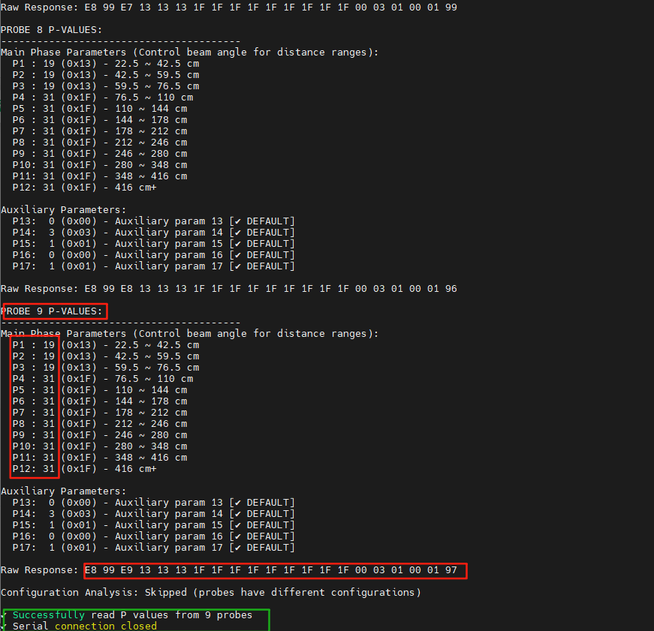  
j). **docker start ultrasonic\_sensors** # Run steps j and k if no further steps are needed, otherwise skip.

k). **deactivate**

P.S.:Using the -h or --help option will show you all available options and some examples for the script.

|  |
| --- |
|  |
| Using -h or --help can show all available options |

Part 2: Procedures and Methods for Online Debugging of Ultrasonic KS236

**Important Notes:**

During testing, ensure that ***there are no other Halos or any devices using ultrasonic waves within 5 meters around the Halo!***

***Ensure that the test space is at least 5m \* 5m; otherwise, it is extremely prone to echo interference and intensified illusions.***

***Ensure that the tire pressure is within [15, 20] psi during testing.***

**Tips:** The obstacles mentioned in the following text refer to those within the detection range of the probes (for US2~4, it should be in [0.2, 0.68]; for US1, 5~9, it should be in [0.2, 0.3]).

Under the above premises, when there is a serious ***illusion*** in the direction of a certain probe (that is, there are noise points even though there is no obstacle), please troubleshoot and debug according to the following steps:

**Step 1.** Open 2 new Smart+ windows in the browser, select the corresponding robot, and open the Pilot and Topic Monitor pages respectively. On the Pilot page, open Pilot Menu -> Map -> Map Streaming -> /move\_base/global\_costmap/local\_costmap; in the search box on the Topic Monitor page, enter /ultrasonic\_list. /ultrasonic\_list will list the distance readings (value) of obstacles detected by each probe (key) in real-time. Find the problematic probe and compare the value of the probe before and after the illusion occurs. If any of the following four situations occur, troubleshoot in the order of wiping the probe surface with flexible fabric to remove possible grease and water stains, etc. -> reinstalling the probe -> replacing the probe and re-detecting:

Phenomenon A: When there is no obstacle, the value always reads an abnormal value (that is, the value is within the detection range of the probe).

Phenomenon B: When there is no obstacle, the value is [0.2, 0.8); when there is an obstacle, the value is [0.8, 2.55].

Phenomenon C: Regardless of the presence of obstacles, the value is always stable in [0.2, 0.8).

Phenomenon D: The value frequently jumps between 0.2 and [1, 2.55].

If the problem is solved, skip the subsequent steps; otherwise, proceed to Step 2.

**Step 2.** Connect to the Halo's control terminal via Smart+ Terminal (or connect the PC to LP's AP, right-click the Windows icon to open the terminal, and enter ssh ubuntu@[10.7.5.72](http://10.7.5.72" \t "_blank)) and perform the following steps:

a. Enter docker exec -it ultrasonic\_sensors bash.

b. Enter vim ./src/ultrasonic\_ks236\_bridge/launch/us\_ks236.launch.

c. After entering the vim editor, press i to enter edit mode.

|  |  |
| --- | --- |
|  |  |
| When entering vim, it is in normal command mode by default. | Press i to enter edit mode, and pay attention to "insert" in the lower left corner; to exit from edit mode to normal command mode, press ESC. |

d. Find the problematic probe (US\_1~9 correspond to US1~9), and modify the value behind it. This value represents the limit value at which the detection distance of each probe is fed back to the NAV PC and judged as an obstacle noise by the NAV PC (that is, it will not be judged as an obstacle by the NAV PC after exceeding this value).

e. Press ESC to exit edit mode, and enter :wq to save and exit.

|  |
| --- |
|  |
| In normal command mode, press any of ;, /, or ? to enter command line mode. In this mode, enter :wq to save and exit. |

f. Enter exit.

g. Enter docker restart ultrasonic\_sensors.

h. Retest. If the problem still cannot be solved, proceed to Step 3.

**Step 3.** Refer to the "Operating Steps for Online Adjustment of Ultrasonic KS236 Energy" in Part 1, change the energy (2.5m range) of the corresponding problematic probe to 2 and 1 respectively (that is, --energy takes 2 and 1 respectively) and retest (for 2.5m range, the default value of --energy is 3, the default value of --time is 2, and the default value of --threshold is 2). If it cannot be solved, proceed to Step 4.

**Step 4.** Refer to the "Operating Steps for Online Adjustment of P Value (Segmented FOV) of Ultrasonic KS236" in Part 1, and adjust the P value of the corresponding problematic probe.

**Warning:** The P values mentioned below are in decimal, but they will eventually be displayed in hexadecimal in the script.

For US1, US5~9: It is recommended that the value range of P1~P2 is [15, 24], the value range of P3 is [15, 23], and P4~P12 can be 31. For US2~4: It is recommended that the value range of P1~P3 is [15, 23], and P4~P12 can be 31. Note: The smaller the P value, the larger the detection range of the probe, and the easier it is for ultrasonic waves to hit the ground; and vice versa. ***It is recommended to adjust the P value carefully***. Experiments show that: indoors, for US2~4, when P1=P2=10, P3=12, P4～P12=31; for US1, US5~9, when P1=P2=24, P3=23, P4～P12=31, the obstacle avoidance effect and navigation effect are the best. Outdoors or in poor road conditions, when all probes take P1=P2=P3=19, P4~P12=31, the obstacle avoidance effect and navigation effect are the best.