# 实验三 中断实验

1. **实验目的和要求**

1、运用中断技术，实现中断控制；

2、运用定时器中断原理，实现定时控制；

3、熟练运用INT0中断和定时器中断原理，编程实现中断控制流水灯。

1. **主要仪器设备**

1、TX-1C单片机实验板1块；

2、PC机一台

3、软件环境：OS：WIN7、keil uVision4、STC下载器

1. **实验内容及实验步骤**

**实验电路图**

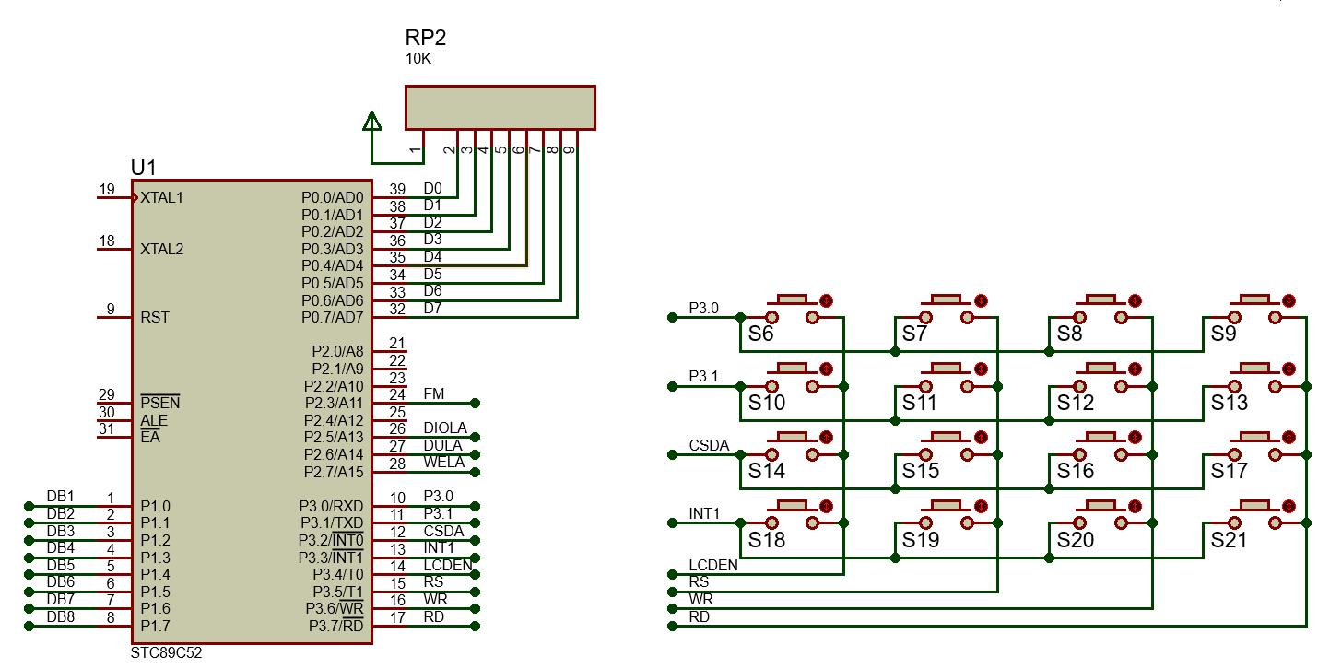

图3-1 外中断实验电路原理图

如果未能在课上展示实物运行现象，请在实验结果上截图说明。

**基础实验1：在数码管上循环显示0～F，当中断INT0发生时，则点亮第一个发光二极管**

**#include <reg52.h>**

**#define uchar unsigned char**

**#define uint unsigned int**

**sbit dula = P2^6;**

**sbit wela = P2^7;**

**sbit led1 = P1^0;**

**uchar code table[] = {0x3f,0x06,0x5b,0x4f,**

**0x66,0x6d,0x7d,0x07,**

**0x7f,0x6f,0x77,0x7c,**

**0x39,0x5e,0x79,0x71};**

**uchar num = 0;**

**void delayms(uint xms);**

**void main() {**

**int i;**

**EA = 1;**

**EX0 = 1;**

**for(i=0;i<17;i++)**

**{**

**led1=1;**

**if(i>=16)**

**i=0;**

**wela=1;**

**P0=0xfe;**

**wela=0;**

**delayms(500);**

**dula=1;**

**P0=table[i];**

**dula=0;**

**delayms(500);**

**WR=0;**

**if(INT0==0)**

**{**

**while(INT0==0)**

**IT0=0;**

**}**

**}**

**}**

**void external0_isr() interrupt 0 {**

**led1 = 0;**

**}**

**void delayms(uint xms) {**

**uint i, j;**

**for (i = xms; i > 0; i--)**

**for (j = 110; j > 0; j--);**

**}**

经测试，该代码可以实现**在数码管上循环显示0～F，当中断INT0发生时，则点亮第一个发光二极管**

**基础实验2：用定时器0的方式1实现第一个发光二极管以1Hz频率闪烁**

**#include<reg52.h>**

**#define uchar unsigned char**

**#define uint unsigned int**

**sbit led1=P1^0;**

**uchar num;**

**void main()**

**{**

**TMOD=0X01;**

**TH0=(65536-45872)/256;**

**TL0=(65536-45872)%256;**

**EA=1;**

**ET0=1;**

**TR0=1;**

**while(1);**

**}**

**void T0_time() interrupt 1**

**{**

**TH0=(65536-45872)/256;**

**TL0=(65536-45872)%256;**

**num++;**

**if(num==20)**

**{num=0;**

**led1=~led1;**

**}**

**}**

经测试，该代码可以实现**用定时器0的方式1实现第一个发光二极管以1Hz频率闪烁**

**基础实验3：用定时器1的方式1实现数码管前2位59s循环计时**

**#include <reg52.h>**

**#define uchar unsigned char**

**#define uint unsigned int**

**sbit dula = P2 ^ 6;**

**sbit wela = P2 ^ 7;**

**sbit led1 = P1 ^ 0;**

**uchar code table[] = {0x3f, 0x06, 0x5b, 0x4f, 0x66, 0x6d, 0x7d, 0x07, 0x7f, 0x6f, 0x77, 0x7c, 0x39, 0x5e, 0x79, 0x71};**

**void delayms(uint);**

**void display(uchar, uchar);**

**uchar num, num1, num2, shi, ge;**

**void main()**

**{**

**TMOD = 0x11;**

**TH0 = (65536 - 45872) / 256;**

**TL0 = (65536 - 45872) % 256;**

**TH1 = (65536 - 45872) / 256;**

**TL1 = (65536 - 45872) % 256;**

**EA = 1;**

**ET0 = 1;**

**ET1 = 1;**

**TR0 = 1;**

**TR1 = 1;**

**num = 0;**

**shi = 0;**

**ge = 0;**

**while (1)**

**{**

**display(shi, ge);**

**}**

**}**

**void display(uchar shi, uchar ge)**

**{**

**dula = 1;**

**P0 = table[shi];**

**dula = 0;**

**P0 = 0xff;**

**wela = 1;**

**P0 = 0xfe;**

**wela = 0;**

**delayms(5);**

**dula = 1;**

**P0 = table[ge];**

**dula = 0;**

**P0 = 0xff;**

**wela = 1;**

**P0 = 0xfd;**

**wela = 0;**

**delayms(5);**

**}**

**void delayms(uint xms)**

**{**

**uint i, j;**

**for (i = xms; i > 0; i--)**

**for (j = 110; j > 0; j--)**

**;**

**}**

**void T0_time() interrupt 1**

**{**

**TH0 = (65536 - 45872) / 256;**

**TL0 = (65536 - 45872) % 256;**

**num1++;**

**if (num1 == 4)**

**{**

**num1 = 0;**

**led1 = ~led1;**

**}**

**}**

**void T1_time() interrupt 3**

**{**

**TH1 = (65536 - 45872) / 256;**

**TL1 = (65536 - 45872) % 256;**

**num2++;**

**if (num2 == 20)**

**{**

**num2 = 0;**

**num++;**

**if (num == 60)**

**num = 00;**

**shi = num / 10;**

**ge = num % 10;**

**}**

**}**

经测试，该代码可以实现**用定时器1的方式1实现数码管前2位59s循环计时**