ER Diagram:

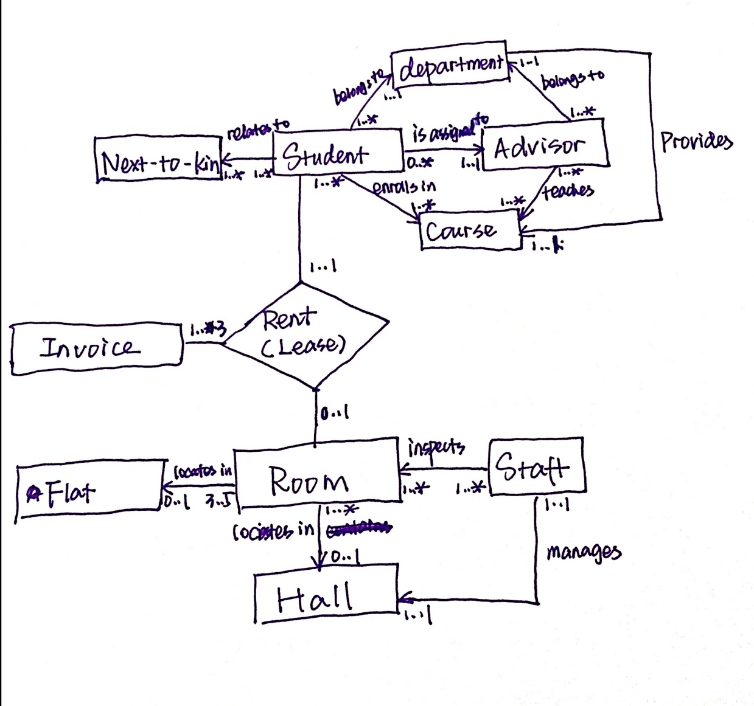

**Tables:**

**Student** (bannerNo, name, homeAdd, mobile, email, DOB, gender, category, nationality, specialNeeds, comments,curstatus, major, minor, advisorNo);

PK: bannerNo;

FK: advisorNo refers to Advisor table; departmentNo refers to Department table.

NOT NULL: bannerNo, name, gender, curstatus, advisorNo;

Constraint: gender is ‘m’ or ‘f’;

**Advisor** (advisorNo, name, position, departmentNo, internalTelNo, email, roomNo);

PK: advisorNo;

FK: departmentNo refers to Department table.

NOT NULL: advisorNo, name, departmentNo;

**Department** (departmentNo, name);

PK: deparmentNo;

NOT NULL: departmentNo, name;

**Hall** (hallNo, name, address, telNo, managerNo);

PK: hallNo;

FK: managerNo refers to Staff table (staffNo);

NOT NULL: hallNo, name, address, managerNo;

**Flat** (flatNo, address, availableRoom);

PK: flatNo;

NOT NULL: flatNo, address, availableBed;

Constraint: availableBed should be 3, 4 or 5.

**Room** (placeNo, roomNo, rentRate, hallNo, flatNo);

PK: placeNo;

FK: hallNo refers to Hall table; flatNo refers to Flat;

NOT NULL: placeNo, roomNo, rate;

Constraint: One of hallNo and flatNo is NULL, the other is NOT NULL;

**Lease** (leaseNo, duration, bannerNo, placeNo, dateFrom, dateTo);

PK: leaseNo;

FK: bannerNo refers to Student table; placeNo refers to Room table;

NOT NULL: leaseNo, bannerNo, placeNo, duration, dateFrom;

Constraint: duration should be 1, 2 or 3, which stands for the count of semesters.

**Invoice** (invoiceNo, leaseNo, semester, payDue, payDate, payMethod, firstReminder, secondReminder);

PK: invoiceNo;

FK: leaseNo refers to Lease table;

NOT NULL: invoiceNo, leaseNo, semester, payDue;

Assume that student should pay by semester.

**Inspection** (staffNo, placeNo, date, indication, comments);

PK: placeNo and date;

FK: placeNo refers to Room table; staffNo refers to Staff table;

NOT NULL: staffNo, placeNo, date, indication;

Constraint: indication is ‘y’ or ‘n’;

**Staff** (staffNo, name, email, home, DOB, gender, position, location);

PK: staffNo;

NOT NULL: staffNo, name, position, location;

Constraint: gender is ‘m’ or ‘f’ or NULL;

**Course** (courseNo, title, year, advisorNo);

PK: courseNo;

FK: advisorNo refers to Advisor;

NOT NULL: courseNo, title, year, advisorNo;

**NextToKin** (bannerNo, name, relationship, address, telNo);

PK: bannerNo and name;

FK: bannerNo refers to Student table;

NOT NULL: bannerNo, name, relationship, telNo;