The project contains mainly 3 parts:

1. Building up scenarios.
2. Initialize basic configs for the MCTS approach.
3. The main body of the MCTS algorithm.
4. Display the result of the MCTS.

**How to run the project?**

**Just find the file mctsPlanning, and press run. The program will automatically plot the performance of the egoVehicle using MCTS in the scenario.**

1. Building Up Scenarios:

Files:

**ds6_lanes_roadWith5Cars_horizontal_crossing,**

**ds6_lanes_roadWith5Cars_stucked,**

**ds6_lanes_roadWith5CarsCuttingIn**

**ds6_lanes_roadWith5CarsTurningLeft** are 5 cars at a 6 lanes road intersection. We built several situations that the ego vehicle would encounter in the real world.

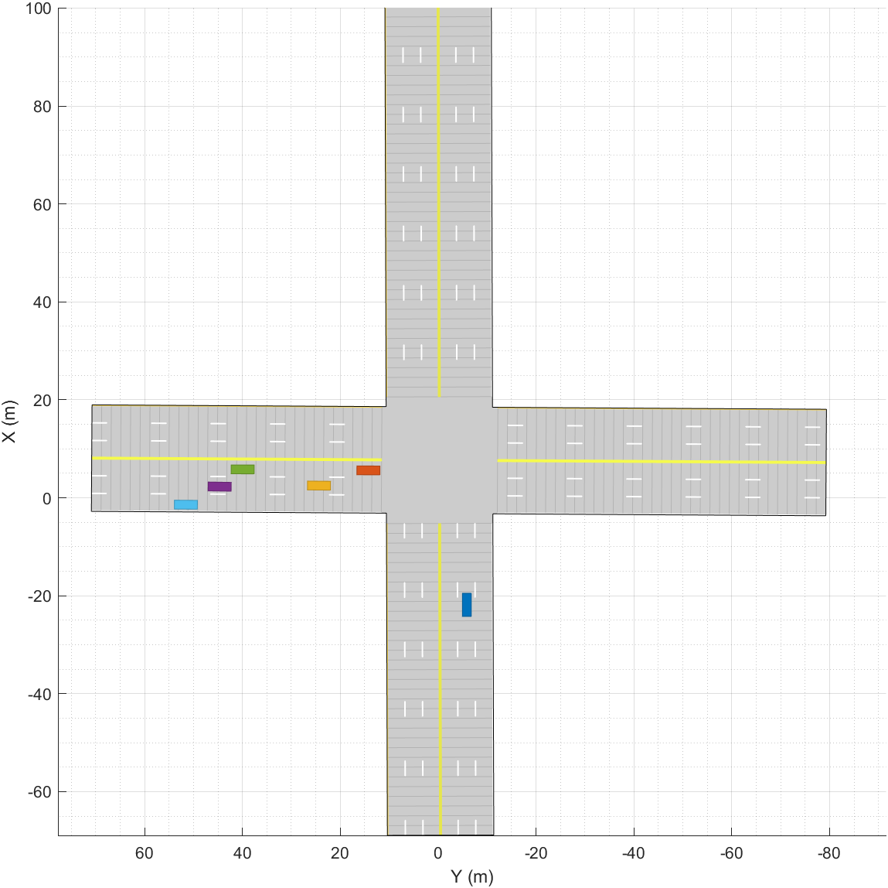Let’s pick **ds6_lanes_roadWith5Cars_horizontal_crossing** as an example. As you can see, the blue car whose X position around -20 m is the ego Vehicle.

Every function of creating scenarios gives several returns: [scenario, egoVehicle, egoWaypoints, allrefPaths, allStatus]. The **scenario**, **egoVehicle** are basic parameters in the Matlab driving toolbox, however, other three are the necessary parameters for we to build up a fully detected environment. **egoWaypoints** is the reference line for egoVehicle, which would be transfer to Frenet coordinate later. **allrefPaths** are the Frenet state of all other actor Vehicles in terms of their own waypoints, and allStatus records their speed, waittime, yaw on their trajectories.

1. Initialize basic configs for the MCTS approach.

Files:

**setStartEgoState,**

**helperMoveEgoVehicleToState**

**mctsPlanning,**

**startEgoState = setStartEgoState(egoWaypoints, initialVelocity, initialAcc)** sets the initial state for the egoVehicle, return a 1 * 6 matrix:

[x y theta kappa speed acceleration].

**helperMoveEgoVehicleToState(egoVehicle, currentEgoState)** updates the egoVehicle’s status in the scenario(by updating the [x y theta kappa speed acceleration] to the egoVehicle parameter in the scenario.)

Then, in the mctsPlanning script, we use struct to store the properties of each node, and each node has the following properties:

struct(

'state', [x y theta kappa speed acc] , '

time', the current time of node in the MCTS tree(also can be seen as the level of the node),

'children', a matrix containing all index of the children, whose first element is 0.

'visits', the time that the node has been visited

'score', the current score of the node

'index', the index of the node in the MCTS tree

'parent', the index of the parent of the node in the MCTS tree

'UCB', the current UCB amount of the node, whose default value is infinity

'egoFrenetState', the current fernet state of the ego Vehicle

[s ds dss l dl dll]

'avgScore', score / visits

'laneChangingProperties', the current properties of the lane-changing, including times of changing to left, changing to right, and whether the current node has just changed its lane.

);

1. The main body of the MCTS algorithm.

Select:

In the selection phase, the script employs a variant of the Upper Confidence Bound (UCB) formula:

node’s score / node’s visits + 5 * sqrt(log(total visits in the tree) / node’s visits)

to balance exploration and exploitation during selection. It selects the child node with the highest UCB score recursively to iterate each level of the MCTS tree and finally return the target node that we need to take further options.

Expand:

During expansion, the expand function generates new nodes by considering possible actions that the car can take and connect them to the node that we just selected. The actions are combinations of possible acceleration changes (acceleration, deceleration, or maintaining current speed) and lane changes (left, right, or staying in the current lane). The function ensures that the speed is within the defined limits and there is no collision whenever accelerate, decelerate, maintain speed or change lane.

Rollout:

The rollout phase (simulation phase), also known as rollout, involves executing a simulation from the newly expanded node until a terminal state is reached. The terminal state is defined either as a collision or the elapse of a maximum time horizon. During simulation, the algorithm choses one of three driving actions each time based on a constant probability: slowing down (20%), speeding up (20%), and maintaining the current speed (60%). When the rollout process reaches the terminal state, it returns the cost of the current node base on the ego Vehicle’s status (more information in the cost function part).

Backpropagate:

Once the rollout phase is completed, the algorithm enters the backpropagation phase. The cost of the simulation is propagated back up the tree, from the terminal node to the root. Each node's score and visit count are updated during this phase.

Cost function:

The cost function mainly consists of 5 parts, cost_comfort, cost_safety, cost_pass, cost_stimulation & cost_is_break_to_stop and cost_lane_changing.

We consider the start node and the end node’s status of the simulation.

AccLevel = 0.8 * endnode’s acc + 0.2 * startnode’s acc;

comfort = (endnode’s acc + startnode’s acc) / 2;

1. **Cost of stimulation:**

The cost of stimulation promotes the car to move forward when the car has not reached the speed limit whose standard level of this amount is 0.0.

if speed < speedlimit

cost = 10 * (speedlimit – speed)^2 - 5 * (3 – Acclevel);

elseif speed > speedlimit

expectAcc = (speed - speedlimit) / TimeResolution;

cost = abs(acc - expectAcc);

This case determines how much should we decrease the acceleration when we have already reached the speedlimit(represented by the parameter expectAcc).

else

cost = 0.0, the standard level.

Moreover, we also want to make sure the car would search for possible paths when encounter obstacles rather than just stop, ( Stopping is kind of like a “comfort zone ” for the ego Vehicle.) we add another variable on the stimulation: **cost_is_break_to_stop**

if node.time >= MaxTimeHorizon && node.velocity < 1

cost_is_break_to_stop = 50.0;

else

cost_is_break_to_stop = 0.0;

end

This ensure the egoVehicle to get punished at the terminal state when its velocity is lower than 1.

1. **Cost of comfort:**

**The cost of comfort are composed of 3 parts:**

cost_comfort_jerk, cost_comfort_acc, cost_comfort_alter

First we set up the comfort cost of jerk, we made it a sigmoid function, restricting the value between 0 to 2.0.

cost_comfort_jerk = 2 / (1 + exp(-jerk));

Then, we consider two factors, the comfort cost of the acceleration, determined by the absolute amount of the acceleration; and the comfort cost of the alternation, we do not expect the ego Vehicle to decelerate more than 2 m/s^2, and also we would like to avoid the ego Vehicle to have different direction of acceleration between two respective time resolution.

cost_comfort_acc = 0;

cost_comfort_alter = 0;

if comfort < -2

cost_comfort_acc = - 2 * comfort;

end

if acc * node.parentaCC < 0

cost_comfort_alter = 5.0;

end

The total amount of the cost_comfort is the sum of the above three factors:

cost_comfort = cost_comfort_acc + cost_comfort_jerk + cost_comfort_alter;

1. **Cost of safety:**

**In this part we consider 6 variables:**

1.SAFE_DISTANCE = 5; We consider 5m to be the safe distance between two cars.

2.Emergency_Distance = 1; We consider 1m to be the emergency distance between two cars, at this time we would call for a emergency break.

3.Speed = the ego Vehicle’s current speed.

4.acc = the ego Vehicle’s current acceleration.

5.predicted = predicted poses of the actor Vehicles at current time.

6.distance: the distance between ego Vehicle and the actor Vehicle

The initial cost of safety is 0.0: cost_safety = 0;

Then for all the detected poses of actor cars, we use a for loop to calculate the cost_safety of each car, then added them together. We use AABB function to check the collision of two cars.

Here’s the detailed process and the cost function of safety that we create:

First we compute the real distance on the x, y - axis separately, (the real distance is the distance between two cars’ positions minus half of both their length/width).

xdistance = abs(node.state(1) - predicted(i).Position(1)) - 0.5 * objCarDim(1) - 0.5 * egoCarDim(1);

ydistance = abs(node.state(2) - predicted(i).Position(2)) - 0.5 * objCarDim(2) - 0.5 * egoCarDim(2);

Then, if on the y axis, ydistance <= 0, that means on the current lane, ego Vehicle may collide with the actor Vehicle, so we continue to check the xdistance:

if xdistance <= Emergency_Distance && xdistance >= 0:

cost_safety_temp = -10 * (xdistance - Emergency_Distance) + 3.0 + 20 * speed ^2 + 10 * acc^3;

This graph show the draft of the cost function, where xdistance <= emergency_distance = 1; The cost function follows a linear trend depending on the distance, whereas also depends on speed^2 and acc^3, to give punishment to cars with higher speed and high acceleration when facing a strong likelihood of collision.

elseif xdistance > Emergency_Distance && xdistance <= SAFE_DISTANCE

cost_safety_temp = 1.0 * (xdistance - SAFE_DISTANCE) / (Emergency_Distance - SAFE_DISTANCE) + 2.0 + 3 * speed ^2 + acc^3;

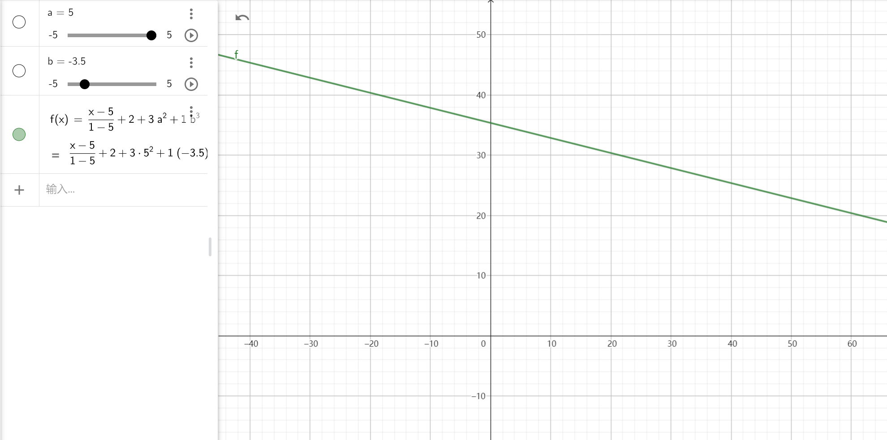

In this situation, we adjust the slope of the line to -0.25, making it milder. Meanwhile we lower down the coefficient of the speed^2 and the acceleration^3, to make the car would stop near the actor Vehicle around the safety distance.

else meaning that the distance between cars are safe, so

cost_safety_temp = max(-1/100 * (xdistance - SAFE_DISTANCE) + 2.0, 0.0);

When the xdistance is more than safety distance, we consider the car is driving in a safe environment, so we only give a small cost(no more than 2) to the ego Vehicle, only depending on xdistance to the actor Vehicle.

1. **Cost of pass goal or not:**

**We check the terminal state which the current time of the node is no smaller than the max time horizon we set. If the current position of the ego Vehicle has passed the checkpoint, we consider the car has completed the basic target in the scenario - passing through the intersection, so the cost of pass is 0.0.**

**Otherwise, we consider the distance between the current position and the checkpoint, the more far away from the checkpoint, the more cost it is for the ego Vehicle.**

if node’s current time >= MaxTimeHorizon

then check：

if node’s position on S side > checkPoint

cost_pass = 0.0;

else

cost_pass = 2.0 + abs(node’s position on S side - checkPoint);

end

else meaning that the node is not at terminal state, so

cost_pass = 0.0;

end

1. **Cost of lane-changing:**

**If in the node we expand, ego Vehicle has changed the its lane, then we give a 20 cost on it. However, we make sure that the lane-changing cost could be balanced with the cost_safety function if there’s an obstacle in front of it.**

if the ego Vehilce has changed its lane

cost_laneChanging = 35.0;

else meaning that the ego Vehicle has not changed its lane, so

cost_laneChanging = 0.0;

end

Result:

1. ds6_lanes_roadWith5CarsTurningLeft scenario

The first possibility is that the car would change its right lane to avoid the left-cut-in vehicle.

Another possibility is that the car would speed up so that the cut in vehicle is behind it.