# Roll A Ball

Step 1: Create a new project

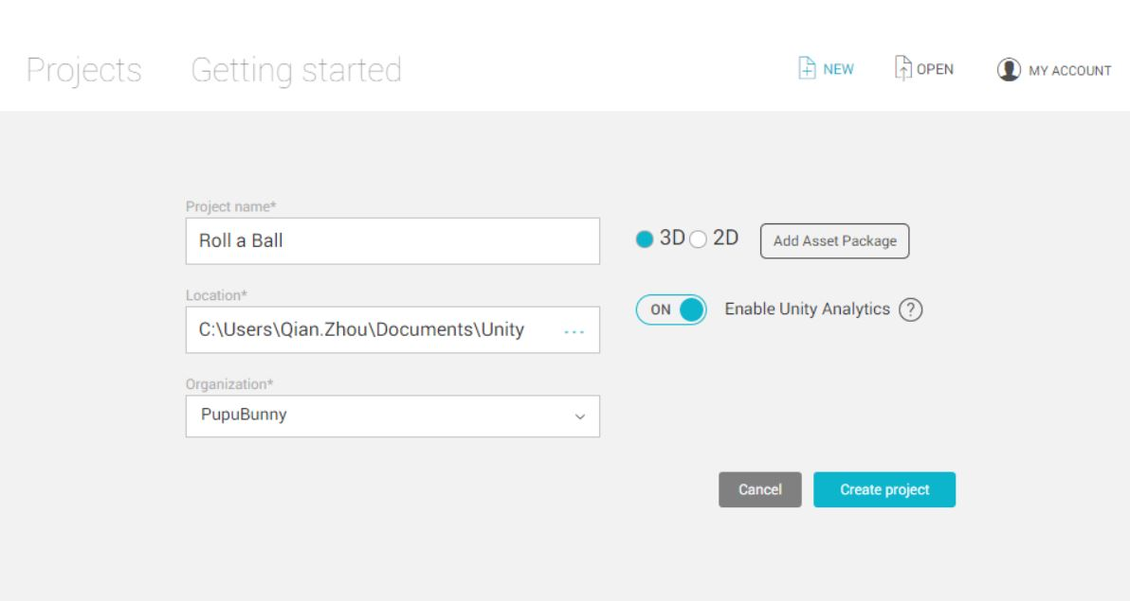

Step 2: Save a scene -> File -> Save Scene in folder Assets and create a folder called _Scenes under Assets -> Name the file MiniGame

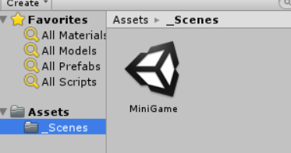

Step 3: Create game board or play field by using a **stock Unity plane**

Two options to create the plane

* GameObject -> 3D Object -> Plane
* From Inside Hierarchy View to create the Plane

Step 4: Rename the Plane as Ground by right click the Plane folder

Step 5: Reset the transform component, so the location will be (0,0,0) which is known as **original point** of the world

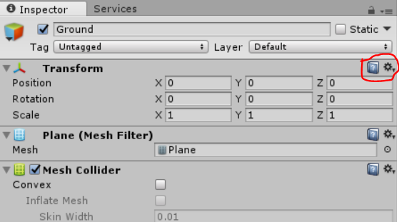

Step 6: To see the entire game object in the Scene view

With game object selected (ground) -> cursor on the Scene view -> type F key (or Edit menu -> Frame Selected )

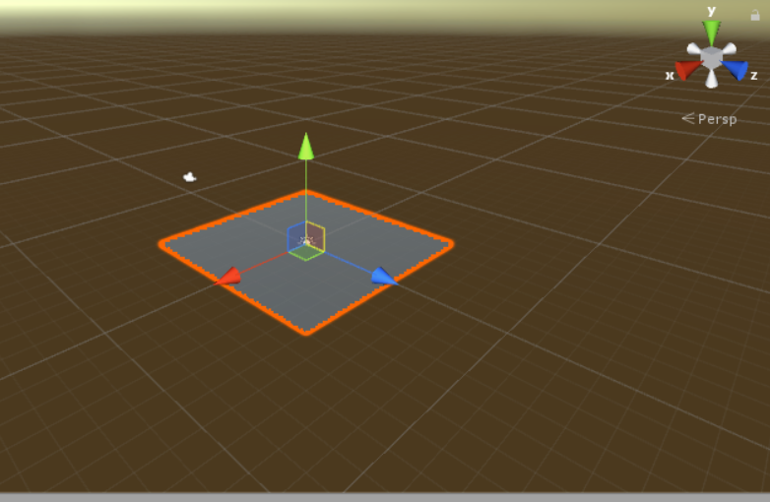

Looking at the scene, we can see grid lines -> means the plane at origin

Step 7: For the purpose the project, turn the plane off

Select Gizmos menu in the Scene view -> Dis-select Show Grid

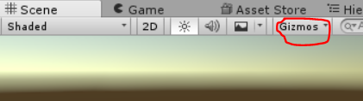

Now no grid lines as we see below

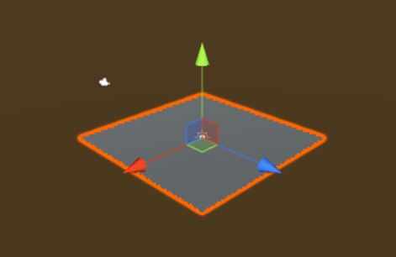

Step 8: Change the scale of the ground plane

Method 1: click the **Scale tool** and drag the axis handle

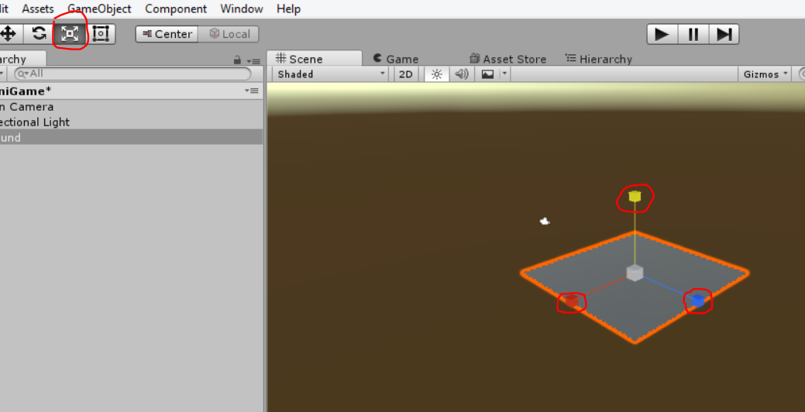

Method 2: tab between fields and hit enter or return

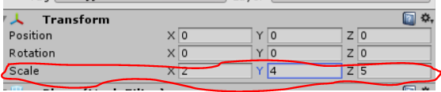

**Note: a plane has no volume and scale doesn’t work on Y-axis, there will be no change unless you go with negative number. In case of negative value on Y-axis, the plane is a single sided object will simply face the other direction. => cannot see it => Check orientation between the plane and camera?? => Y value is usually 1**

Step 9: Create our player objectwhich is a **Unity Sphere** in this assignment

From Hierarchy -> Create menu -> 3D Object -> Select Sphere and Rename the Sphere as Player -> Reset the transform to make sure it is origin -> Select Edit menu -> Frame Selected to focus on our camera on our game object