Conical finite element applicable for curved panels

Saullo G. P. Castroa , Francisco A. C. Monteirob

a Embraer, Brazilian Aerospace Company, 12227-901, São José dos Campos-SP, Brazil

e ITA, Technological Institute of Aeronautics, LME - Laboratory of Structural Modelling, 12228-900, São José dos Campos, SP, Brazil

Abstract

A semi-analytical model for the non-linear analysis of unstiffened laminated composite panels using the Ritz method and the Classical Laminated Plate Theory is proposed. A matrix notation is used to formulate the problem using the Donnell’s equations. The approximation functions proposed are capable to simulate a general load case with applied membrane distributed forces and bending moments. Solutions for linear static, linear buckling and non-linear buckling analyses are presented and verified using finite elements. The integration of the linear stiffness matrices is analytical while the non-linear terms are integrated numerically using a two-dimensional trapezoidal rule.

Keywords: Ritz method, linear buckling, linear static, non-linear analysis, composite, panels

# Kinematic equations

Kinematic equations (CLPT).

|  |  |  |
| --- | --- | --- |
|  |  | (1) |

Kinematic equations (FSDT).

|  |  |  |
| --- | --- | --- |
|  |  | (2) |

In order to apply the natural coordinate system of FIG::: FIXME

NATURAL COORDINATE SYSTEM

Fig. 1: Cone/cylinder coordinate system and geometric variables

Defining a

|  |  | (3) |
| --- | --- | --- |

Natural coordinates (CLPT):

|  |  | (4) |
| --- | --- | --- |

The variation of the strain vector can be written as (CLPT):

|  |  | (5) |
| --- | --- | --- |

Natural coordinates (FSDT):

|  |  | (6) |
| --- | --- | --- |

The variation of the strain vector can be written as (FSDT):

|  |  | (7) |
| --- | --- | --- |

# Finite elements

* 1. Conical element with 8 nodes

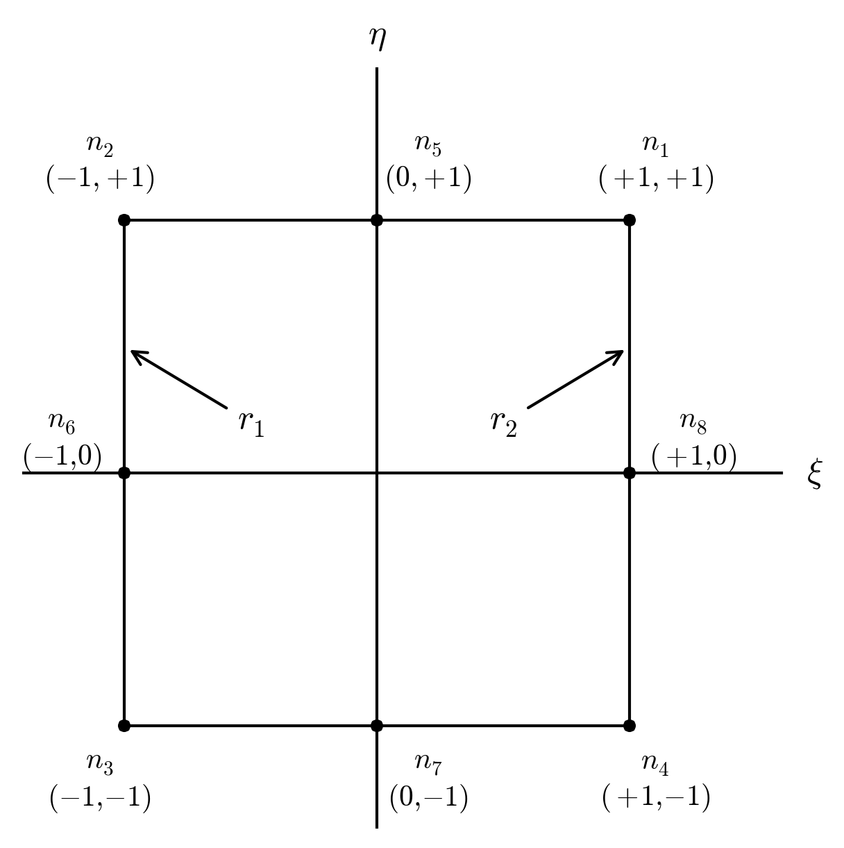

Fig. 2: Cone/cylinder coordinate system and geometric variables

|  |  | (8) |
| --- | --- | --- |

Quadrature rule using points, as suggested by Bathe (1996) [1]:

Table 1: Integration points (adapted from Ref. [1], Table 5.6)

|  |  |  |  |
| --- | --- | --- | --- |
| Point |  |  |  |
| 1 |  |  |  |
| 2 |  |  |  |
| 3 |  |  |  |
| 4 |  |  |  |
| 5 | 0 |  |  |
| 6 |  | 0 |  |
| 7 | 0 |  |  |
| 8 |  |  |  |
| 9 | 0 | 0 |  |

The stiffness matrices are integrated numerically where the integrands are evaluated at each integration point:

|  |  | (8) |
| --- | --- | --- |

with:

|  |  | (8) |
| --- | --- | --- |

with:

|  |  | (8) |
| --- | --- | --- |

The displacements are approximated as:

|  |  | (8) |
| --- | --- | --- |

The coordinates are approximated as:

|  |  | (8) |
| --- | --- | --- |

Table 2: Material properties

|  |  |  |  |  |  |  |  |
| --- | --- | --- | --- | --- | --- | --- | --- |
| Material name | Reference | (GPa) | (GPa) |  | (GPa) | (GPa) | (GPa) |
| Geier2002 | [2] | 123.55 | 8.708 | 0.319 | 5.695 | 5.695 | 5.695 |
| DegCocomat | [3] | 142.50 | 8.700 | 0.28 | 5.100 | 5.100 | 5.100 |

# Conclusions

A semi-analytical model has been proposed for the non-linear analysis of simply supported laminated composite cylinders and cones under axial, torsion and pressure loads, using the Ritz method, the Classical Laminated Plate Theory and both Donnell’s and Sanders’ equations. The evaluated results for linear static, linear buckling and non-linear buckling are in close agreement with finite element predictions and the elephant’s foot effect has been successfully modeled making the proposed model applicable to identify this failure mode.

For linear buckling analysis it was shown how the orthotropic assumption can limit the prediction of linear buckling modes for composite structures, and the proposed model could appropriately take into account the shear-tension, torsion-tension and torsion-bending couplings.

Despite the results using Donnell’s and Sanders’ equations are in agreement with Simitses et al. (1985) [4] and Goldfeld [5] [6], where the Sanders’ model gives a buckling load which is smaller or equal the Donnell’s model, in the present study the use of Sanders’s equation is not justifiable, since it significantly increases the computational cost.

The proposed implementation leads to faster linear analyses when compared to finite elements but the non-linear analyses are considerably slower, and the bottleneck is currently the integration of the non-linear matrices , and . Therefore, further studies regarding the implementation should focus on this point. All the presented models and algorithms are publicly available in Ref. [7].

# Acknowledgments

The research leading to these results has received funding from the European Community's Seventh Framework Programme (FP7/2007-2013) under Priority Space, G under grant Agreement Number n282522 (www.DESICOS.eu). The information in this paper reflects only the author’s views and the European Community is not liable for any use that may be made of the information contained therein.

Special thanks are given to the free software communities that have provided convenient packages for the Python programming language: the Matplotlib [8] community with a complete plotting library; the Cython community with a very straightforward package that links the performance of the C programming language with the flexibility of Python [9]; the SciPy and NumPy communities that have provided Python modules for scientific and numeric analysis [10]; the SymPy community that has provided Python modules for symbolic manipulation.

# References

|  |  |
| --- | --- |
| [1] | K.-J. Bathe, Finite element procedures, New Jersey: Prentice Hall, 1996. |
| [2] | B. Geier, H. Meyer-Piening and R. Zimmermann, "On the influence of laminate stacking on buckling of composite cylindrical shells subjected to axial compression," *Composite Structures,* vol. 55, pp. 467-474, 2002. |
| [3] | R. Degenhardt, A. Kling, A. Bethge, J. Orf, L. Kärger, R. Zimmermann, K. Rohwer and A. Calvi, "Investigations on imperfection sensitivity and deduction of improved knock-down factors for unstiffened CFRP cylindrical shells," *Composite Structures,* vol. 92, no. 8, pp. 1939-1946, 2010. |
| [4] | G. J. Simitses, I. Sheinman and D. Shaw, "The accuracy of the Donnell's equations for axially-loaded, imperfect orthotropic cylinders," *Computers & Strutures,* vol. 20, no. 6, pp. 939-945, 1985. |
| [5] | Y. Goldfeld, I. Sheinman and M. Baruch, "Imperfection sensitivity of conical shells," *AIAA Journal,* vol. 4, no. 3, pp. 517-524, 2003. |
| [6] | Y. Goldfeld, "Imperfection sensitivity of laminated conical shells," *International Journal of Solids and Structures,* vol. 44, pp. 1221-1241, 2007. |
| [7] | S. G. P. Castro, "Computational Mechanics Tools, Version 0.2.0," 1 March 2014. [Online]. Available: http://compmech.github.io/compmech/. |
| [8] | J. D. Hunter, "Matplotlib: A 2D graphics environment," *Computing In Science & Engineering,* vol. 9, no. 3, pp. 90-95, 2007. |
| [9] | S. Behnel, R. Bradshaw, C. Citro, L. Dalcin, D. S. Seljebotn and K. Smith, "Cython: the best of both worlds," *Computing in Science and Engineering,* vol. 13, no. 2, pp. 31-39, 2011. |
| [10] | T. E. Oliphant, "Python for scientific computing," *Computing in Science & Engineering,* vol. 9, no. 3, pp. 10-20, 2007. |
| [11] | R. Zimmermann, "Optimierung axial gedrückter CFK-Zylinderschalen," *Fortschrittsberichte VDI-Reihe 1, Nr.207, Düsseldorf VDI Verlag,* 1992. |
| [12] | C. Hühne, R. Rolfes, E. Breitbach and J. Teßmer, "Robust design of composite cylindrical shells under axial compression - simulation and validation," *Thin-Walled Structures,* vol. 46, pp. 947-962, 2008. |
| [13] | S. G. P. Castro, M. A. Arbelo, R. Zimmermann and R. Degenhardt, "Exploring the constancy of the global buckling load after a critical geometric imperfection level in thin-walled cylindrical shells for less conservative knock-down factors," *Thin-Walled Structures,* vol. 72, pp. 76-87, 2013. |
| [14] | S. P. Timoshenko and J. M. Gere, Theory of elastic stability. Second edition, New York: McGraw-Hill, 1985. |
| [15] | P. Buermann, R. Rolfes, J. Tessmer and M. Schagerl, "A semi-analytical model for local post-buckling analysis of stringer- and frame-stiffened cylindrical panels," *Thin-Walled Structures,* vol. 44, pp. 102-114, 2006. |
| [16] | R. M. Jones, Mechanics of composite materials, United States of America: Taylor & Francis, 1999. |
| [17] | S. G. P. Castro, R. Zimmermann, M. A. Arbelo, R. Khakimova, M. W. Hilburger and R. Degenhardt, "Geometric imperfections and lower-bound methods used to calculate knock-down factors for axially compressed composite cylindrical shells," *Thin-Walled Structures,* vol. 74, pp. 118-132, 2014. |
| [18] | O. C. Zienkiewicz and R. L. Taylor, The Finite Element Method, Volume 2: Solid Mechanics, Fifth Edition, Oxford: Butterworth-Heinemann, 2000. |
| [19] | R. D. Cook, Finite Element Modeling for Stress Analysis, University of Wisconsin, Madison: John Wiley & Sons, 1995. |
| [20] | R. V. Southwell, "On the general theory of elastic stability," *Philosophical Transactions of the Royal Society A, London,* vol. 213, pp. 187-244, January 1914. |
| [21] | L. H. Donnell, "A new theory for the buckling of thin cylinders under axial compression and bending," *ASME Transactions,* vol. 56, pp. 795-806, 1934. |
| [22] | G. J. Simitses, D. Shaw, I. Sheinman and J. Giri, "Imperfection sensitivity of fiber-reinforced, composite, thin cylinders," *Composite Science and Technology,* vol. 22, pp. 259-276, 1985. |
| [23] | C. Hühne, Robuster Entwurf beulgefährdeter, unversteifter Kreiszylinderschalen aus Faserverbundwerkstoff, Braunschweig: PhD vom Fachbereich Maschinenbau der Technischen Universität Carolo-Wilhelmina, 2005. |
| [24] | R. C. Tennyson, "Buckling of laminated composite cylinders: a review," *Composites,* vol. 6, p. 17, 1975. |
| [25] | J. L. Sanders, "Nonlinear theories of thin shells," *Quarterly of Applied Mathematics,* vol. 21, pp. 21-36, 1936. |
| [26] | C. Hühne, R. Rolfes and J. Tessmer, "A new approach for robust design of composite cylindrical shells under axial compression," *In: Proceedings of the international ESA conference, Nordwijk,* 2005. |
| [27] | F. Shadmehri, Buckling of laminated composite conical shells; theory and experiment, Montreal, Quebec, Canada: PhD thesis, Concordia University, 2012. |
| [28] | F. Shadmehri, S. V. Hoa and M. Hojjati, "Buckling of conical composite shells," *Composite Structures,* vol. 94, pp. 787-792, 2012. |
| [29] | W. C. Young and R. G. Budynas, Roark's formulas for stress and strain. Seventh Edition, New York: McGraw-Hill, 2002. |
| [30] | D. S. ABAQUS User's Manual, Abaqus Analysis User's Manual, 2011. |
| [31] | J. M. Rotter, "Elephant's foot buckling in pressurized cylindrical shells," *Stahlbau,* vol. 75, no. 9, pp. 742-747, 2006. |
| [32] | B. Geier and G. Singh, "Some simple solutions for buckling loads of thin and moredate thick cylindrical shells and panels made of laminated composite material," *Aerospace Science and Technology,* vol. 1, pp. 47-63, 1997. |
| [33] | J. N. Reddy, Energy Principles and Variational Methods in Applied Mechanics, Second Edition, New Jersey: John Wiley & Sons, 2002. |
| [34] | J. N. Reddy, Mechanics of laminated composite plates and shells, theory and analysis. Second Edition, Boca Raton: CRC Press, 2004. |
| [35] | E. Riks, "An incremental approach to the solution of snapping and buckling problems," *International Journal of Solids and Structures,* vol. 15, pp. 529-551, 1979. |
| [36] | R. M. Jones, Buckling of bars, plates and shells, Blacksburg, Virginia, USA: Bull Ridge Publishing, 2006. |
| [37] | Wolfram Research, Inc., Mathematica, Version 9.0, Champaign, IL (2012). |
| [38] | S. G. P. Castro, C. Mittelstedt, F. A. C. Monteiro, M. A. Arbelo, G. Ziegmann and R. Degenhardt, "Linear buckling predictions of unstiffened laminated composite cylinders and cones under various loading and boundary conditions using semi-analytical models," *Composite Structures,* vol. 10.1016/j.compstruct.2014.07.037, 2014. |
| [39] | Y. Goldfeld and J. Arbocz, "Buckling of laminated conical shells given the variations of the stiffness coefficients," *AIAA Journal,* vol. 42, no. 3, pp. 642-649, 2004. |
| [40] | M. A. Crisfield, Non-linear finite element analysis of solids and structures - Volume 1, London, UK: John Wiley & Sons, 2000. |
| [41] | R. Degenhardt, A. Kling, H. Klein, W. Hillger, H. C. Goetting, R. Zimmermann and K. Rohwer, "Experiments on buckling and postbuckling of thin-walled CFRP structures using advanced measurement systems," *International Journal of Structural Stability and Dynamics,* vol. 7, no. 2, pp. 337-358, 2007. |
| [42] | J. Arbocz, "The imperfection data bank, a mean to obtain realistic buckling loads," *Journal of Applied Mechanics,* pp. 535-567, 1968. |

1. Geometric stiffness matrix for the Donnell’s and Sanders’ equations

Recalling from Eqs. **Fehler! Verweisquelle konnte nicht gefunden werden.** and **Fehler! Verweisquelle konnte nicht gefunden werden.** that , since does not depend on the Ritz constants, the first integral of Eq. **Fehler! Verweisquelle konnte nicht gefunden werden.** can be expanded using the Donnell’s equations as:

|  |  |  |
| --- | --- | --- |
|  |  | (A.1) |