roscore
rviz
设置rviz的配置，同HW1

source devel/setup.bash
roslaunch grid_path_searcher demo.launch
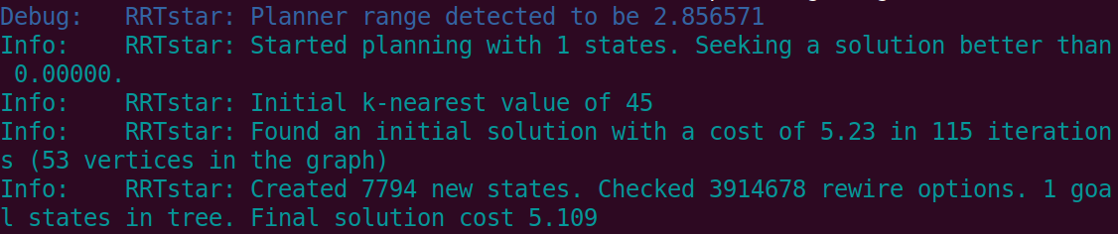
效果见视频

