Inline image regression
BEFORE_IMAGE: The following diagram explains how INPUT is converted into OUTPUT. Preserve this paragraph before the picture.
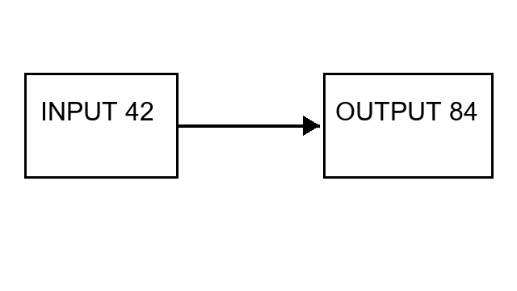
AFTER_IMAGE: This paragraph continues the explanation after the diagram.

