**4.2**

状态：状态由轨道块的组合方式决定

初始状态：任选一个工件均可作为初始状态

行动：当前组合工件的扇出与一个的扇入相连，弧形工件需要与弧形工件或者分支工件相连。工件相连时拐角需要对应，连接时可以有[-10,10]度角度误差。

转移模型：行动会产生期待的后果

目标测试：所有零件拼接成铁路，无重叠的轨道

路径耗散：无

**4.4**

生成八数码问题和八皇后问题各1000个，编码求解如下。

八数码问题：

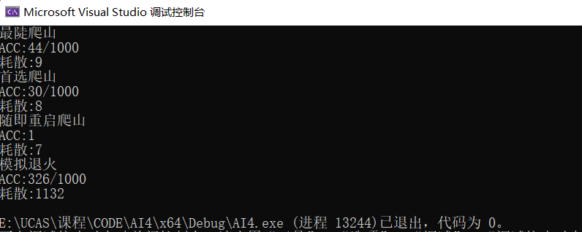

八皇后问题：

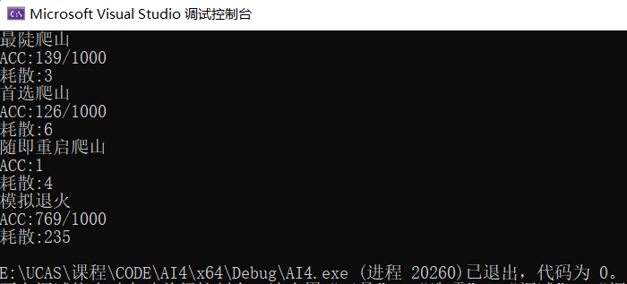

四种方法求解八数码问题和八皇后问题，求解率及耗散值如下图

观察上图发现最陡爬山法以及首选爬山法问题求解能力很相似，性能比较低的原因是陷入了局部极值。

模拟退火法相比最陡爬山法以及首选爬山法性能得到了提升，这是因为模拟退火法能够以一定概率跳出局部极值，获得问题的全局极值。

随机重启爬山法的性能最好，这是因为对一个有解问题，随机重启总能够寻找到问题的解。

4.6

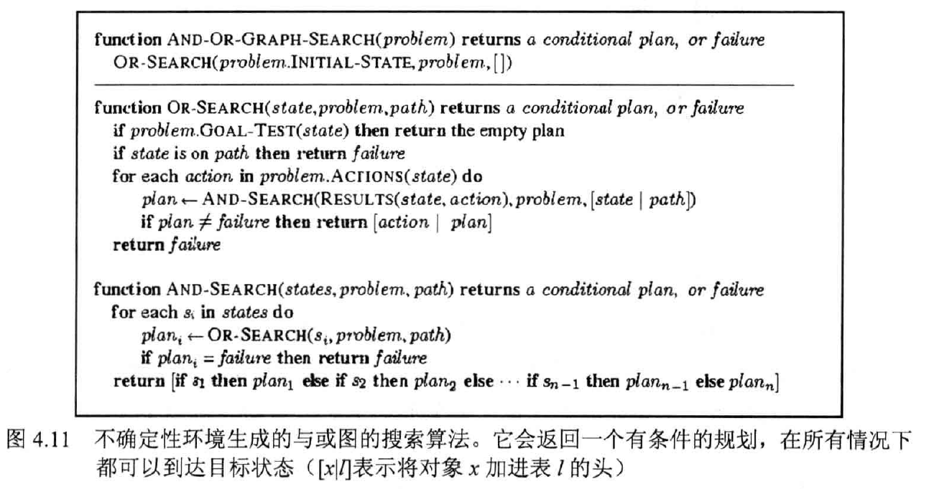

对书上图4.11不确定性环境的与或图搜索算法进行改进。伪代码如下所示：

|  |
| --- |
| Function and-or-graph-search(problem) returns a conditional plan, or failure  Or-search(problem.initial-state, problem,[])  Function or search(state, problem, path) returns a conditional plan, or failure  If problem.goal-test(state) then return the empty plan  If state is on path then return loop  Plan-a = none  For each action in problem.actions(state) do  Plan = and-search(results(state, action), problem, [state | path])  If plan != failure then  If plan is 无环 then return [action | plan]  Else plan-a = [action | plan]  If plan-a != none then return plan-a  Else return failure  Function and-search(state, problem, path) returns a conditional plan ,or failure  flag = none  For each si in states do  Plani = or-search(si, problem, path)  If plani = failure then return failure  If plan != loop then flag = false  Else flag= true  If not flag then  Return[if s1 then plan1 else if s2 then plan2 ………..else palnn]  Return failure  注：and-search算法里的flag表示是否循环 |

在或搜索中，如果循环到路径上的状态时，就返回一个loop信号；在搜索过程中，如果有环，则plan-a存储当前plan条件下的action；通过这两种做法，既使得有环规划可以指向规划的早期部分，还能够在找到有环规划后继续寻找无环规划。

**附录**

**Code1.cpp**

**//**八数码问题

#include <iostream>

#include <time.h>

#include <stdlib.h>

#include <algorithm>

#include <cmath>

#include <vector>

using namespace std;

int direction[4][2] = { {0, 1}, {1, 0}, {0, -1}, {-1, 0} }; // 右下左上

int current[3][3]; // 当前状态

int row_0, col_0; // 记录0的坐标

int totalTrial; // 统计移动步数

int Manhattan() { // 计算曼哈顿距离

int sum = 0;

for (int i = 0; i < 3; i++) {

for (int j = 0; j < 3; j++) {

if (current[i][j] == 0) continue;

int row = current[i][j] / 3;

int col = current[i][j] % 3;

int distance = abs(row - i) + abs(col - j);

sum += distance;

}

}

return sum;

}

void print() {

for (int i = 0; i < 3; ++i) {

for (int j = 0; j < 3; ++j)

cout << current[i][j] << " ";

cout << endl;

}

cout << endl;

}

void initial() {

for (int i = 0; i < 3; ++i) { // 初始状态为目标状态

for (int j = 0; j < 3; ++j) {

current[i][j] = i * 3 + j;

}

}

row_0 = 0, col_0 = 0;

int last = -1; // 上一次移动方向

for (int i = 0; i < 20; i++) { // 随机打乱

bool upset = false;

while (!upset) { // 打乱成功才跳出循环

int dir = rand() % 4; // 随机选取一个方向

if (last != -1 && last != dir && abs(last - dir) == 2) continue; // 避免反向走

int x = row_0 + direction[dir][0];

int y = col_0 + direction[dir][1];

if (x >= 0 && x < 3 && y >= 0 && y < 3) { // 方向可行

swap(current[row_0][col_0], current[x][y]); // 交换0和相邻数字的位置

row_0 = x, col_0 = y; // 更新0的坐标

last = dir; // 更新此次移动方向

upset = true; // 标记打乱成功

}

}

}

}

// 判定是否有解

bool check() {

for (int i = 0; i < 3; ++i) {

for (int j = 0; j < 3; ++j)

if (current[i][j] != i * 3 + j)

return false;

}

return true;

}

// 爬山法

bool hillClimbing() {

for (int trial = 0; trial < 200; trial++) {

int curManha = Manhattan(); // 当前状态

int minMan = 99999, minX = 0, minY = 0;

for (int i = 0; i < 4; i++) { // 在后继状态中找最小值

int x = row_0 + direction[i][0];

int y = col_0 + direction[i][1];

if (x >= 0 && x < 3 && y >= 0 && y < 3) { // 方向可行

swap(current[row_0][col_0], current[x][y]); // 交换0和相邻位置

int nextManha = Manhattan();

if (nextManha < minMan) { // 获取下一状态的最小值

minMan = nextManha;

minX = x, minY = y;

}

swap(current[x][y], current[row_0][col_0]); // 复原0和相邻位置

}

}

if (curManha > minMan) { // 最小值优于当前状态

swap(current[row_0][col_0], current[minX][minY]);

row_0 = minX, col_0 = minY;

}

if (check()) { // 成功找到解

totalTrial += trial;

return true;

}

}

return false;

}

// 首选爬山法

bool firstchose() {

for (int trial = 0; trial < 500; trial++) {

// 随机选取第一个优于当前状态的下一步

bool next = false;

int times = 0;

while (!next) {

int dir = rand() % 4;

int curManha = Manhattan();

int x = row_0 + direction[dir][0];

int y = col_0 + direction[dir][1];

if (x >= 0 && x < 3 && y >= 0 && y < 3) { // 方向可行

swap(current[row_0][col_0], current[x][y]);

int nextManha = Manhattan();

if (nextManha < curManha) {

row_0 = x, col_0 = y;

next = true;

}

else {

swap(current[x][y], current[row_0][col_0]);

}

}

if (++times > 20) break;

}

if (check()) { // 成功找到解

totalTrial += trial;

return true;

}

}

return false;

}

// 模拟退火算法

bool simulated() {

double temperature = 5; // 初始温度

int trial = 0;

while (temperature > 0.00001) {

vector<int> v; // 选出可行的方向

for (int i = 0; i < 4; i++) {

int x = row_0 + direction[i][0];

int y = col_0 + direction[i][1];

if (x >= 0 && x < 3 && y >= 0 && y < 3) { // 方向可行

v.push_back(i);

}

}

int curManha = Manhattan(); // 当前状态的曼哈顿距离之和

int dir = v[rand() % v.size()]; // 随机选取一个可行方向

int x = row_0 + direction[dir][0];

int y = col_0 + direction[dir][1];

swap(current[row_0][col_0], current[x][y]); // 交换0和相邻节点的位置

int nextManha = Manhattan(); // 交换之后的曼哈顿距离之和

int E = nextManha - curManha;

if (E < 0) { // 下一状态优于当前状态

row_0 = x, col_0 = y; // 更新0的位置

trial++;

}

else if (exp((-1) * E / temperature) > ((double)(rand() % 1000) / 1000)) { // 以一定的概率选取

row_0 = x, col_0 = y;

trial++;

}

else { // 不成功的话，复原0和相邻节点的位置

swap(current[x][y], current[row_0][col_0]);

}

temperature *= 0.999; // 温度下降

if (check()) { // 成功找到解

totalTrial += trial;

return true;

}

}

return false;

}

// 最陡上升爬山法

int steepestAscent() {

int count = 0;

for (int i = 0; i < 1000; i++) {

initial();

if (hillClimbing())

count++;

}

return count;

}

// 首选爬山法

int firstChose() {

int count = 0;

for (int i = 0; i < 1000; i++) {

initial();

if (firstchose())

count++;

}

return count;

}

// 随机重新开始爬山法

int randomRestart() {

bool find = false;

while (!find) {

initial();

find = hillClimbing();

}

return find;

}

// 模拟退火搜索

int simulatedAnnealing() {

int count = 0;

for (int i = 0; i < 1000; i++) {

initial();

if (simulated())

count++;

}

return count;

}

int main(int argc, char const* argv[]) {

srand((int)time(0));

totalTrial = 0;

cout << "最陡爬山" << endl;

int count = steepestAscent();

cout << "ACC:" << count << "/1000" << endl;

cout << "耗散:" << totalTrial / count << endl;

totalTrial = 0;

cout << "首选爬山" << endl;

int count3 = firstChose();

cout << "ACC:" << count3 << "/1000" << endl;

cout << "耗散:" << totalTrial / count3 << endl;

totalTrial = 0;

cout << "随即重启爬山" << endl;

int count2 = randomRestart();

cout << "ACC:" << count2 << endl;

cout << "耗散:" << totalTrial / count2 << endl;

totalTrial = 0;

cout << "模拟退火" << endl;

int count4 = simulatedAnnealing();

cout << "ACC:" << count4 << "/1000" << endl;

cout << "耗散:" << totalTrial / count4 << endl;

return 0;

}

Code2.cpp

//八皇后问题

#include <iostream>

#include <time.h>

#include <stdlib.h>

#include <algorithm>

#include <cmath>

using namespace std;

int queens[8][8]; // 8*8棋盘

int temp[8][8];

int totalTrial; // 统计移动步数

// 随机生成初始状态

void initial() {

for (int i = 0; i < 8; ++i) {

for (int j = 0; j < 8; j++) {

queens[i][j] = 0;

}

}

for (int i = 0; i < 8; i++) {

int num = rand() % 8;

queens[i][num] = 1;

}

}

void print() {

for (int i = 0; i < 8; ++i) {

for (int j = 0; j < 8; j++)

cout << queens[i][j] << " ";

cout << endl;

}

}

// 统计在该位置下所有皇后的冲突个数

int findCollision(int row, int col) {

int count = 0;

// 该位置为1

temp[row][col] = 1;

for (int k = 0; k < 64; k++) {

if (temp[k / 8][k % 8] == 1) {

for (int i = 0; i < 8; i++) // 同一列

if (i != k / 8 && temp[i][k % 8] == 1)

count++;

for (int i = k / 8, j = k % 8; i < 8 && j < 8; i++, j++) // 右下方

if (i != k / 8 && temp[i][j] == 1)

count++;

for (int i = k / 8, j = k % 8; i >= 0 && j >= 0; i--, j--) // 左上方

if (i != k / 8 && temp[i][j] == 1)

count++;

for (int i = k / 8, j = k % 8; i < 8 && j >= 0; i++, j--) // 左下方

if (i != k / 8 && temp[i][j] == 1)

count++;

for (int i = k / 8, j = k % 8; i >= 0 && j < 8; i--, j++) // 右上方

if (i != k / 8 && temp[i][j] == 1)

count++;

}

}

temp[row][col] = 0; // 复原位置

return count / 2;

}

bool check(int h[8][8]) {

for (int i = 0; i < 8; i++) {

bool flag = false;

for (int j = 0; j < 8; j++) {

if (queens[i][j] == 1 && h[i][j] == 0) { //皇后所在位置没有冲突

flag = true;

break;

}

}

if (!flag) { // 皇后所在位置仍有冲突，还需要继续查找

return false;

}

}

return true;

}

int ct = 0;

// 爬山法

bool hillClimbing() {

// 尝试次数大于100则判定为无解

for (int trial = 0; trial <= 100; trial++) {

// 拷贝原始棋盘数据到temp

for (int i = 0; i < 8; i++) {

for (int j = 0; j < 8; j++) {

temp[i][j] = queens[i][j];

}

}

int h[8][8];

int minH = 9999, minX = 0, minY = 0, curState;

for (int i = 0; i < 8; i++) {

for (int j = 0; j < 8; j++) {

// 在计算h(i, j)之前，对i行所有位置赋值为0

for (int k = 0; k < 8; k++)

temp[i][k] = 0;

// 查找h(i, j)

h[i][j] = findCollision(i, j);

// 当前状态的h值

if (queens[i][j] == 1) {

curState = h[i][j];

}

// 先找出冲突个数最小的位置

if (h[i][j] < minH) {

minH = h[i][j];

minX = i;

minY = j;

}

// 计算h(i,j)之后要复原数据，避免计算错误

for (int k = 0; k < 8; k++)

temp[i][k] = queens[i][k];

}

}

// 将皇后放在该行冲突最少的位置处

if (curState > minH) {

for (int i = 0; i < 8; i++)

queens[minX][i] = 0;

queens[minX][minY] = 1;

}

// 判断是否找到解, 有解则返回值为真

if (check(h)) {

totalTrial += trial;

return true;

}

}

return false;

}

// 首选爬山法

bool firstchose() {

// 尝试次数大于100则判定为无解

for (int trial = 0; trial <= 100; trial++) {

// 拷贝原始棋盘数据到temp

for (int i = 0; i < 8; i++) {

for (int j = 0; j < 8; j++) {

temp[i][j] = queens[i][j];

}

}

int h[8][8], curState;

for (int i = 0; i < 8; i++) {

for (int j = 0; j < 8; j++) {

// 在计算h(i, j)之前，对i行所有位置赋值为0

for (int k = 0; k < 8; k++)

temp[i][k] = 0;

// 查找h(i, j)

h[i][j] = findCollision(i, j);

// 当前状态的h值

if (queens[i][j] == 1) {

curState = h[i][j];

}

// 计算h(i,j)之后要复原数据，避免计算错误

for (int k = 0; k < 8; k++)

temp[i][k] = queens[i][k];

}

}

// 随机选取第一个优于当前状态的下一状态

bool better = false;

int next, nextState, times = 0;

while (!better) {

next = rand() % 64;

nextState = h[next / 8][next % 8];

if (nextState < curState) {

better = true;

}

if (++times > 100) break;

}

if (better) {

for (int i = 0; i < 8; i++)

queens[next / 8][i] = 0;

queens[next / 8][next % 8] = 1; // 放置皇后

}

// 判断是否找到解, 有解则返回值为真

if (check(h)) {

totalTrial += trial;

return true;

}

}

return false;

}

// 模拟退火搜索

bool simulated() {

double temperature = 5;

int trial = 0;

while (temperature > 0.00001) {

// 拷贝原始棋盘数据到temp

for (int i = 0; i < 8; i++) {

for (int j = 0; j < 8; j++) {

temp[i][j] = queens[i][j];

}

}

int h[8][8], curState;

for (int i = 0; i < 8; i++) {

for (int j = 0; j < 8; j++) {

// 在计算h(i, j)之前，对i行所有位置赋值为0

for (int k = 0; k < 8; k++)

temp[i][k] = 0;

// 查找h(i, j)

h[i][j] = findCollision(i, j);

// 当前状态的h值

if (queens[i][j] == 1) {

curState = h[i][j];

}

// 计算h(i,j)之后要复原数据，避免计算错误

for (int k = 0; k < 8; k++)

temp[i][k] = queens[i][k];

}

}

// 随机选取一个下一状态

bool better = false;

int next, nextState, times = 0;

next = rand() % 64;

nextState = h[next / 8][next % 8];

int E = nextState - curState;

if (E < 0) {

better = true;

}

else if (exp((-1) * E / temperature) > ((double)(rand() % 1000) / 1000)) {

better = true;

}

if (better) {

for (int i = 0; i < 8; i++)

queens[next / 8][i] = 0;

queens[next / 8][next % 8] = 1; // 放置皇后

trial++;

}

// 判断是否找到解, 有解则返回值为真

if (check(h)) {

totalTrial += trial;

return true;

}

temperature *= 0.99;

}

return false;

}

// 最陡上升爬山法

int steepestAscent() {

int count = 0;

for (int i = 0; i < 1000; i++) {

initial();

if (hillClimbing())

count++;

}

return count;

}

// 首选爬山法

int firstChose() {

int count = 0;

for (int i = 0; i < 1000; i++) {

initial();

if (firstchose())

count++;

}

return count;

}

// 随机重新开始爬山法

int randomRestart() {

bool find = false;

while (!find) {

initial();

find = hillClimbing();

}

return find;

}

// 模拟退火搜索

int simulatedAnnealing() {

int count = 0;

for (int i = 0; i < 1000; i++) {

initial();

if (simulated())

count++;

}

return count;

}

int main(int argc, char const* argv[]) {

srand((int)time(0));

totalTrial = 0;

cout << "最陡爬山" << endl;

int count = steepestAscent();

cout << "ACC:" << count << "/1000" << endl;

cout << "耗散:" << totalTrial / count << endl;

totalTrial = 0;

cout << "首选爬山" << endl;

int count3 = firstChose();

cout << "ACC:" << count3 << "/1000" << endl;

cout << "耗散:" << totalTrial / count3 << endl;

totalTrial = 0;

cout << "随即重启爬山" << endl;

int count2 = randomRestart();

cout << "ACC:" << count2 << endl;

cout << "耗散:" << totalTrial / count2 << endl;

totalTrial = 0;

cout << "模拟退火" << endl;

int count4 = simulatedAnnealing();

cout << "ACC:" << count4 << "/1000" << endl;

cout << "耗散:" << totalTrial / count4 << endl;

return 0;

}