My creative works
Applicant: Qianyang Peng

- 3D Chinese Chess Game
On the very first course when python was introduced to zero based students, I decided to go beyond teacher’s requirement of writing a chess game and implemented a 3D one. I spent long time learning about pygame and pyOpenGL, and constructed the game little by little from basic objects and textures to lighting, camera, bindings and response actions.
Here is the main interface. You can freely rotate the camera with arrow keys.
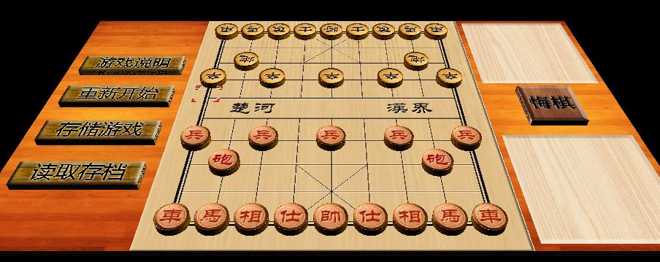

Layered interface hierarchy:
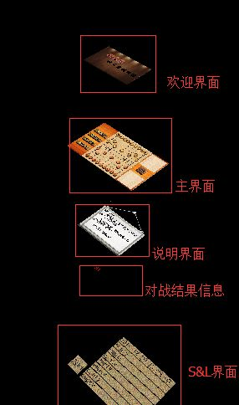
As a beginner, I have little idea how to implement multiple scenarios and switch between them, especially for a 3D game. So I implemented all the interfaces together in one scenario, but their y-coordinates are different. So we can let users see different interfaces by pulling cameras up and down.
Translations of interfaces in the right picture (from up to down):
- Welcome Interface
- Main Interface
- Instruction
- Battle Result
- Save and Load

- LOGO design for SEIEE Student Union

I have worked in the Designing Department of SEIEE (School of Electronics, Information and Electrical Engineering). The right picture is the logo I designed as their new logo for the year of 2014. I used Photoshop to design this logo. It was not chosen as the final version, but my design has been innovative and impressive.
2014 is the Chinese “Horse Year”, So I added two symbols to the character “S” to make it like a Chinese character “马”, which exactly means horse. I also made the character looks like a light bulb, which means creative and thought provoking.

- Background Music and Sound Effect work for high school class stage show
When I was in high school, I picked and arranged appropriate background music and sound effects (e.g. thunder) for our high school’s stage show. By these experience I got familiar with music process software such as Adobe Audition and got the experience of how we can use music and sound to enhance the motion we want to convey to the audience.

Video Link: http://www.tudou.com/programs/view/GwEwLoNfE20/?spm=a2h0k.8191414.GwEwLoNfE20.A

- Online Judge Client
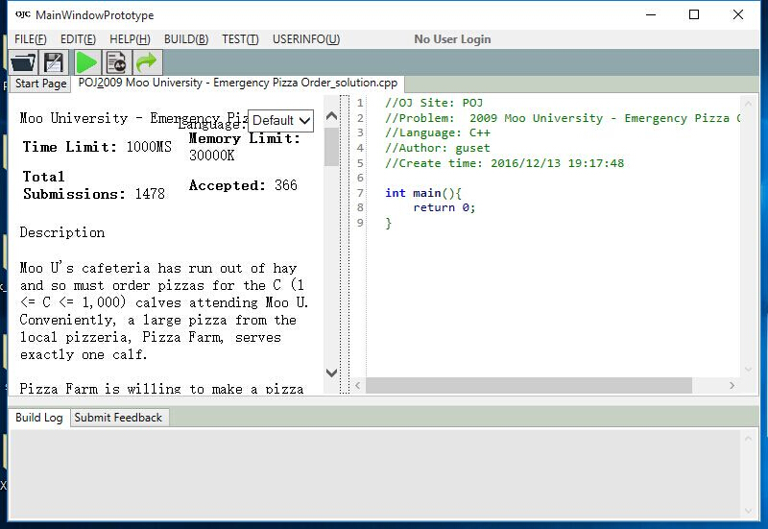
This work is not really creative in interface design, but I really like it in its function design. In my software Engineering class, I as a team leader led a five students group implemented a IDE specially designed for Online Judge Website users. They can use this software view OJ problems, write and run code in different languages, automatically test example input & output, submit your solutions, and even share your questions and codes with other users. I got this idea when we were busy in solving problems in OJ sites every day, and my software had provided lots of convenience to ourselves and has been widely used among students.

