My creative works
Appliant: Qianyang Peng

- 3D Chinese Chess Game
On the very first course when python was introduced to zero based students, I decided to go beyond teacher’s requirement of writing a chess game and implemented a 3D one. I spent long time learning about pygame and pyOpenGL, and constructed the game little by little from basic objects and textures to lighting, camera, bindings and response actions.
Here is the main interface. You can freely rotate the camera with arrowkeys.
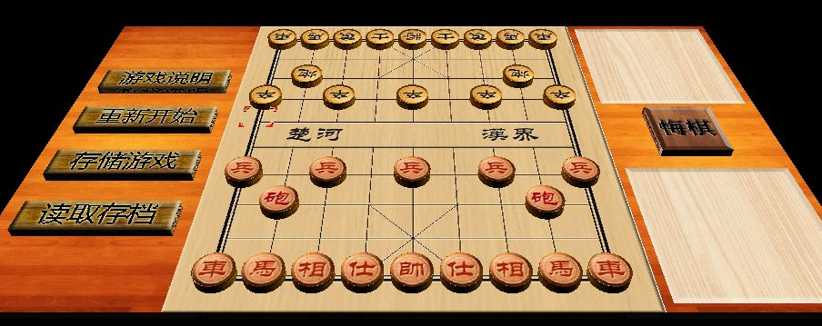

Layered interface hierarchy:
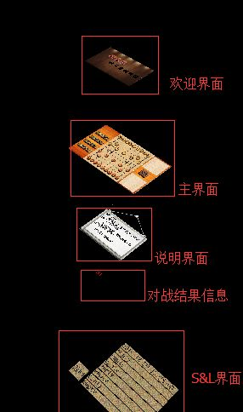
As a beginner, I have little idea how to implement multiple scenarios and switch between them, especially for a 3D game. So I implemented all the interfaces together in one scenario, but their y-coordinates are different. So we can let users see different interfaces by pulling cameras up and down.
Translations of interfaces in the right picture (from up to down):
- Welcome Interface
- Main Interface
- Instruction
- Battle Result
- Save and Load

- Photoshop
- Videos
- Vocaloid
- Games

